Transmission Timings Report Week - 6
5/02/2024 - 11/02/2024

SBR2 Cloud Production2 - Single Requests (SRP)

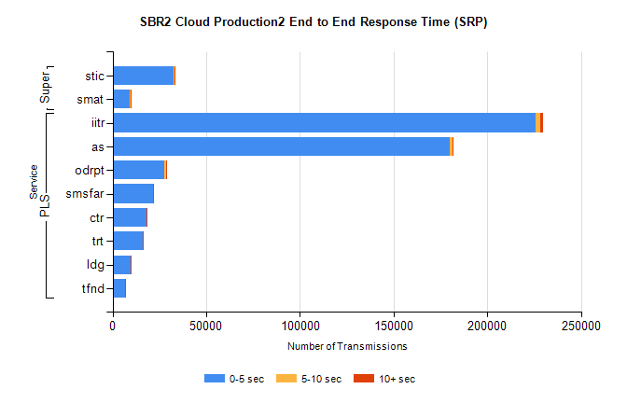
Stream | Service | 0-5 sec | 5-10 sec | >10 sec | Total | % within 5 sec timing target
PLS | iitr | 225745 | 2491 | 1261 | 229525 | 98.4%
PLS | as | 180067 | 1379 | 545 | 182022 | 98.9%
PLS | odrpt | 27476 | 1114 | 121 | 28711 | 95.7%
PLS | smsfar | 21618 | 183 | 78 | 21881 | 98.8%
PLS | ctr | 17924 | 160 | 66 | 18152 | 98.7%
PLS | trt | 15914 | 121 | 58 | 16099 | 98.9%
PLS | ldg | 9647 | 57 | 15 | 9719 | 99.3%
PLS | tfnd | 6757 | 59 | 19 | 6837 | 98.8%
Super | stic | 32683 | 390 | 151 | 33229 | 98.4%
Super | smat | 9382 | 206 | 63 | 9654 | 97.2%

SBR2 Cloud Production2 - Bulk or Batch Requests (BBRP)

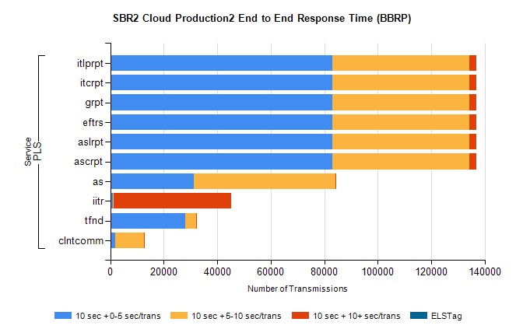
Stream | Service | 10 sec + 0-5 sec /trans | 10 sec + 5-10 sec /trans | 10 sec + >10 sec /trans | Processing Incomplete | ELStag | Total
PLS | ascrpt | 82898 | 51262 | 2768 | 24 | 0 | 140814
PLS | aslrpt | 82898 | 51262 | 2768 | 24 | 0 | 140814
PLS | eftrs | 82898 | 51262 | 2768 | 24 | 0 | 140814
PLS | grpt | 82898 | 51262 | 2768 | 24 | 0 | 140814
PLS | itcrpt | 82898 | 51262 | 2768 | 24 | 0 | 140814
PLS | itlprpt | 82898 | 51262 | 2768 | 24 | 0 | 140814
PLS | as | 31253 | 52881 | 459 | 163 | 0 | 85609
PLS | iitr | 1052 | 268 | 43779 | 117 | 0 | 46080
PLS | tfnd | 28164 | 3870 | 98 | 2554 | 0 | 34908
PLS | clntcomm | 1846 | 10752 | 168 | 2213 | 0 | 15628

SBR2 Cloud Production2 - ...

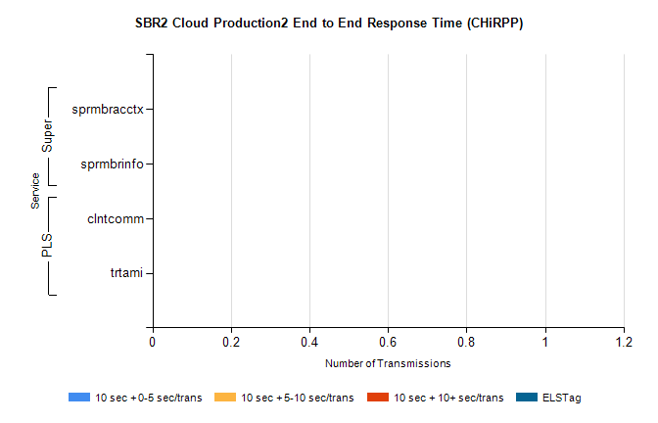
Stream | Service | 10 sec + 0-5 sec /trans | 10 sec + 5-10 sec /trans | 10 sec + >10 sec /trans | Total | % within 5 sec timing target
PLS | clntcomm | 0 | 0 | 0 | 11218 | 0.0%
PLS | trtami | 0 | 0 | 0 | 2 | 0.0%
Super | sprmbracctx | 0 | 0 | 0 | 3595 | 0.0%
Super | sprmbrinfo | 0 | 0 | 0 | 2843 | 0.0%

SBR1 Production Transactions

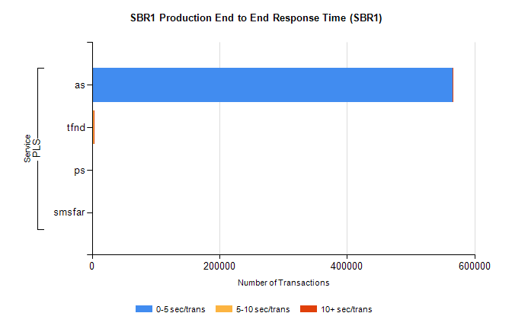
Stream | Service | 0-5 sec/trans | 5-10 sec/trans | 10+ sec/trans | Total | % within 5 sec timing target
PLS | as | 565841 | 242 | 501 | 566584 | 99.9%
PLS | tfnd | 1787 | 892 | 18 | 2697 | 66.3%
PLS | ps | 17 | 43 | 125 | 185 | 9.2%
PLS | smsfar | 6 | 26 | 1 | 33 | 18.2%

