Transmission Timings Report Week - 7
12/02/2024 - 18/02/2024

SBR2 External Vendor Testing Environment (EVTE3)

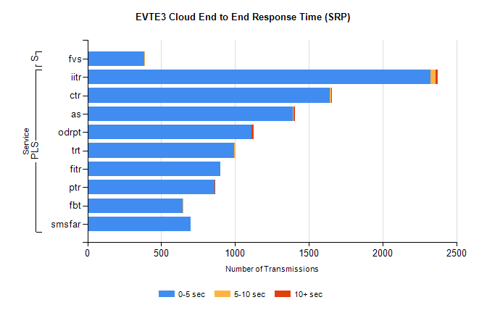
Stream | Service | 0-5 sec | 5-10 sec | >10 sec | Total | % within 5 sec timing target
PLS | iitr | 2326 | 32 | 14 | 2425 | 95.9%
PLS | ctr | 1641 | 10 | 1 | 1684 | 97.4%
PLS | as | 1393 | 6 | 6 | 1422 | 98.0%
PLS | odrpt | 1113 | 0 | 14 | 1137 | 97.9%
PLS | trt | 996 | 8 | 0 | 1008 | 98.8%
PLS | fitr | 901 | 0 | 0 | 912 | 98.8%
PLS | ptr | 859 | 1 | 1 | 866 | 99.2%
PLS | fbt | 647 | 4 | 0 | 715 | 90.5%
PLS | smsfar | 698 | 0 | 0 | 698 | 100.0%
Super | fvs | 384 | 1 | 0 | 385 | 99.7%

SBR2 External Vendor Testing Environment (EVTE3)

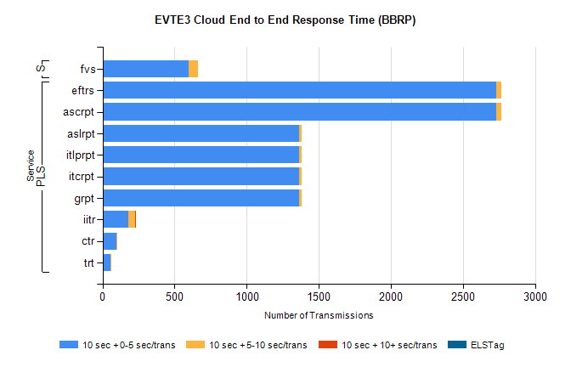
Stream | Service | 10 sec + 0-5 sec /trans | 10 sec + 5-10 sec /trans | 10 sec + >10 sec /trans | Processing Incomplete | ELStag | Total
PLS | ascrpt | 2728 | 38 | 0 | 14 | 0 | 2780
PLS | eftrs | 2728 | 38 | 0 | 14 | 0 | 2780
PLS | aslrpt | 1364 | 19 | 0 | 8 | 0 | 1391
PLS | grpt | 1364 | 19 | 0 | 7 | 0 | 1390
PLS | itcrpt | 1364 | 19 | 0 | 7 | 0 | 1390
PLS | itlprpt | 1364 | 19 | 0 | 7 | 0 | 1390
PLS | iitr | 177 | 50 | 2 | 173 | 0 | 405
PLS | ctr | 99 | 2 | 0 | 214 | 0 | 317
PLS | trt | 57 | 1 | 0 | 212 | 0 | 271
Super | fvs | 595 | 68 | 0 | 270 | 0 | 933

