Transmission Timings Report Week - 10
4/03/2024 - 10/03/2024

SBR2 External Vendor Testing Environment (EVTE3)

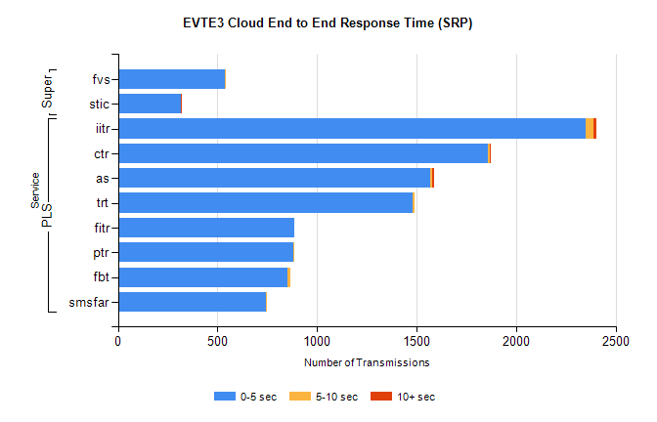
Stream | Service | 0-5 sec | 5-10 sec | >10 sec | Total | % within 5 sec timing target
PLS | iitr | 2351 | 35 | 16 | 2409 | 97.6%
PLS | ctr | 1856 | 10 | 1 | 1946 | 95.4%
PLS | as | 1570 | 9 | 9 | 1602 | 98.0%
PLS | trt | 1479 | 11 | 0 | 1545 | 95.7%
PLS | fitr | 886 | 0 | 0 | 926 | 95.7%
PLS | ptr | 882 | 1 | 0 | 922 | 95.7%
PLS | fbt | 853 | 15 | 0 | 879 | 97.0%
PLS | smsfar | 744 | 2 | 0 | 746 | 99.7%
Super | fvs | 536 | 2 | 0 | 539 | 99.4%
Super | stic | 314 | 0 | 1 | 315 | 99.7%

SBR2 External Vendor Testing Environment (EVTE3)

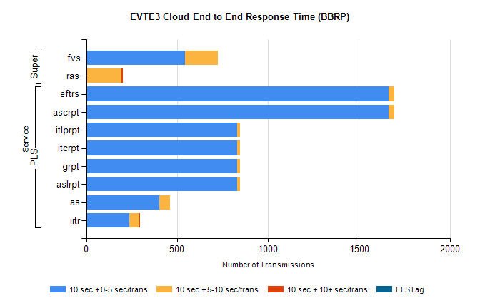
Stream | Service | 10 sec + 0-5 sec /trans | 10 sec + 5-10 sec /trans | 10 sec + >10 sec /trans | Processing Incomplete | ELStag | Total
PLS | ascrpt | 1662 | 34 | 0 | 48 | 0 | 1744
PLS | eftrs | 1662 | 34 | 0 | 48 | 0 | 1744
PLS | aslrpt | 831 | 17 | 0 | 24 | 0 | 872
PLS | grpt | 831 | 17 | 0 | 24 | 0 | 872
PLS | itcrpt | 831 | 17 | 0 | 24 | 0 | 872
PLS | itlprpt | 831 | 17 | 0 | 24 | 0 | 872
PLS | as | 402 | 59 | 0 | 4 | 0 | 480
PLS | iitr | 237 | 57 | 1 | 0 | 0 | 299
Super | fvs | 545 | 180 | 0 | 281 | 0 | 1009
Super | ras | 2 | 193 | 6 | 0 | 0 | 567

