Transmission Timings Report Week - 10
4/03/2024 - 10/03/2024

SBR2 Cloud Production2 - Single Requests (SRP)

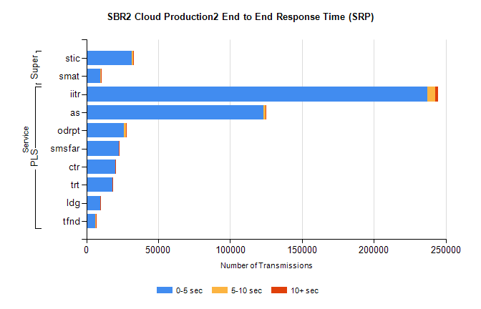
Stream | Service | 0-5 sec | 5-10 sec | >10 sec | Total | % within 5 sec timing target
PLS | iitr | 237270 | 5507 | 1743 | 244542 | 97.0%
PLS | as | 123238 | 1306 | 660 | 128567 | 95.9%
PLS | odrpt | 26220 | 1466 | 327 | 28041 | 93.5%
PLS | smsfar | 22424 | 242 | 128 | 22797 | 98.4%
PLS | ctr | 20089 | 220 | 139 | 20448 | 98.2%
PLS | trt | 18146 | 192 | 101 | 18440 | 98.4%
PLS | ldg | 9690 | 87 | 32 | 9809 | 98.8%
PLS | tfnd | 6408 | 79 | 36 | 6523 | 98.2%
Super | stic | 31527 | 876 | 289 | 32692 | 96.4%
Super | smat | 9710 | 522 | 175 | 10407 | 93.3%

SBR2 Cloud Production2 - Bulk or Batch Requests (BBRP)

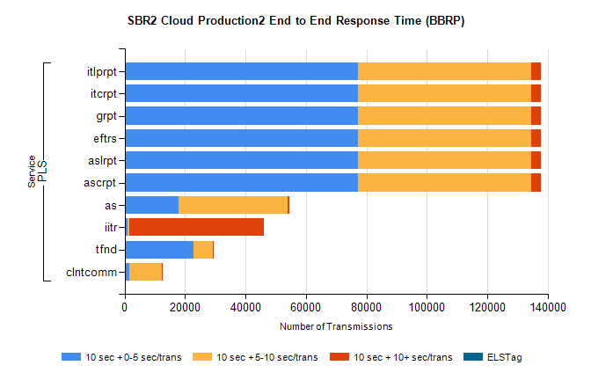
Stream | Service | 10 sec + 0-5 sec /trans | 10 sec + 5-10 sec /trans | 10 sec + >10 sec /trans | Processing Incomplete | ELStag | Total
PLS | ascrpt | 77122 | 57468 | 3087 | 9 | 0 | 143149
PLS | aslrpt | 77122 | 57468 | 3087 | 9 | 0 | 143149
PLS | eftrs | 77122 | 57468 | 3087 | 9 | 0 | 143149
PLS | grpt | 77122 | 57468 | 3087 | 9 | 0 | 143149
PLS | itcrpt | 77122 | 57468 | 3087 | 9 | 0 | 143149
PLS | itlprpt | 77122 | 57468 | 3087 | 9 | 0 | 143149
PLS | as | 17768 | 36288 | 361 | 92 | 0 | 55376
PLS | iitr | 1101 | 360 | 44608 | 135 | 0 | 47171
PLS | tfnd | 22885 | 6217 | 240 | 2434 | 0 | 32177
PLS | clntcomm | 1659 | 10749 | 156 | 0 | 0 | 13023

SBR2 Cloud Production2 - ...

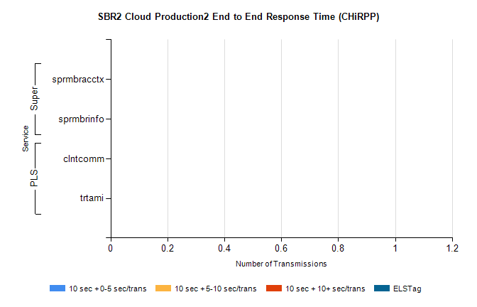
Stream | Service | 10 sec + 0-5 sec /trans | 10 sec + 5-10 sec /trans | 10 sec + >10 sec /trans | Total | % within 5 sec timing target
PLS | clntcomm | 0 | 0 | 0 | 11615 | 0.0%
PLS | trtami | 0 | 0 | 0 | 21 | 0.0%
Super | sprmbracctx | 0 | 0 | 0 | 2899 | 0.0%
Super | sprmbrinfo | 0 | 0 | 0 | 2770 | 0.0%

SBR1 Production Transactions

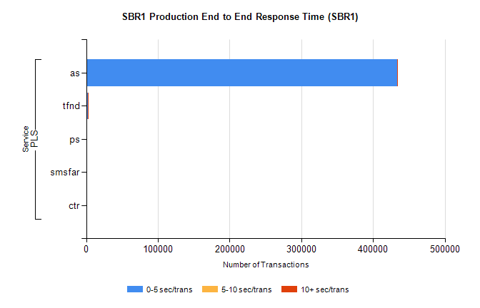
Stream | Service | 0-5 sec/trans | 5-10 sec/trans | 10+ sec/trans | Total | % within 5 sec timing target
PLS | as | 433693 | 167 | 173 | 434033 | 99.9%
PLS | tfnd | 1927 | 905 | 8 | 2840 | 67.9%
PLS | ps | 25 | 47 | 73 | 145 | 17.2%
PLS | smsfar | 8 | 24 |  | 32 | 25.0%
PLS | ctr |  |  | 1 | 1 | 0.0%

