Transmission Timings Report Week - 8
19/02/2024 - 25/02/2024

SBR2 External Vendor Testing Environment (EVTE3)

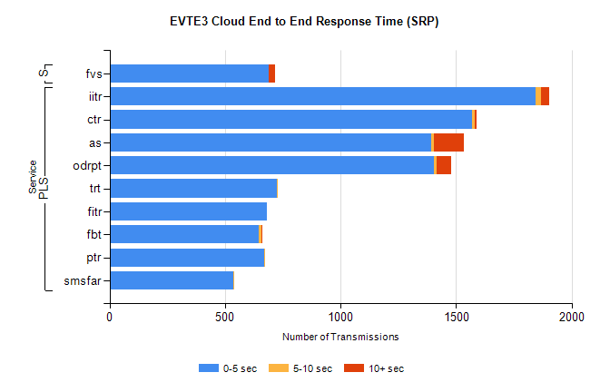
Stream | Service | 0-5 sec | 5-10 sec | >10 sec | Total | % within 5 sec timing target
PLS | iitr | 1842 | 25 | 36 | 1913 | 96.3%
PLS | ctr | 1569 | 12 | 9 | 1608 | 97.6%
PLS | as | 1394 | 11 | 130 | 1574 | 88.6%
PLS | odrpt | 1404 | 10 | 65 | 1479 | 94.9%
PLS | trt | 724 | 1 | 0 | 735 | 98.5%
PLS | fitr | 683 | 0 | 0 | 683 | 100.0%
PLS | fbt | 644 | 12 | 1 | 680 | 94.7%
PLS | ptr | 668 | 2 | 0 | 670 | 99.7%
PLS | smsfar | 537 | 1 | 0 | 538 | 99.8%
Super | fvs | 690 | 1 | 27 | 718 | 96.1%

SBR2 External Vendor Testing Environment (EVTE3)

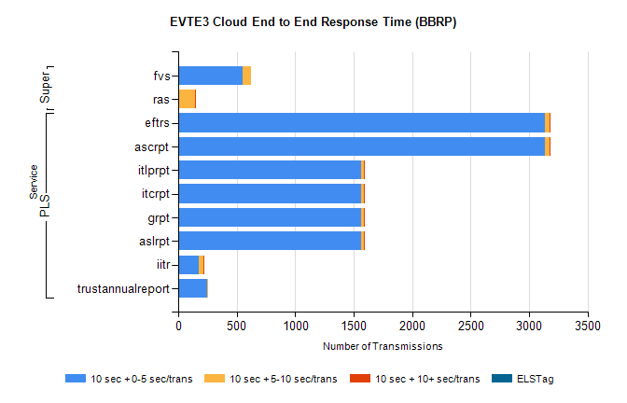
Stream | Service | 10 sec + 0-5 sec /trans | 10 sec + 5-10 sec /trans | 10 sec + >10 sec /trans | Processing Incomplete | ELStag | Total
PLS | ascrpt | 3134 | 44 | 6 | 6 | 0 | 3192
PLS | eftrs | 3134 | 44 | 6 | 6 | 0 | 3192
PLS | aslrpt | 1567 | 22 | 3 | 3 | 0 | 1596
PLS | grpt | 1567 | 22 | 3 | 3 | 0 | 1596
PLS | itcrpt | 1567 | 22 | 3 | 3 | 0 | 1596
PLS | itlprpt | 1567 | 22 | 3 | 3 | 0 | 1596
PLS | iitr | 176 | 37 | 7 | 73 | 0 | 295
PLS | trustannualreport | 245 | 2 | 0 | 0 | 0 | 247
Super | fvs | 548 | 78 | 0 | 195 | 0 | 825
Super | ras | 0 | 144 | 6 | 18 | 0 | 598

