Transmission Timings Report Week - 8
19/02/2024 - 25/02/2024

SBR2 Cloud Production2 - Single Requests (SRP)

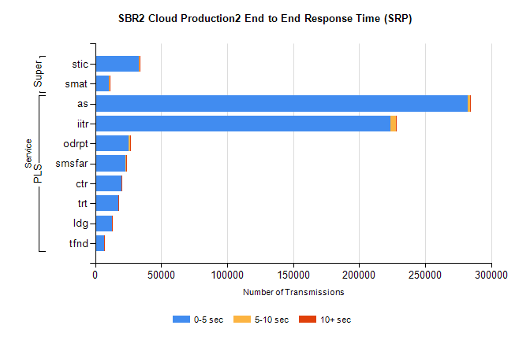
Stream | Service | 0-5 sec | 5-10 sec | >10 sec | Total | % within 5 sec timing target
PLS | as | 282252 | 1773 | 915 | 284975 | 99.0%
PLS | iitr | 223601 | 4282 | 862 | 228751 | 97.7%
PLS | odrpt | 25555 | 1258 | 109 | 26922 | 94.9%
PLS | smsfar | 23245 | 126 | 79 | 23450 | 99.1%
PLS | ctr | 19695 | 124 | 43 | 19862 | 99.2%
PLS | trt | 17640 | 135 | 59 | 17836 | 98.9%
PLS | ldg | 12922 | 76 | 19 | 13017 | 99.3%
PLS | tfnd | 6692 | 40 | 21 | 6753 | 99.1%
Super | stic | 33222 | 426 | 131 | 33779 | 98.4%
Super | smat | 10556 | 253 | 67 | 10876 | 97.1%

SBR2 Cloud Production2 - Bulk or Batch Requests (BBRP)

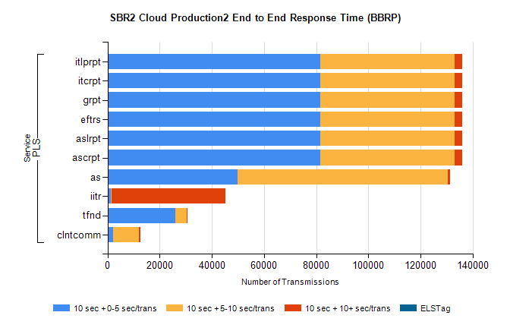
Stream | Service | 10 sec + 0-5 sec /trans | 10 sec + 5-10 sec /trans | 10 sec + >10 sec /trans | Processing Incomplete | ELStag | Total
PLS | ascrpt | 81497 | 51555 | 3054 | 21 | 0 | 138854
PLS | aslrpt | 81497 | 51555 | 3054 | 21 | 0 | 138854
PLS | eftrs | 81497 | 51555 | 3054 | 21 | 0 | 138854
PLS | grpt | 81497 | 51555 | 3054 | 21 | 0 | 138854
PLS | itcrpt | 81497 | 51555 | 3054 | 21 | 0 | 138854
PLS | itlprpt | 81497 | 51555 | 3054 | 21 | 0 | 138854
PLS | as | 49721 | 80835 | 945 | 275 | 0 | 132753
PLS | iitr | 1133 | 303 | 43710 | 133 | 0 | 46125
PLS | tfnd | 26104 | 4387 | 197 | 2409 | 0 | 33266
PLS | clntcomm | 2028 | 9988 | 455 | 2 | 0 | 12757

SBR2 Cloud Production2 - ...

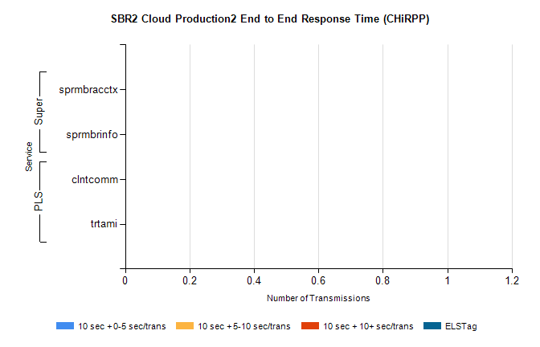
Stream | Service | 10 sec + 0-5 sec /trans | 10 sec + 5-10 sec /trans | 10 sec + >10 sec /trans | Total | % within 5 sec timing target
PLS | clntcomm | 0 | 0 | 0 | 10549 | 0.0%
PLS | trtami | 0 | 0 | 0 | 51 | 0.0%
Super | sprmbracctx | 0 | 0 | 0 | 3141 | 0.0%
Super | sprmbrinfo | 0 | 0 | 0 | 2617 | 0.0%

SBR1 Production Transactions

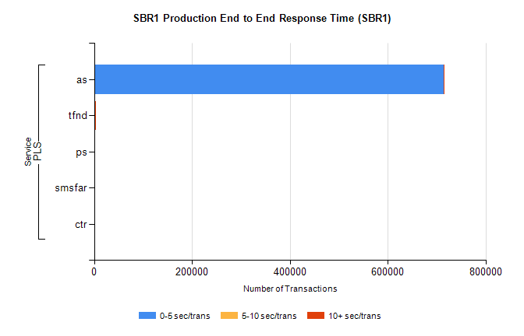
Stream | Service | 0-5 sec/trans | 5-10 sec/trans | 10+ sec/trans | Total | % within 5 sec timing target
PLS | as | 713904 | 347 | 313 | 714564 | 99.9%
PLS | tfnd | 2065 | 936 | 13 | 3014 | 68.5%
PLS | ps | 18 | 44 | 124 | 186 | 9.7%
PLS | smsfar |  | 17 | 1 | 18 | 0.0%
PLS | ctr |  |  | 1 | 1 | 0.0%

