Transmission Timings Report Week - 9
26/02/2024 - 3/03/2024

SBR2 External Vendor Testing Environment (EVTE3)

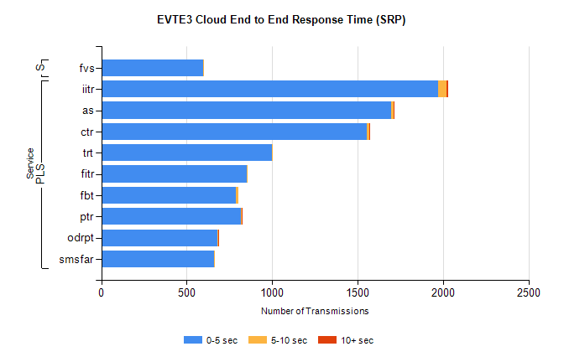
Stream | Service | 0-5 sec | 5-10 sec | >10 sec | Total | % within 5 sec timing target
PLS | iitr | 1971 | 47 | 11 | 2029 | 97.1%
PLS | as | 1697 | 16 | 4 | 1746 | 97.2%
PLS | ctr | 1556 | 10 | 1 | 1618 | 96.2%
PLS | trt | 1001 | 3 | 0 | 1028 | 97.4%
PLS | fitr | 853 | 2 | 0 | 871 | 97.9%
PLS | fbt | 788 | 13 | 0 | 853 | 92.4%
PLS | ptr | 818 | 5 | 1 | 852 | 96.0%
PLS | odrpt | 678 | 5 | 6 | 689 | 98.4%
PLS | smsfar | 659 | 2 | 0 | 661 | 99.7%
Super | fvs | 594 | 2 | 0 | 596 | 99.7%

SBR2 External Vendor Testing Environment (EVTE3)

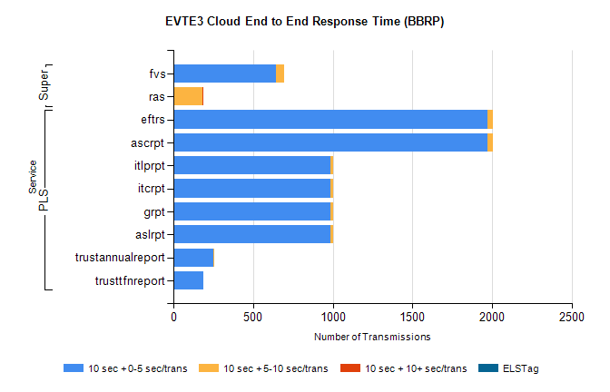
Stream | Service | 10 sec + 0-5 sec /trans | 10 sec + 5-10 sec /trans | 10 sec + >10 sec /trans | Processing Incomplete | ELStag | Total
PLS | ascrpt | 1974 | 34 | 0 | 42 | 0 | 2052
PLS | eftrs | 1974 | 34 | 0 | 42 | 0 | 2052
PLS | aslrpt | 987 | 17 | 0 | 21 | 0 | 1026
PLS | grpt | 987 | 17 | 0 | 21 | 0 | 1026
PLS | itcrpt | 987 | 17 | 0 | 21 | 0 | 1026
PLS | itlprpt | 987 | 17 | 0 | 21 | 0 | 1026
PLS | trustannualreport | 252 | 3 | 0 | 0 | 0 | 255
PLS | trusttfnreport | 187 | 0 | 0 | 0 | 0 | 187
Super | fvs | 646 | 49 | 0 | 239 | 0 | 936
Super | ras | 0 | 181 | 8 | 0 | 0 | 606

