Transmission Timings Report Week - 9
26/02/2024 - 3/03/2024

SBR2 Cloud Production2 - Single Requests (SRP)

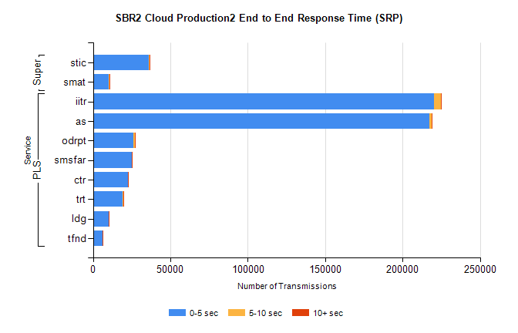
Stream | Service | 0-5 sec | 5-10 sec | >10 sec | Total | % within 5 sec timing target
PLS | iitr | 220445 | 4223 | 778 | 225467 | 97.8%
PLS | as | 217482 | 1422 | 430 | 219528 | 99.1%
PLS | odrpt | 26129 | 1102 | 95 | 27326 | 95.6%
PLS | smsfar | 24875 | 145 | 97 | 25117 | 99.0%
PLS | ctr | 22469 | 163 | 50 | 22686 | 99.0%
PLS | trt | 19255 | 138 | 34 | 19427 | 99.1%
PLS | ldg | 10098 | 65 | 22 | 10185 | 99.1%
PLS | tfnd | 6266 | 29 | 11 | 6306 | 99.4%
Super | stic | 35880 | 564 | 174 | 36618 | 98.0%
Super | smat | 10213 | 281 | 75 | 10570 | 96.6%

SBR2 Cloud Production2 - Bulk or Batch Requests (BBRP)

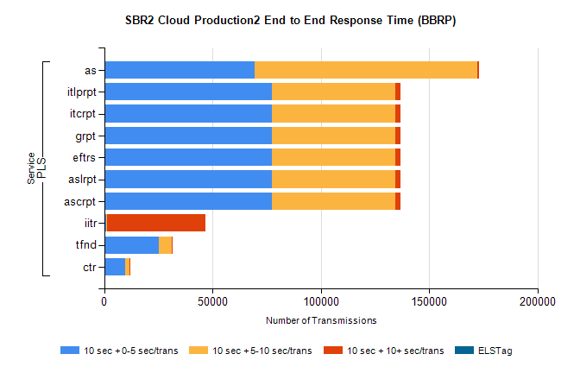
Stream | Service | 10 sec + 0-5 sec /trans | 10 sec + 5-10 sec /trans | 10 sec + >10 sec /trans | Processing Incomplete | ELStag | Total
PLS | as | 69665 | 102610 | 945 | 877 | 0 | 175536
PLS | ascrpt | 77327 | 56909 | 2630 | 20 | 0 | 139813
PLS | aslrpt | 77327 | 56909 | 2630 | 20 | 0 | 139813
PLS | eftrs | 77327 | 56909 | 2630 | 20 | 0 | 139813
PLS | grpt | 77327 | 56909 | 2630 | 20 | 0 | 139813
PLS | itcrpt | 77327 | 56909 | 2630 | 20 | 0 | 139813
PLS | itlprpt | 77327 | 56909 | 2630 | 20 | 0 | 139813
PLS | iitr | 1149 | 343 | 45154 | 108 | 0 | 47535
PLS | tfnd | 25303 | 5822 | 134 | 2609 | 0 | 34084
PLS | ctr | 9916 | 1671 | 56 | 10 | 0 | 11732

SBR2 Cloud Production2 - ...

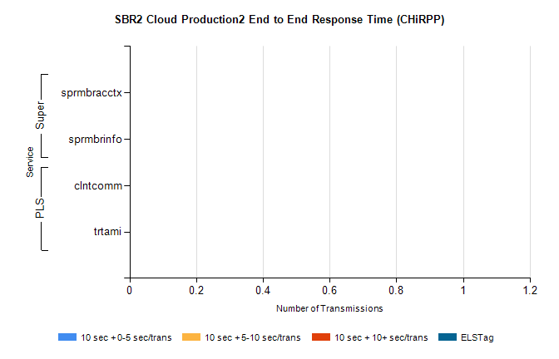
Stream | Service | 10 sec + 0-5 sec /trans | 10 sec + 5-10 sec /trans | 10 sec + >10 sec /trans | Total | % within 5 sec timing target
PLS | clntcomm | 0 | 0 | 0 | 9434 | 0.0%
PLS | trtami | 0 | 0 | 0 | 6 | 0.0%
Super | sprmbracctx | 0 | 0 | 0 | 3821 | 0.0%
Super | sprmbrinfo | 0 | 0 | 0 | 2565 | 0.0%

SBR1 Production Transactions

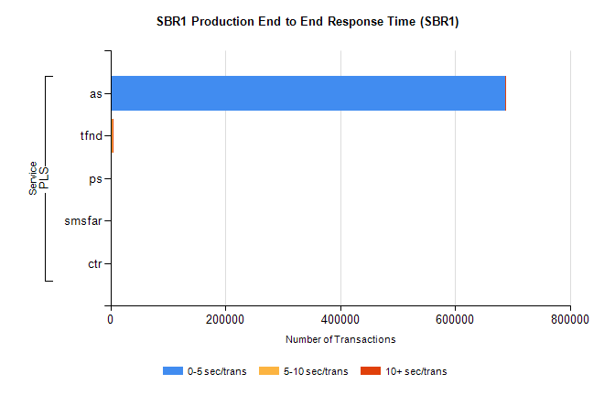
Stream | Service | 0-5 sec/trans | 5-10 sec/trans | 10+ sec/trans | Total | % within 5 sec timing target
PLS | as | 687174 | 208 | 709 | 688091 | 99.9%
PLS | tfnd | 2190 | 983 | 108 | 3281 | 66.7%
PLS | ps | 45 | 31 | 145 | 221 | 20.4%
PLS | smsfar | 10 | 33 | 1 | 44 | 22.7%
PLS | ctr |  |  | 2 | 2 | 0.0%

