Transmission Timings Report Week - 11
11/03/2024 - 17/03/2024

SBR2 External Vendor Testing Environment (EVTE3)

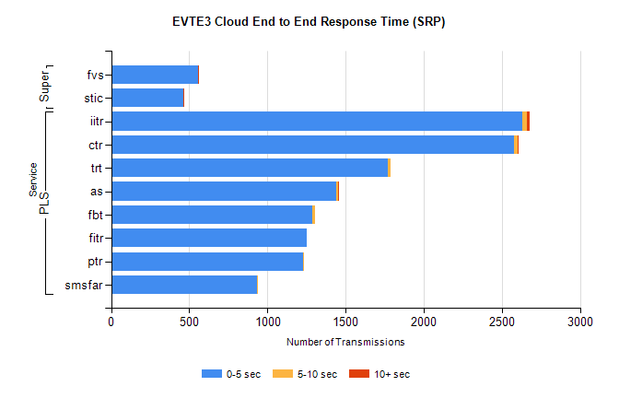
Stream | Service | 0-5 sec | 5-10 sec | >10 sec | Total | % within 5 sec timing target
PLS | iitr | 2629 | 31 | 19 | 2717 | 96.8%
PLS | ctr | 2578 | 22 | 5 | 2613 | 98.7%
PLS | trt | 1770 | 19 | 0 | 1883 | 94.0%
PLS | as | 1441 | 9 | 8 | 1479 | 97.4%
PLS | fbt | 1286 | 19 | 0 | 1307 | 98.4%
PLS | fitr | 1250 | 0 | 0 | 1253 | 99.8%
PLS | ptr | 1229 | 2 | 0 | 1231 | 99.8%
PLS | smsfar | 936 | 1 | 0 | 937 | 99.9%
Super | fvs | 559 | 0 | 1 | 560 | 99.8%
Super | stic | 460 | 0 | 4 | 464 | 99.1%

SBR2 External Vendor Testing Environment (EVTE3)

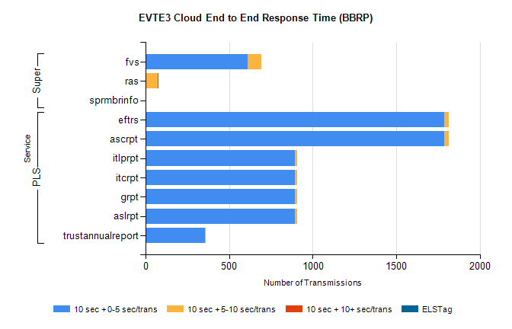
Stream | Service | 10 sec + 0-5 sec /trans | 10 sec + 5-10 sec /trans | 10 sec + >10 sec /trans | Processing Incomplete | ELStag | Total
PLS | ascrpt | 1788 | 28 | 0 | 52 | 0 | 1868
PLS | eftrs | 1788 | 28 | 0 | 52 | 0 | 1868
PLS | aslrpt | 894 | 14 | 0 | 26 | 0 | 934
PLS | grpt | 894 | 14 | 0 | 26 | 0 | 934
PLS | itcrpt | 894 | 14 | 0 | 26 | 0 | 934
PLS | itlprpt | 894 | 14 | 0 | 26 | 0 | 934
PLS | trustannualreport | 357 | 5 | 0 | 0 | 0 | 362
Super | fvs | 610 | 83 | 0 | 222 | 0 | 915
Super | ras | 1 | 71 | 7 | 0 | 0 | 474
Super | sprmbrinfo | 0 | 0 | 0 | 0 | 0 | 350

