Transmission Timings Report Week - 11
11/03/2024 - 17/03/2024

SBR2 Cloud Production2 - Single Requests (SRP)

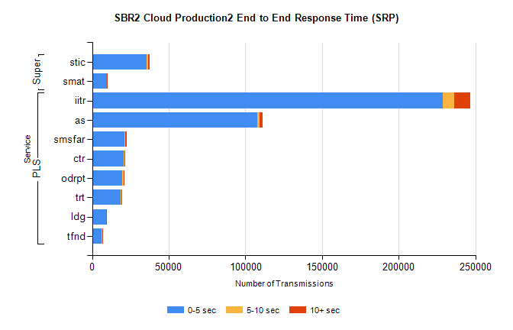
Stream | Service | 0-5 sec | 5-10 sec | >10 sec | Total | % within 5 sec timing target
PLS | iitr | 228896 | 7268 | 10579 | 247706 | 92.4%
PLS | as | 107908 | 1395 | 2159 | 112660 | 95.8%
PLS | smsfar | 21353 | 322 | 926 | 22641 | 94.3%
PLS | ctr | 20543 | 337 | 684 | 21660 | 94.8%
PLS | odrpt | 19661 | 1134 | 306 | 21108 | 93.1%
PLS | trt | 18661 | 341 | 677 | 19742 | 94.5%
PLS | ldg | 9209 | 125 | 89 | 9469 | 97.3%
PLS | tfnd | 6292 | 151 | 300 | 6770 | 92.9%
Super | stic | 35586 | 880 | 939 | 38089 | 93.4%
Super | smat | 9442 | 342 | 376 | 10277 | 91.9%

SBR2 Cloud Production2 - Bulk or Batch Requests (BBRP)

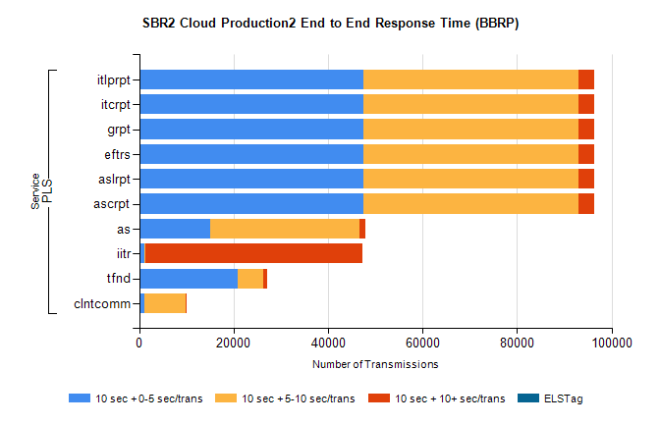
Stream | Service | 10 sec + 0-5 sec /trans | 10 sec + 5-10 sec /trans | 10 sec + >10 sec /trans | Processing Incomplete | ELStag | Total
PLS | ascrpt | 47479 | 45615 | 3131 | 1166 | 0 | 102783
PLS | aslrpt | 47479 | 45615 | 3131 | 1166 | 0 | 102783
PLS | eftrs | 47479 | 45615 | 3131 | 1166 | 0 | 102783
PLS | grpt | 47479 | 45615 | 3131 | 1166 | 0 | 102783
PLS | itcrpt | 47479 | 45615 | 3131 | 1166 | 0 | 102783
PLS | itlprpt | 47479 | 45615 | 3131 | 1166 | 0 | 102783
PLS | as | 15129 | 31548 | 1285 | 314 | 0 | 49984
PLS | iitr | 1006 | 362 | 45810 | 349 | 0 | 48902
PLS | tfnd | 20833 | 5433 | 744 | 2285 | 0 | 30150
PLS | clntcomm | 1013 | 8872 | 165 | 3408 | 0 | 14158

SBR2 Cloud Production2 - ...

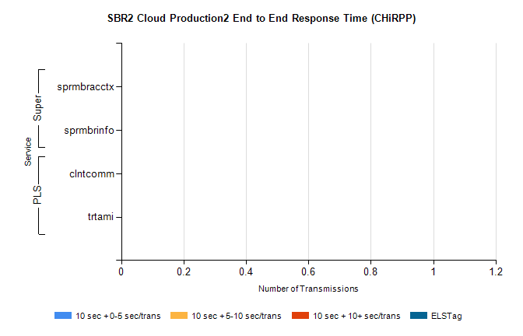
Stream | Service | 10 sec + 0-5 sec /trans | 10 sec + 5-10 sec /trans | 10 sec + >10 sec /trans | Total | % within 5 sec timing target
PLS | clntcomm | 0 | 0 | 0 | 10964 | 0.0%
PLS | trtami | 0 | 0 | 0 | 25 | 0.0%
Super | sprmbracctx | 0 | 0 | 0 | 2980 | 0.0%
Super | sprmbrinfo | 0 | 0 | 0 | 2768 | 0.0%

SBR1 Production Transactions

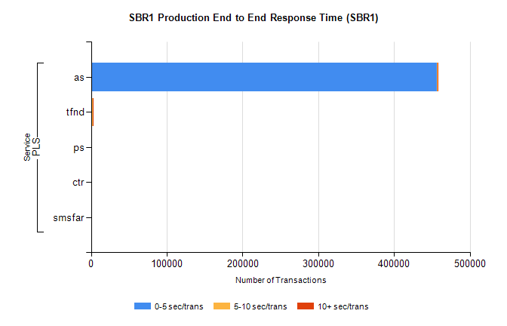
Stream | Service | 0-5 sec/trans | 5-10 sec/trans | 10+ sec/trans | Total | % within 5 sec timing target
PLS | as | 456794 | 617 | 1356 | 458767 | 99.6%
PLS | tfnd | 1854 | 945 | 73 | 2872 | 64.6%
PLS | ps | 34 | 42 | 113 | 189 | 18.0%
PLS | ctr | 49 |  | 24 | 73 | 67.1%
PLS | smsfar | 18 | 39 | 1 | 58 | 31.0%

