Transmission Timings Report Week - 12
18/03/2024 - 24/03/2024

SBR2 External Vendor Testing Environment (EVTE3)

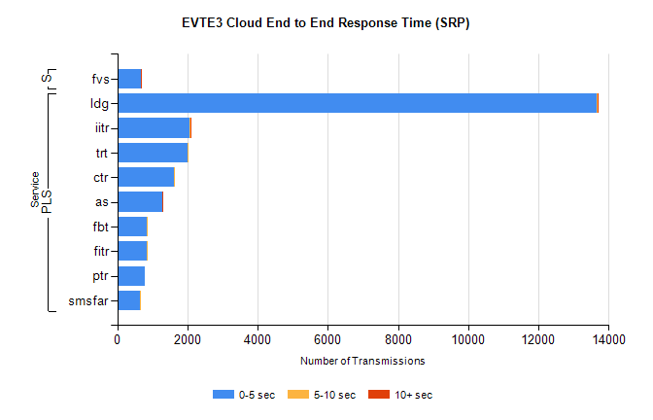
Stream | Service | 0-5 sec | 5-10 sec | >10 sec | Total | % within 5 sec timing target
PLS | ldg | 13667 | 9 | 6 | 13685 | 99.9%
PLS | iitr | 2047 | 28 | 18 | 2099 | 97.5%
PLS | trt | 2002 | 22 | 0 | 2069 | 96.8%
PLS | ctr | 1613 | 8 | 0 | 1629 | 99.0%
PLS | as | 1291 | 6 | 5 | 1335 | 96.7%
PLS | fbt | 837 | 16 | 0 | 856 | 97.8%
PLS | fitr | 838 | 2 | 0 | 841 | 99.6%
PLS | ptr | 783 | 0 | 0 | 784 | 99.9%
PLS | smsfar | 648 | 2 | 0 | 650 | 99.7%
Super | fvs | 677 | 1 | 1 | 679 | 99.7%

SBR2 External Vendor Testing Environment (EVTE3)

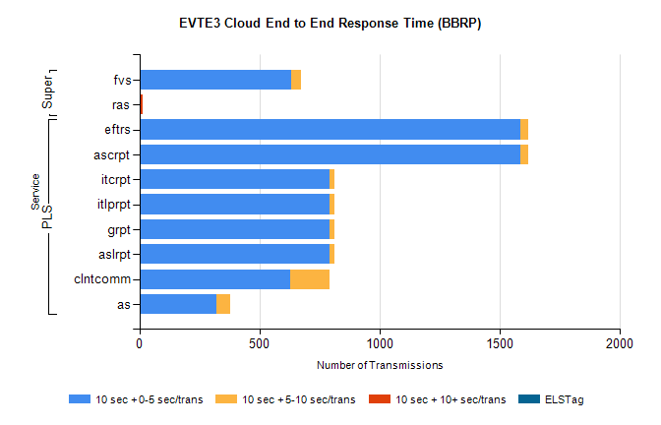
Stream | Service | 10 sec + 0-5 sec /trans | 10 sec + 5-10 sec /trans | 10 sec + >10 sec /trans | Processing Incomplete | ELStag | Total
PLS | ascrpt | 1586 | 36 | 0 | 60 | 0 | 1684
PLS | eftrs | 1586 | 36 | 0 | 60 | 0 | 1684
PLS | aslrpt | 793 | 18 | 0 | 30 | 0 | 842
PLS | grpt | 793 | 18 | 0 | 30 | 0 | 842
PLS | itlprpt | 793 | 18 | 0 | 30 | 0 | 842
PLS | itcrpt | 793 | 18 | 0 | 30 | 0 | 842
PLS | clntcomm | 628 | 165 | 0 | 0 | 0 | 797
PLS | as | 320 | 57 | 0 | 12 | 0 | 416
Super | fvs | 633 | 39 | 0 | 215 | 0 | 887
Super | ras | 1 | 4 | 7 | 0 | 0 | 538

