Transmission Timings Report Week - 12
18/03/2024 - 24/03/2024

SBR2 Cloud Production2 - Single Requests (SRP)

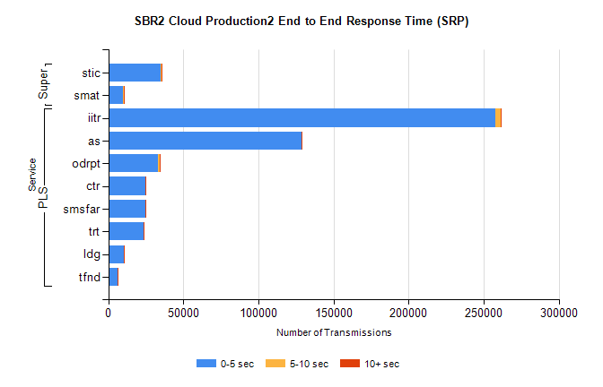
Stream | Service | 0-5 sec | 5-10 sec | >10 sec | Total | % within 5 sec timing target
PLS | iitr | 257767 | 3759 | 377 | 261930 | 98.4%
PLS | as | 128415 | 451 | 69 | 128958 | 99.6%
PLS | odrpt | 33080 | 1420 | 331 | 34877 | 94.8%
PLS | ctr | 24784 | 98 | 22 | 24908 | 99.5%
PLS | smsfar | 24490 | 83 | 22 | 24599 | 99.6%
PLS | trt | 23483 | 93 | 20 | 23596 | 99.5%
PLS | ldg | 10499 | 43 | 7 | 11268 | 93.2%
PLS | tfnd | 6227 | 21 | 7 | 6258 | 99.5%
Super | stic | 35005 | 340 | 186 | 35531 | 98.5%
Super | smat | 9977 | 176 | 86 | 10240 | 97.4%

SBR2 Cloud Production2 - Bulk or Batch Requests (BBRP)

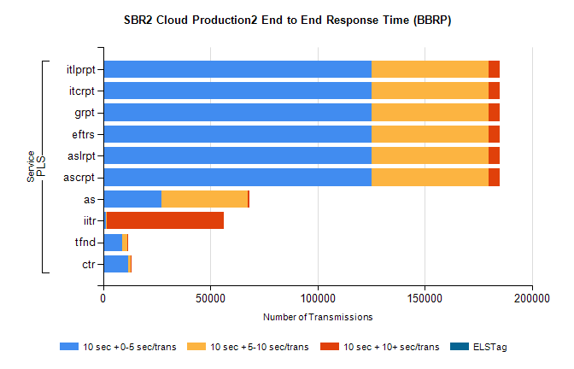
Stream | Service | 10 sec + 0-5 sec /trans | 10 sec + 5-10 sec /trans | 10 sec + >10 sec /trans | Processing Incomplete | ELStag | Total
PLS | ascrpt | 125065 | 54566 | 5418 | 35 | 0 | 191592
PLS | aslrpt | 125065 | 54566 | 5418 | 35 | 0 | 191592
PLS | eftrs | 125065 | 54566 | 5418 | 35 | 0 | 191592
PLS | grpt | 125065 | 54566 | 5418 | 35 | 0 | 191592
PLS | itcrpt | 125065 | 54566 | 5418 | 35 | 0 | 191592
PLS | itlprpt | 125065 | 54566 | 5418 | 35 | 0 | 191592
PLS | as | 27303 | 40362 | 765 | 105 | 0 | 69320
PLS | iitr | 1335 | 445 | 54749 | 217 | 0 | 58643
PLS | tfnd | 8800 | 2492 | 292 | 988 | 0 | 13048
PLS | ctr | 11688 | 1086 | 89 | 17 | 0 | 12970

SBR2 Cloud Production2 - ...

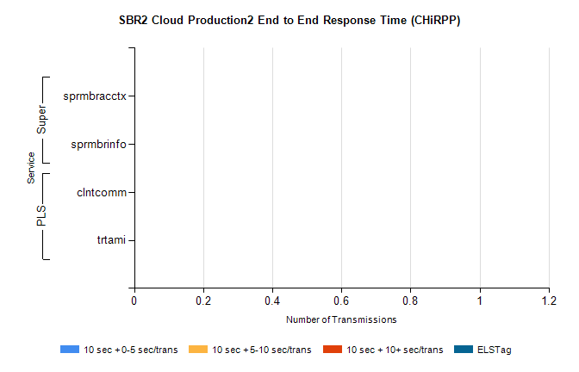
Stream | Service | 10 sec + 0-5 sec /trans | 10 sec + 5-10 sec /trans | 10 sec + >10 sec /trans | Total | % within 5 sec timing target
PLS | clntcomm | 0 | 0 | 0 | 16751 | 0.0%
PLS | trtami | 0 | 0 | 0 | 31 | 0.0%
Super | sprmbracctx | 0 | 0 | 0 | 3357 | 0.0%
Super | sprmbrinfo | 0 | 0 | 0 | 2799 | 0.0%

SBR1 Production Transactions

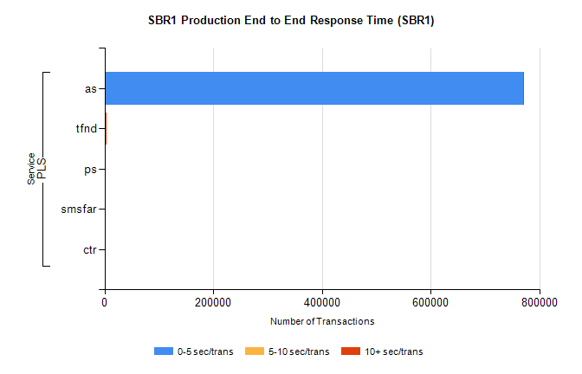
Stream | Service | 0-5 sec/trans | 5-10 sec/trans | 10+ sec/trans | Total | % within 5 sec timing target
PLS | as | 770438 | 224 | 232 | 770894 | 99.9%
PLS | tfnd | 2191 | 797 | 5 | 2993 | 73.2%
PLS | ps | 27 | 44 | 139 | 210 | 12.9%
PLS | smsfar | 5 | 32 | 3 | 40 | 12.5%
PLS | ctr | 5 | 4 | 10 | 19 | 26.3%

