Transmission Timings Report Week - 13
25/03/2024 - 31/03/2024

SBR2 External Vendor Testing Environment (EVTE3)

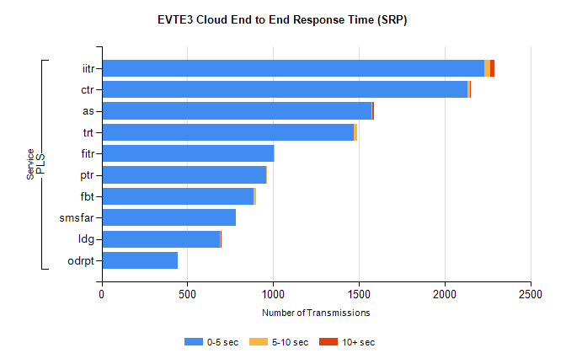
Stream | Service | 0-5 sec | 5-10 sec | >10 sec | Total | % within 5 sec timing target
PLS | iitr | 2229 | 37 | 23 | 2300 | 96.9%
PLS | ctr | 2133 | 15 | 2 | 2185 | 97.6%
PLS | as | 1575 | 4 | 7 | 1641 | 96.0%
PLS | trt | 1472 | 20 | 0 | 1518 | 97.0%
PLS | fitr | 1005 | 2 | 0 | 1015 | 99.0%
PLS | ptr | 958 | 4 | 0 | 966 | 99.2%
PLS | fbt | 884 | 15 | 0 | 903 | 97.9%
PLS | smsfar | 781 | 0 | 0 | 782 | 99.9%
PLS | ldg | 689 | 7 | 5 | 706 | 97.6%
PLS | odrpt | 442 | 0 | 0 | 445 | 99.3%

SBR2 External Vendor Testing Environment (EVTE3)

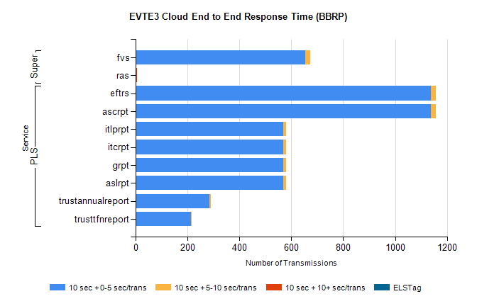
Stream | Service | 10 sec + 0-5 sec /trans | 10 sec + 5-10 sec /trans | 10 sec + >10 sec /trans | Processing Incomplete | ELStag | Total
PLS | ascrpt | 1138 | 20 | 0 | 16 | 0 | 1174
PLS | eftrs | 1138 | 20 | 0 | 16 | 0 | 1174
PLS | aslrpt | 569 | 10 | 0 | 8 | 0 | 587
PLS | grpt | 569 | 10 | 0 | 8 | 0 | 587
PLS | itcrpt | 569 | 10 | 0 | 8 | 0 | 587
PLS | itlprpt | 569 | 10 | 0 | 8 | 0 | 587
PLS | trustannualreport | 284 | 5 | 0 | 1 | 0 | 290
PLS | trusttfnreport | 214 | 2 | 0 | 1 | 0 | 217
Super | fvs | 655 | 17 | 0 | 238 | 0 | 910
Super | ras | 0 | 0 | 5 | 4 | 0 | 278

