Transmission Timings Report Week - 13
25/03/2024 - 31/03/2024

SBR2 Cloud Production2 - Single Requests (SRP)

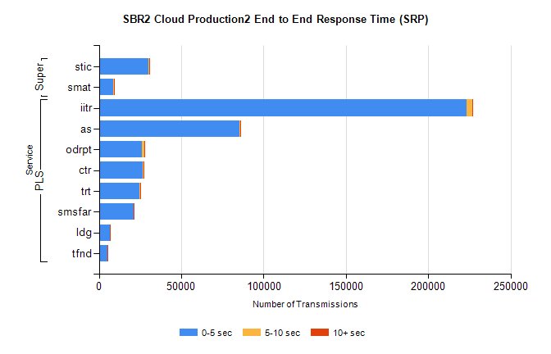
Stream | Service | 0-5 sec | 5-10 sec | >10 sec | Total | % within 5 sec timing target
PLS | iitr | 223099 | 3477 | 376 | 226981 | 98.3%
PLS | as | 85480 | 357 | 53 | 85904 | 99.5%
PLS | odrpt | 26191 | 1172 | 135 | 27498 | 95.2%
PLS | ctr | 26716 | 149 | 26 | 26894 | 99.3%
PLS | trt | 24731 | 143 | 22 | 24899 | 99.3%
PLS | smsfar | 20931 | 100 | 21 | 21056 | 99.4%
PLS | ldg | 6615 | 23 | 5 | 6737 | 98.2%
PLS | tfnd | 5369 | 41 | 3 | 5413 | 99.2%
Super | stic | 29896 | 466 | 339 | 30704 | 97.4%
Super | smat | 8793 | 213 | 131 | 9138 | 96.2%

SBR2 Cloud Production2 - Bulk or Batch Requests (BBRP)

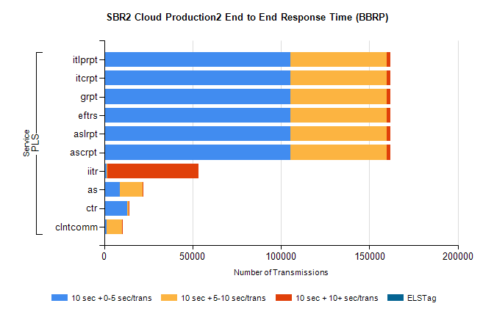
Stream | Service | 10 sec + 0-5 sec /trans | 10 sec + 5-10 sec /trans | 10 sec + >10 sec /trans | Processing Incomplete | ELStag | Total
PLS | ascrpt | 105118 | 54649 | 2229 | 16 | 0 | 165943
PLS | aslrpt | 105118 | 54649 | 2229 | 16 | 0 | 165943
PLS | eftrs | 105118 | 54649 | 2229 | 16 | 0 | 165943
PLS | grpt | 105118 | 54649 | 2229 | 16 | 0 | 165943
PLS | itcrpt | 105118 | 54649 | 2229 | 16 | 0 | 165943
PLS | itlprpt | 105118 | 54649 | 2229 | 16 | 0 | 165943
PLS | iitr | 1233 | 431 | 51880 | 129 | 0 | 55661
PLS | as | 8908 | 12699 | 59 | 165 | 0 | 22145
PLS | ctr | 12855 | 1178 | 10 | 6 | 0 | 14146
PLS | clntcomm | 1253 | 8683 | 461 | 1057 | 0 | 13480

SBR2 Cloud Production2 - ...

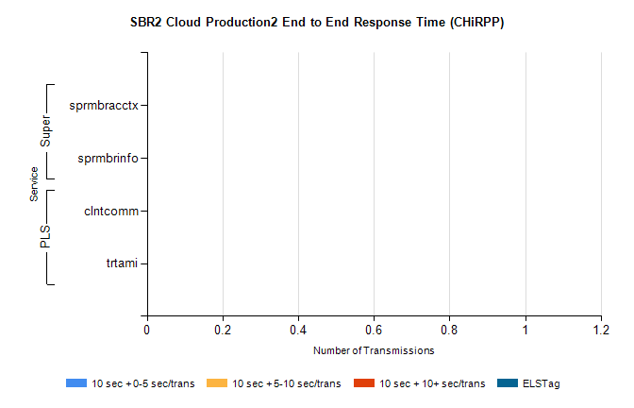
Stream | Service | 10 sec + 0-5 sec /trans | 10 sec + 5-10 sec /trans | 10 sec + >10 sec /trans | Total | % within 5 sec timing target
PLS | clntcomm | 0 | 0 | 0 | 9149 | 0.0%
PLS | trtami | 0 | 0 | 0 | 7 | 0.0%
Super | sprmbracctx | 0 | 0 | 0 | 2508 | 0.0%
Super | sprmbrinfo | 0 | 0 | 0 | 2440 | 0.0%

SBR1 Production Transactions

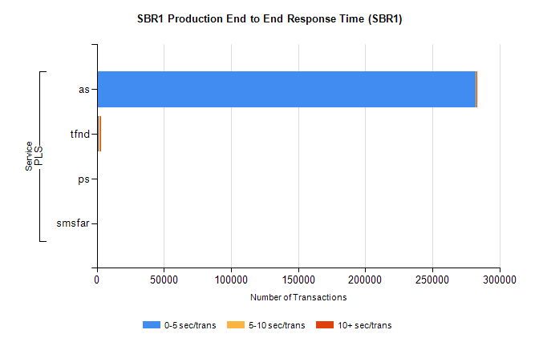
Stream | Service | 0-5 sec/trans | 5-10 sec/trans | 10+ sec/trans | Total | % within 5 sec timing target
PLS | as | 282383 | 200 | 242 | 282825 | 99.8%
PLS | tfnd | 1593 | 847 | 14 | 2454 | 64.9%
PLS | ps | 57 | 54 | 143 | 254 | 22.4%
PLS | smsfar | 14 | 12 | 3 | 29 | 48.3%

