Transmission Timings Report Week - 14
1/04/2024 - 7/04/2024

SBR2 External Vendor Testing Environment (EVTE3)

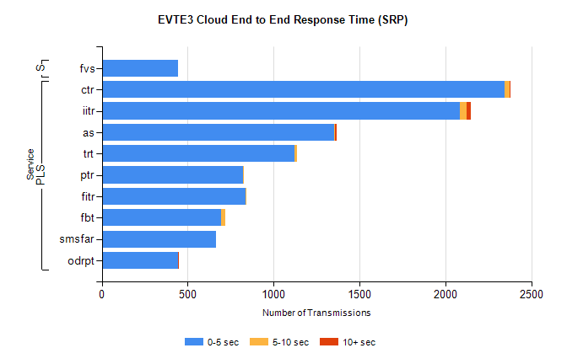
Stream | Service | 0-5 sec | 5-10 sec | >10 sec | Total | % within 5 sec timing target
PLS | ctr | 2344 | 29 | 1 | 2439 | 96.1%
PLS | iitr | 2082 | 42 | 22 | 2171 | 95.9%
PLS | as | 1353 | 6 | 8 | 1377 | 98.3%
PLS | trt | 1121 | 14 | 0 | 1156 | 97.0%
PLS | ptr | 822 | 2 | 0 | 904 | 90.9%
PLS | fitr | 836 | 1 | 0 | 838 | 99.8%
PLS | fbt | 696 | 24 | 0 | 723 | 96.3%
PLS | smsfar | 667 | 0 | 0 | 668 | 99.9%
PLS | odrpt | 443 | 2 | 1 | 447 | 99.1%
Super | fvs | 446 | 0 | 0 | 446 | 100.0%

SBR2 External Vendor Testing Environment (EVTE3)

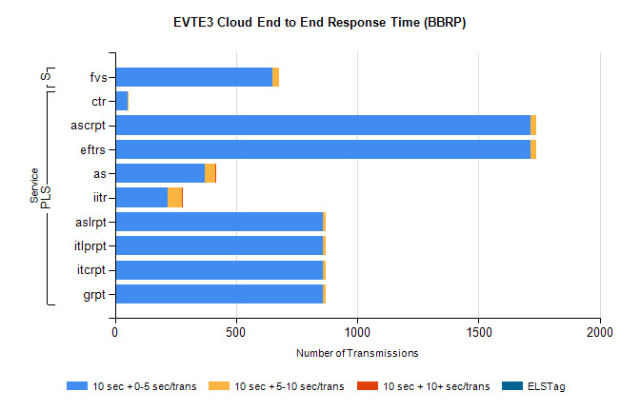
Stream | Service | 10 sec + 0-5 sec /trans | 10 sec + 5-10 sec /trans | 10 sec + >10 sec /trans | Processing Incomplete | ELStag | Total
PLS | ctr | 54 | 4 | 0 | 2873 | 0 | 2933
PLS | eftrs | 1714 | 22 | 0 | 58 | 0 | 1796
PLS | ascrpt | 1714 | 22 | 0 | 58 | 0 | 1796
PLS | as | 371 | 44 | 1 | 1233 | 0 | 1657
PLS | iitr | 219 | 57 | 2 | 942 | 0 | 1225
PLS | aslrpt | 857 | 11 | 0 | 31 | 0 | 900
PLS | grpt | 857 | 11 | 0 | 29 | 0 | 898
PLS | itcrpt | 857 | 11 | 0 | 29 | 0 | 898
PLS | itlprpt | 857 | 11 | 0 | 29 | 0 | 898
Super | fvs | 650 | 26 | 0 | 232 | 0 | 908

