Transmission Timings Report Week - 14
1/04/2024 - 7/04/2024

SBR2 Cloud Production2 - Single Requests (SRP)

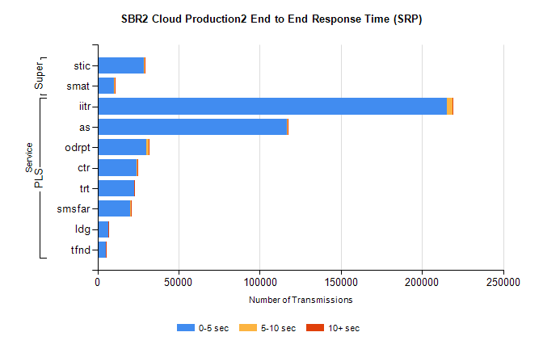
Stream | Service | 0-5 sec | 5-10 sec | >10 sec | Total | % within 5 sec timing target
PLS | iitr | 215358 | 3586 | 382 | 219415 | 98.2%
PLS | as | 116661 | 640 | 99 | 117600 | 99.2%
PLS | odrpt | 30336 | 1308 | 141 | 31825 | 95.3%
PLS | ctr | 24265 | 136 | 27 | 24432 | 99.3%
PLS | trt | 22424 | 148 | 27 | 22605 | 99.2%
PLS | smsfar | 20379 | 102 | 18 | 20503 | 99.4%
PLS | ldg | 6793 | 18 | 4 | 6945 | 97.8%
PLS | tfnd | 5068 | 33 | 1 | 5103 | 99.3%
Super | stic | 28744 | 279 | 58 | 29124 | 98.7%
Super | smat | 10302 | 184 | 40 | 10545 | 97.7%

SBR2 Cloud Production2 - Bulk or Batch Requests (BBRP)

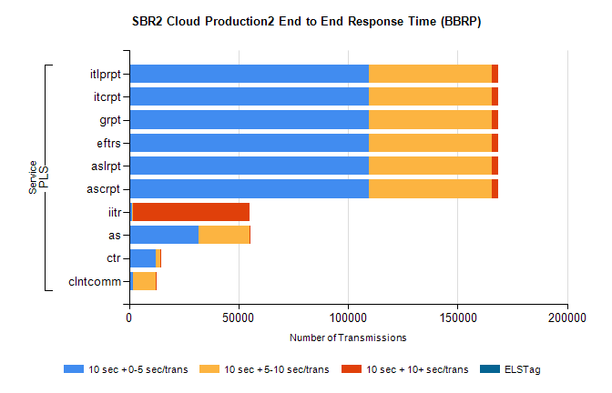
Stream | Service | 10 sec + 0-5 sec /trans | 10 sec + 5-10 sec /trans | 10 sec + >10 sec /trans | Processing Incomplete | ELStag | Total
PLS | ascrpt | 109529 | 56167 | 2904 | 142 | 0 | 172123
PLS | aslrpt | 109529 | 56167 | 2904 | 142 | 0 | 172123
PLS | eftrs | 109529 | 56167 | 2904 | 142 | 0 | 172123
PLS | grpt | 109529 | 56167 | 2904 | 142 | 0 | 172123
PLS | itcrpt | 109529 | 56167 | 2904 | 142 | 0 | 172123
PLS | itlprpt | 109529 | 56167 | 2904 | 142 | 0 | 172123
PLS | iitr | 1192 | 504 | 53199 | 138 | 0 | 56966
PLS | as | 31708 | 23408 | 344 | 109 | 0 | 55899
PLS | ctr | 12201 | 1964 | 122 | 9 | 0 | 14406
PLS | clntcomm | 1676 | 10585 | 87 | 0 | 0 | 13210

SBR2 Cloud Production2 - ...

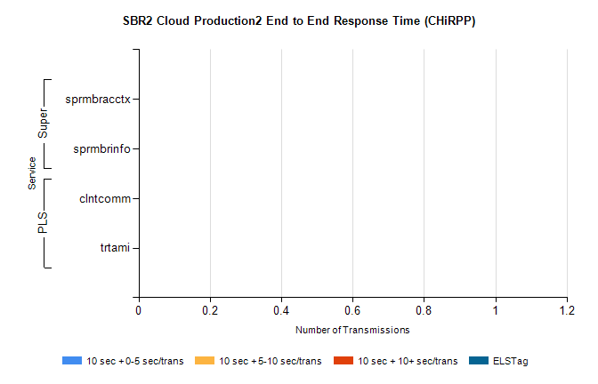
Stream | Service | 10 sec + 0-5 sec /trans | 10 sec + 5-10 sec /trans | 10 sec + >10 sec /trans | Total | % within 5 sec timing target
PLS | clntcomm | 0 | 0 | 0 | 11459 | 0.0%
PLS | trtami | 0 | 0 | 0 | 73 | 0.0%
Super | sprmbracctx | 0 | 0 | 0 | 3849 | 0.0%
Super | sprmbrinfo | 0 | 0 | 0 | 2415 | 0.0%

SBR1 Production Transactions

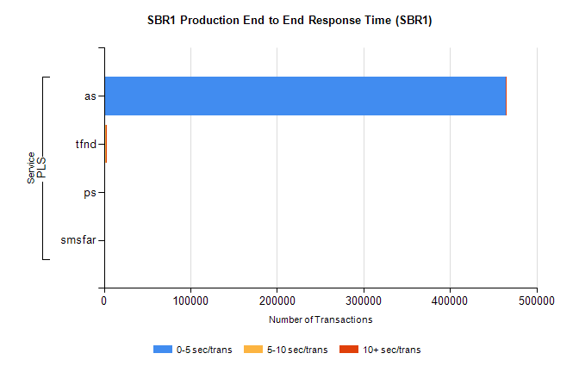
Stream | Service | 0-5 sec/trans | 5-10 sec/trans | 10+ sec/trans | Total | % within 5 sec timing target
PLS | as | 464380 | 251 | 1177 | 465808 | 99.7%
PLS | tfnd | 1269 | 833 | 73 | 2175 | 58.3%
PLS | ps | 19 | 45 | 107 | 171 | 11.1%
PLS | smsfar | 12 | 11 | 2 | 25 | 48.0%

