Transmission Timings Report Week - 15
8/04/2024 - 14/04/2024

SBR2 External Vendor Testing Environment (EVTE3)

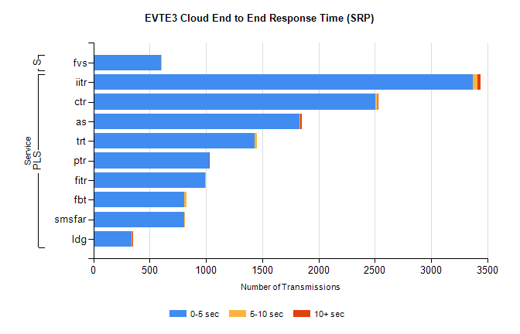
Stream | Service | 0-5 sec | 5-10 sec | >10 sec | Total | % within 5 sec timing target
PLS | iitr | 3371 | 39 | 31 | 3459 | 97.5%
PLS | ctr | 2503 | 24 | 1 | 2551 | 98.1%
PLS | as | 1834 | 6 | 9 | 1871 | 98.0%
PLS | trt | 1432 | 18 | 0 | 1484 | 96.5%
PLS | ptr | 1029 | 1 | 1 | 1065 | 96.6%
PLS | fitr | 994 | 1 | 0 | 1006 | 98.8%
PLS | fbt | 807 | 19 | 0 | 828 | 97.5%
PLS | smsfar | 809 | 1 | 0 | 816 | 99.1%
PLS | ldg | 341 | 6 | 7 | 356 | 95.8%
Super | fvs | 604 | 1 | 0 | 610 | 99.0%

SBR2 External Vendor Testing Environment (EVTE3)

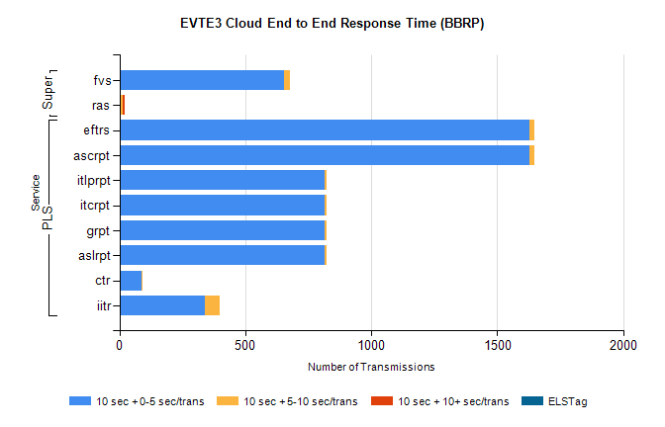
Stream | Service | 10 sec + 0-5 sec /trans | 10 sec + 5-10 sec /trans | 10 sec + >10 sec /trans | Processing Incomplete | ELStag | Total
PLS | ascrpt | 1626 | 22 | 0 | 26 | 0 | 1674
PLS | eftrs | 1626 | 22 | 0 | 26 | 0 | 1674
PLS | aslrpt | 813 | 11 | 0 | 13 | 0 | 837
PLS | grpt | 813 | 11 | 0 | 13 | 0 | 837
PLS | itcrpt | 813 | 11 | 0 | 13 | 0 | 837
PLS | itlprpt | 813 | 11 | 0 | 13 | 0 | 837
PLS | ctr | 89 | 1 | 0 | 734 | 0 | 825
PLS | iitr | 339 | 59 | 0 | 150 | 0 | 557
Super | fvs | 655 | 24 | 0 | 230 | 0 | 910
Super | ras | 0 | 12 | 9 | 2 | 0 | 513

