Transmission Timings Report Week - 15
8/04/2024 - 14/04/2024

SBR2 Cloud Production2 - Single Requests (SRP)

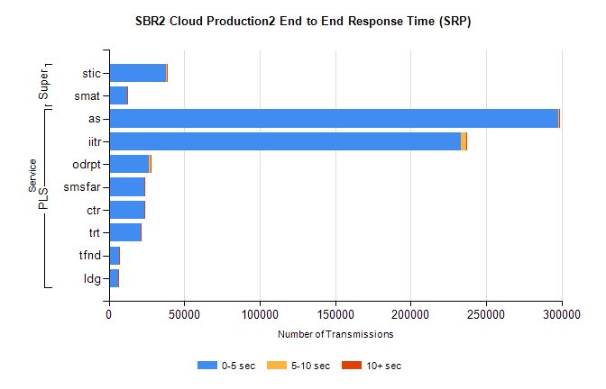
Stream | Service | 0-5 sec | 5-10 sec | >10 sec | Total | % within 5 sec timing target
PLS | as | 297889 | 651 | 667 | 299268 | 99.5%
PLS | iitr | 233496 | 3455 | 362 | 237356 | 98.4%
PLS | odrpt | 26782 | 1015 | 81 | 27895 | 96.0%
PLS | smsfar | 23760 | 92 | 28 | 23883 | 99.5%
PLS | ctr | 23477 | 111 | 20 | 23611 | 99.4%
PLS | trt | 21308 | 115 | 31 | 21460 | 99.3%
PLS | tfnd | 6860 | 33 | 8 | 6901 | 99.4%
PLS | ldg | 6202 | 38 | 4 | 6331 | 98.0%
Super | stic | 38163 | 480 | 240 | 38888 | 98.1%
Super | smat | 12009 | 183 | 68 | 12260 | 98.0%

SBR2 Cloud Production2 - Bulk or Batch Requests (BBRP)

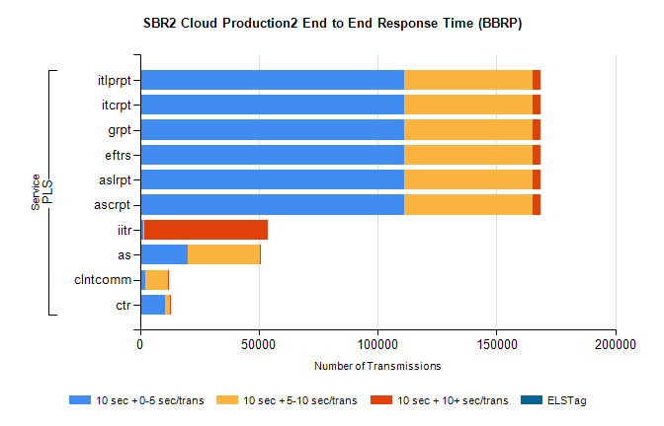
Stream | Service | 10 sec + 0-5 sec /trans | 10 sec + 5-10 sec /trans | 10 sec + >10 sec /trans | Processing Incomplete | ELStag | Total
PLS | ascrpt | 110999 | 54039 | 3407 | 16 | 0 | 171274
PLS | aslrpt | 110999 | 54039 | 3407 | 16 | 0 | 171274
PLS | eftrs | 110999 | 54039 | 3407 | 16 | 0 | 171274
PLS | grpt | 110999 | 54039 | 3407 | 16 | 0 | 171274
PLS | itcrpt | 110999 | 54039 | 3407 | 16 | 0 | 171274
PLS | itlprpt | 110999 | 54039 | 3407 | 16 | 0 | 171274
PLS | iitr | 1242 | 644 | 51886 | 180 | 0 | 55635
PLS | as | 20066 | 30202 | 101 | 99 | 0 | 50619
PLS | clntcomm | 2045 | 9837 | 189 | 3 | 0 | 13177
PLS | ctr | 10483 | 2272 | 29 | 14 | 0 | 12839

SBR2 Cloud Production2 - ...

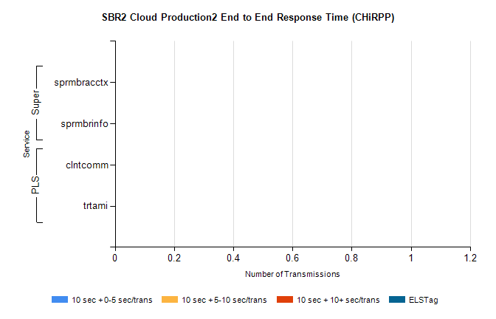
Stream | Service | 10 sec + 0-5 sec /trans | 10 sec + 5-10 sec /trans | 10 sec + >10 sec /trans | Total | % within 5 sec timing target
PLS | clntcomm | 0 | 0 | 0 | 11120 | 0.0%
PLS | trtami | 0 | 0 | 0 | 35 | 0.0%
Super | sprmbracctx | 0 | 0 | 0 | 3408 | 0.0%
Super | sprmbrinfo | 0 | 0 | 0 | 2623 | 0.0%

SBR1 Production Transactions

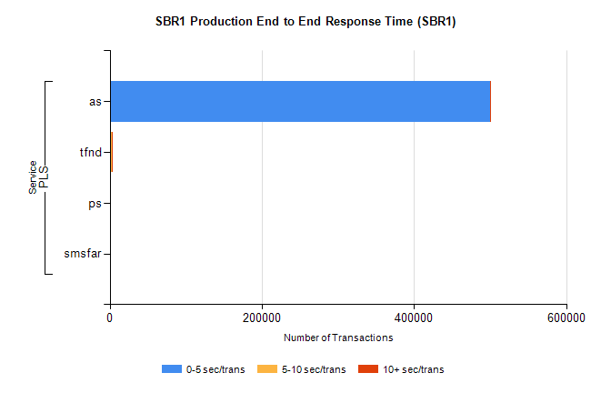
Stream | Service | 0-5 sec/trans | 5-10 sec/trans | 10+ sec/trans | Total | % within 5 sec timing target
PLS | as | 499763 | 233 | 341 | 500337 | 99.9%
PLS | tfnd | 1522 | 851 | 20 | 2393 | 63.6%
PLS | ps | 126 | 45 | 110 | 281 | 44.8%
PLS | smsfar | 13 | 38 | 1 | 52 | 25.0%

