Transmission Timings Report Week - 19
6/05/2024 - 12/05/2024

SBR2 External Vendor Testing Environment (EVTE3)

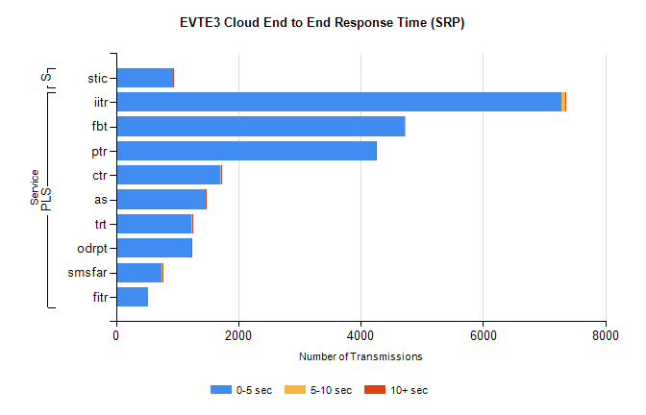
Stream | Service | 0-5 sec | 5-10 sec | >10 sec | Total | % within 5 sec timing target
PLS | iitr | 7289 | 52 | 11 | 7814 | 93.3%
PLS | fbt | 4720 | 11 | 0 | 4966 | 95.0%
PLS | ptr | 4243 | 6 | 6 | 4481 | 94.7%
PLS | ctr | 1705 | 13 | 3 | 2189 | 77.9%
PLS | as | 1463 | 9 | 9 | 1778 | 82.3%
PLS | trt | 1238 | 11 | 9 | 1586 | 78.1%
PLS | odrpt | 1237 | 1 | 1 | 1453 | 85.1%
PLS | smsfar | 749 | 6 | 2 | 936 | 80.0%
PLS | fitr | 520 | 0 | 0 | 690 | 75.4%
Super | stic | 937 | 0 | 2 | 1110 | 84.4%

SBR2 External Vendor Testing Environment (EVTE3)

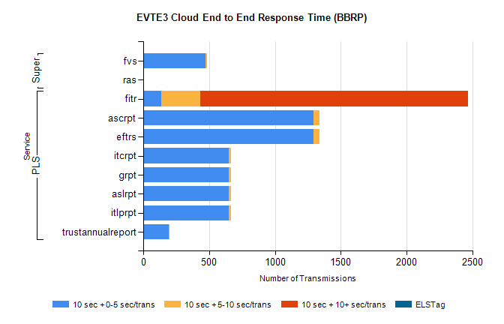
Stream | Service | 10 sec + 0-5 sec /trans | 10 sec + 5-10 sec /trans | 10 sec + >10 sec /trans | Processing Incomplete | ELStag | Total
PLS | fitr | 137 | 294 | 2039 | 4 | 0 | 3637
PLS | eftrs | 1296 | 42 | 0 | 244 | 0 | 1584
PLS | ascrpt | 1296 | 42 | 0 | 244 | 0 | 1584
PLS | itlprpt | 648 | 21 | 0 | 122 | 0 | 792
PLS | aslrpt | 648 | 21 | 0 | 122 | 0 | 792
PLS | grpt | 648 | 21 | 0 | 122 | 0 | 792
PLS | itcrpt | 648 | 21 | 0 | 122 | 0 | 792
PLS | trustannualreport | 196 | 6 | 0 | 100 | 0 | 302
Super | fvs | 474 | 10 | 0 | 244 | 0 | 730
Super | ras | 0 | 0 | 4 | 85 | 0 | 397

