Transmission Timings Report Week - 19
6/05/2024 - 12/05/2024

SBR2 Cloud Production2 - Single Requests (SRP)

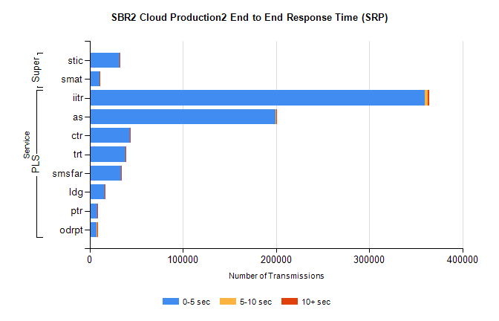
Stream | Service | 0-5 sec | 5-10 sec | >10 sec | Total | % within 5 sec timing target
PLS | iitr | 359856 | 3256 | 968 | 364133 | 98.8%
PLS | as | 199688 | 738 | 159 | 200629 | 99.5%
PLS | ctr | 43130 | 132 | 42 | 43311 | 99.6%
PLS | trt | 38498 | 139 | 37 | 38677 | 99.5%
PLS | smsfar | 33925 | 112 | 34 | 34077 | 99.6%
PLS | ldg | 16073 | 55 | 5 | 16205 | 99.2%
PLS | ptr | 8354 | 23 | 10 | 8388 | 99.6%
PLS | odrpt | 7427 | 487 | 104 | 8022 | 92.6%
Super | stic | 32375 | 172 | 64 | 32616 | 99.3%
Super | smat | 10444 | 138 | 37 | 10621 | 98.3%

SBR2 Cloud Production2 - Bulk or Batch Requests (BBRP)

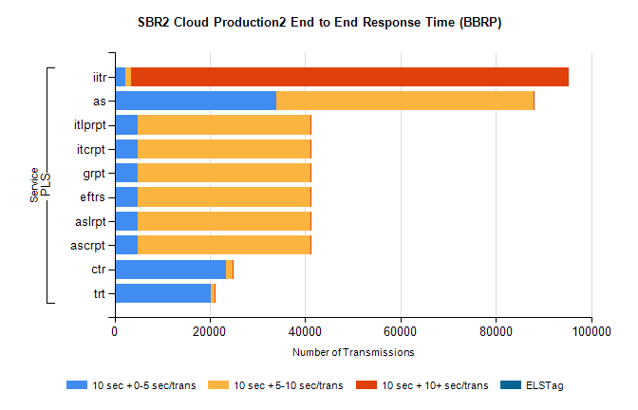
Stream | Service | 10 sec + 0-5 sec /trans | 10 sec + 5-10 sec /trans | 10 sec + >10 sec /trans | Processing Incomplete | ELStag | Total
PLS | iitr | 2268 | 1270 | 91828 | 354 | 0 | 100237
PLS | as | 33968 | 53971 | 175 | 224 | 0 | 88637
PLS | ascrpt | 4797 | 36403 | 189 | 23 | 0 | 41873
PLS | aslrpt | 4797 | 36403 | 189 | 23 | 0 | 41873
PLS | eftrs | 4797 | 36403 | 189 | 23 | 0 | 41873
PLS | grpt | 4797 | 36403 | 189 | 23 | 0 | 41873
PLS | itcrpt | 4797 | 36403 | 189 | 23 | 0 | 41873
PLS | itlprpt | 4797 | 36403 | 189 | 23 | 0 | 41873
PLS | ctr | 23335 | 1485 | 34 | 21 | 0 | 24913
PLS | trt | 20137 | 902 | 11 | 10 | 0 | 21103

SBR2 Cloud Production2 - ...

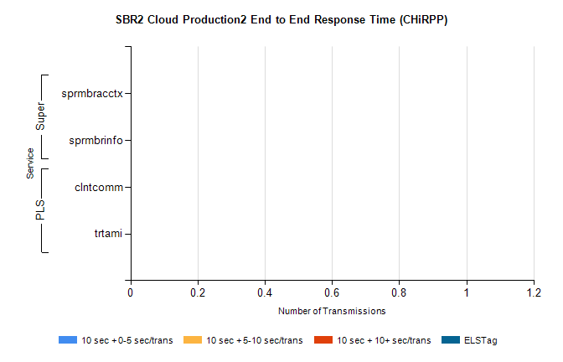
Stream | Service | 10 sec + 0-5 sec /trans | 10 sec + 5-10 sec /trans | 10 sec + >10 sec /trans | Total | % within 5 sec timing target
PLS | clntcomm | 0 | 0 | 0 | 22632 | 0.0%
PLS | trtami | 0 | 0 | 0 | 39 | 0.0%
Super | sprmbracctx | 0 | 0 | 0 | 3084 | 0.0%
Super | sprmbrinfo | 0 | 0 | 0 | 2895 | 0.0%

SBR1 Production Transactions

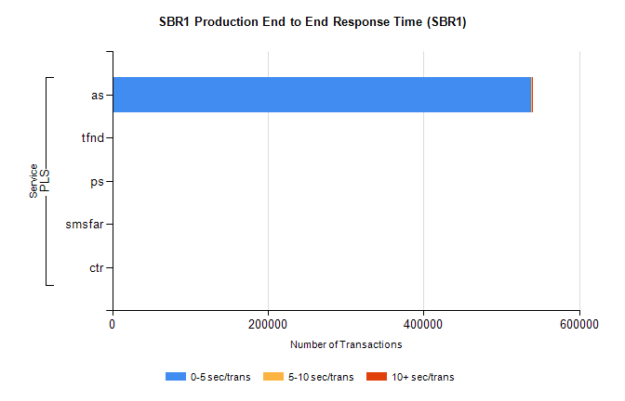
Stream | Service | 0-5 sec/trans | 5-10 sec/trans | 10+ sec/trans | Total | % within 5 sec timing target
PLS | as | 538560 | 424 | 374 | 539358 | 99.9%
PLS | tfnd | 270 | 59 | 5 | 334 | 80.8%
PLS | ps | 36 | 35 | 157 | 228 | 15.8%
PLS | smsfar | 13 | 34 | 1 | 48 | 27.1%
PLS | ctr |  |  | 5 | 5 | 0.0%

