Transmission Timings Report Week - 16
15/04/2024 - 21/04/2024

SBR2 External Vendor Testing Environment (EVTE3)

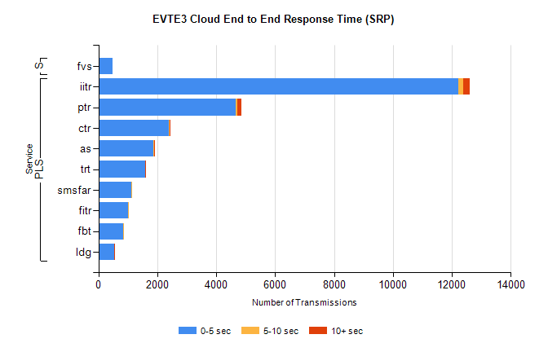
Stream | Service | 0-5 sec | 5-10 sec | >10 sec | Total | % within 5 sec timing target
PLS | iitr | 12234 | 148 | 226 | 13199 | 92.7%
PLS | ptr | 4667 | 53 | 124 | 5062 | 92.2%
PLS | ctr | 2403 | 19 | 3 | 2539 | 94.6%
PLS | as | 1873 | 16 | 7 | 1990 | 94.1%
PLS | trt | 1582 | 6 | 2 | 1670 | 94.7%
PLS | smsfar | 1114 | 5 | 0 | 1160 | 96.0%
PLS | fitr | 998 | 1 | 0 | 1040 | 96.0%
PLS | fbt | 834 | 15 | 0 | 886 | 94.1%
PLS | ldg | 539 | 7 | 7 | 583 | 92.5%
Super | fvs | 496 | 0 | 0 | 517 | 95.9%

SBR2 External Vendor Testing Environment (EVTE3)

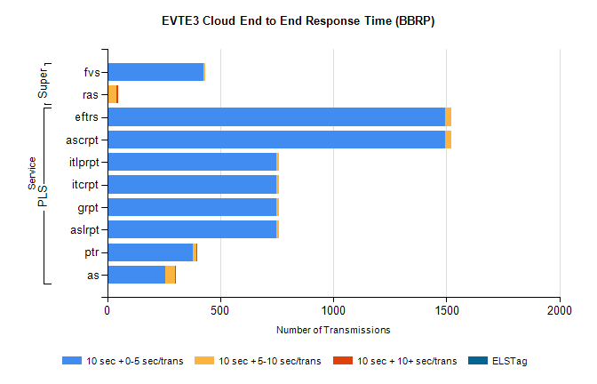
Stream | Service | 10 sec + 0-5 sec /trans | 10 sec + 5-10 sec /trans | 10 sec + >10 sec /trans | Processing Incomplete | ELStag | Total
PLS | ascrpt | 1494 | 28 | 0 | 110 | 0 | 1632
PLS | eftrs | 1494 | 28 | 0 | 110 | 0 | 1632
PLS | aslrpt | 747 | 14 | 0 | 55 | 0 | 816
PLS | grpt | 747 | 14 | 0 | 55 | 0 | 816
PLS | itcrpt | 747 | 14 | 0 | 55 | 0 | 816
PLS | itlprpt | 747 | 14 | 0 | 55 | 0 | 816
PLS | ptr | 377 | 16 | 4 | 70 | 0 | 468
PLS | as | 256 | 44 | 6 | 46 | 0 | 364
Super | fvs | 427 | 8 | 0 | 159 | 0 | 594
Super | ras | 0 | 41 | 6 | 61 | 0 | 451

