Transmission Timings Report Week - 16
15/04/2024 - 21/04/2024

SBR2 Cloud Production2 - Single Requests (SRP)

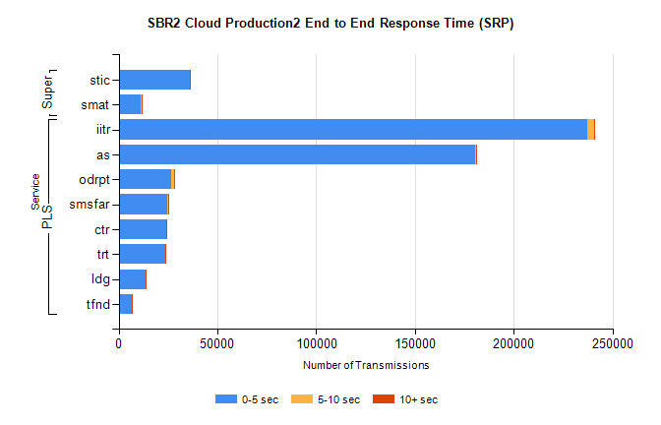
Stream | Service | 0-5 sec | 5-10 sec | >10 sec | Total | % within 5 sec timing target
PLS | iitr | 237272 | 3540 | 433 | 241264 | 98.3%
PLS | as | 180207 | 719 | 103 | 181104 | 99.5%
PLS | odrpt | 26693 | 1231 | 233 | 28159 | 94.8%
PLS | smsfar | 24819 | 82 | 21 | 24927 | 99.6%
PLS | ctr | 24162 | 148 | 17 | 24328 | 99.3%
PLS | trt | 23654 | 86 | 26 | 23773 | 99.5%
PLS | ldg | 13615 | 65 | 93 | 13864 | 98.2%
PLS | tfnd | 6500 | 49 | 6 | 6555 | 99.2%
Super | stic | 36098 | 196 | 72 | 36371 | 99.2%
Super | smat | 11320 | 185 | 40 | 11547 | 98.0%

SBR2 Cloud Production2 - Bulk or Batch Requests (BBRP)

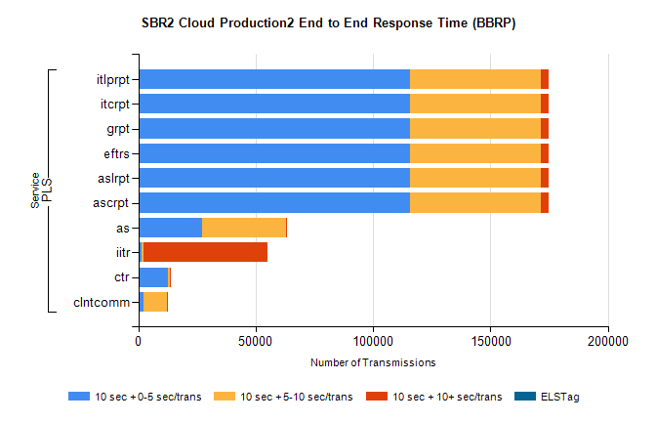
Stream | Service | 10 sec + 0-5 sec /trans | 10 sec + 5-10 sec /trans | 10 sec + >10 sec /trans | Processing Incomplete | ELStag | Total
PLS | ascrpt | 115853 | 55708 | 3244 | 38 | 0 | 177604
PLS | aslrpt | 115853 | 55708 | 3244 | 38 | 0 | 177604
PLS | eftrs | 115853 | 55708 | 3244 | 38 | 0 | 177604
PLS | grpt | 115853 | 55708 | 3244 | 38 | 0 | 177604
PLS | itcrpt | 115853 | 55708 | 3244 | 38 | 0 | 177604
PLS | itlprpt | 115853 | 55708 | 3244 | 38 | 0 | 177604
PLS | as | 27299 | 35551 | 173 | 161 | 0 | 63421
PLS | iitr | 1289 | 1047 | 52661 | 167 | 0 | 57138
PLS | ctr | 12620 | 812 | 29 | 6 | 0 | 13501
PLS | clntcomm | 2363 | 9693 | 130 | 2 | 0 | 13049

SBR2 Cloud Production2 - ...

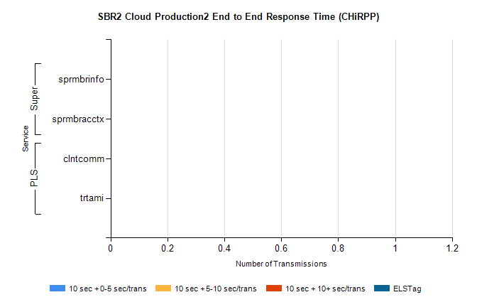
Stream | Service | 10 sec + 0-5 sec /trans | 10 sec + 5-10 sec /trans | 10 sec + >10 sec /trans | Total | % within 5 sec timing target
PLS | clntcomm | 0 | 0 | 0 | 12253 | 0.0%
PLS | trtami | 0 | 0 | 0 | 29 | 0.0%
Super | sprmbrinfo | 0 | 0 | 0 | 3396 | 0.0%
Super | sprmbracctx | 0 | 0 | 0 | 3165 | 0.0%

SBR1 Production Transactions

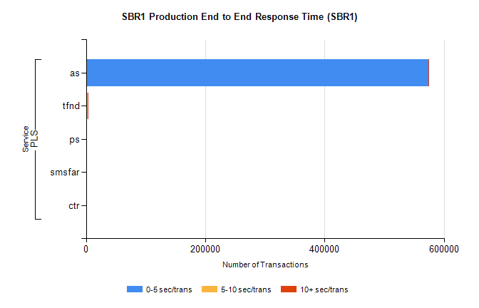
Stream | Service | 0-5 sec/trans | 5-10 sec/trans | 10+ sec/trans | Total | % within 5 sec timing target
PLS | as | 574154 | 339 | 243 | 574736 | 99.9%
PLS | tfnd | 1574 | 921 | 11 | 2506 | 62.8%
PLS | ps | 165 | 59 | 138 | 362 | 45.6%
PLS | smsfar | 24 | 38 |  | 62 | 38.7%
PLS | ctr | 5 | 1 | 10 | 16 | 31.3%

