Transmission Timings Report Week - 17
22/04/2024 - 28/04/2024

SBR2 External Vendor Testing Environment (EVTE3)

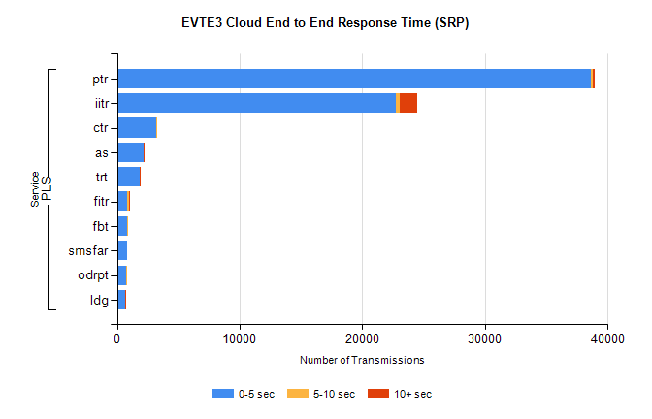
Stream | Service | 0-5 sec | 5-10 sec | >10 sec | Total | % within 5 sec timing target
PLS | ptr | 38604 | 166 | 178 | 39066 | 98.8%
PLS | iitr | 22713 | 303 | 1449 | 24517 | 92.6%
PLS | ctr | 3235 | 27 | 0 | 3279 | 98.7%
PLS | as | 2144 | 17 | 11 | 2202 | 97.4%
PLS | trt | 1866 | 11 | 11 | 1894 | 98.5%
PLS | fitr | 844 | 159 | 2 | 1008 | 83.7%
PLS | fbt | 848 | 37 | 0 | 887 | 95.6%
PLS | smsfar | 833 | 0 | 0 | 847 | 98.3%
PLS | odrpt | 764 | 3 | 0 | 767 | 99.6%
PLS | ldg | 644 | 10 | 7 | 665 | 96.8%

SBR2 External Vendor Testing Environment (EVTE3)

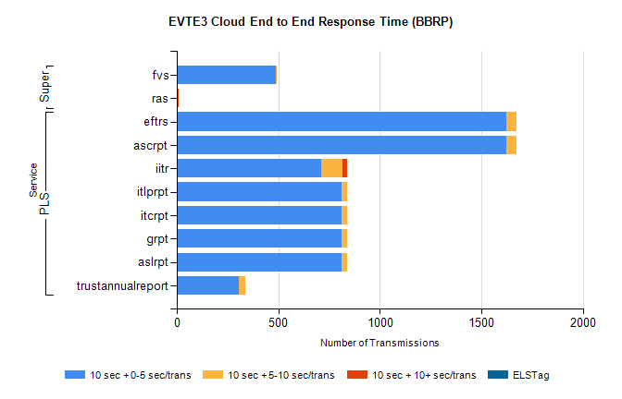
Stream | Service | 10 sec + 0-5 sec /trans | 10 sec + 5-10 sec /trans | 10 sec + >10 sec /trans | Processing Incomplete | ELStag | Total
PLS | ascrpt | 1622 | 52 | 0 | 10 | 0 | 1684
PLS | eftrs | 1622 | 52 | 0 | 10 | 0 | 1684
PLS | iitr | 711 | 103 | 25 | 30 | 0 | 875
PLS | aslrpt | 811 | 26 | 0 | 5 | 0 | 842
PLS | grpt | 811 | 26 | 0 | 5 | 0 | 842
PLS | itcrpt | 811 | 26 | 0 | 5 | 0 | 842
PLS | itlprpt | 811 | 26 | 0 | 5 | 0 | 842
PLS | trustannualreport | 305 | 30 | 0 | 2 | 0 | 337
Super | fvs | 486 | 6 | 0 | 125 | 0 | 617
Super | ras | 0 | 3 | 5 | 4 | 0 | 398

