Transmission Timings Report Week - 17
22/04/2024 - 28/04/2024

SBR2 Cloud Production2 - Single Requests (SRP)

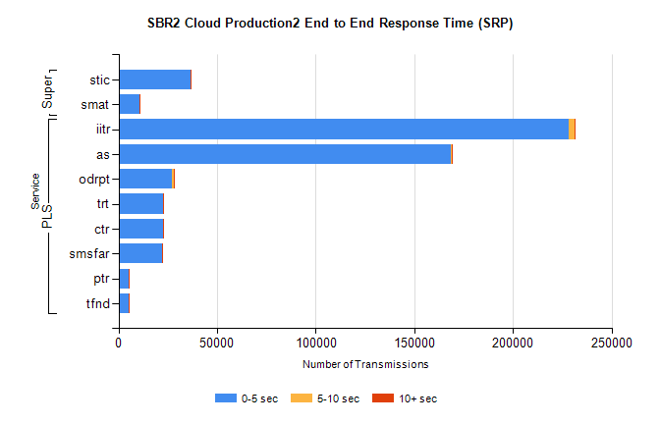
Stream | Service | 0-5 sec | 5-10 sec | >10 sec | Total | % within 5 sec timing target
PLS | iitr | 228030 | 3091 | 282 | 231443 | 98.5%
PLS | as | 168450 | 487 | 86 | 169041 | 99.7%
PLS | odrpt | 26976 | 1153 | 176 | 28314 | 95.3%
PLS | trt | 22660 | 90 | 18 | 22769 | 99.5%
PLS | ctr | 22485 | 83 | 30 | 22604 | 99.5%
PLS | smsfar | 22314 | 47 | 22 | 22383 | 99.7%
PLS | ptr | 5137 | 23 | 4 | 5164 | 99.5%
PLS | tfnd | 5080 | 28 | 9 | 5118 | 99.3%
Super | stic | 36340 | 185 | 45 | 36570 | 99.4%
Super | smat | 10765 | 153 | 29 | 10947 | 98.3%

SBR2 Cloud Production2 - Bulk or Batch Requests (BBRP)

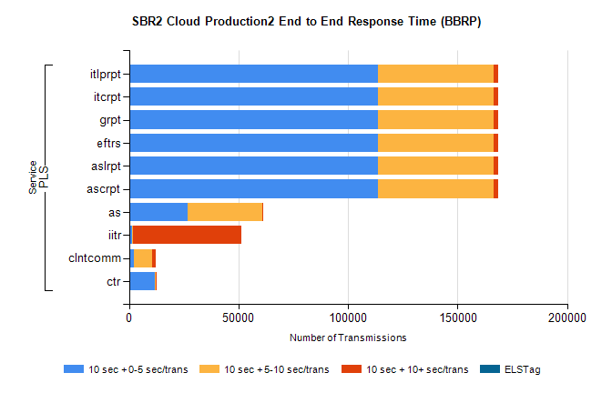
Stream | Service | 10 sec + 0-5 sec /trans | 10 sec + 5-10 sec /trans | 10 sec + >10 sec /trans | Processing Incomplete | ELStag | Total
PLS | ascrpt | 113561 | 52700 | 2232 | 16 | 0 | 170461
PLS | aslrpt | 113561 | 52700 | 2232 | 16 | 0 | 170461
PLS | eftrs | 113561 | 52700 | 2232 | 16 | 0 | 170461
PLS | grpt | 113561 | 52700 | 2232 | 16 | 0 | 170461
PLS | itcrpt | 113561 | 52700 | 2232 | 16 | 0 | 170461
PLS | itlprpt | 113561 | 52700 | 2232 | 16 | 0 | 170461
PLS | as | 26555 | 34237 | 99 | 220 | 0 | 61305
PLS | iitr | 1167 | 593 | 49561 | 122 | 0 | 53048
PLS | clntcomm | 2045 | 8550 | 1388 | 0 | 0 | 13036
PLS | ctr | 11574 | 611 | 21 | 3 | 0 | 12220

SBR2 Cloud Production2 - ...

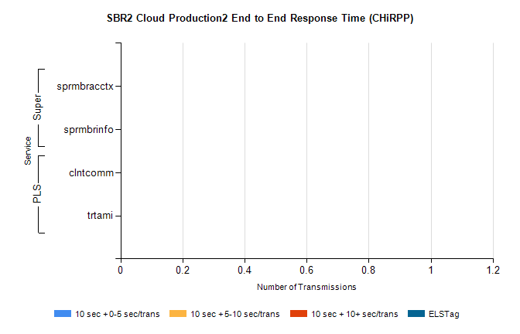
Stream | Service | 10 sec + 0-5 sec /trans | 10 sec + 5-10 sec /trans | 10 sec + >10 sec /trans | Total | % within 5 sec timing target
PLS | clntcomm | 0 | 0 | 0 | 17068 | 0.0%
PLS | trtami | 0 | 0 | 0 | 14 | 0.0%
Super | sprmbracctx | 0 | 0 | 0 | 3208 | 0.0%
Super | sprmbrinfo | 0 | 0 | 0 | 2434 | 0.0%

SBR1 Production Transactions

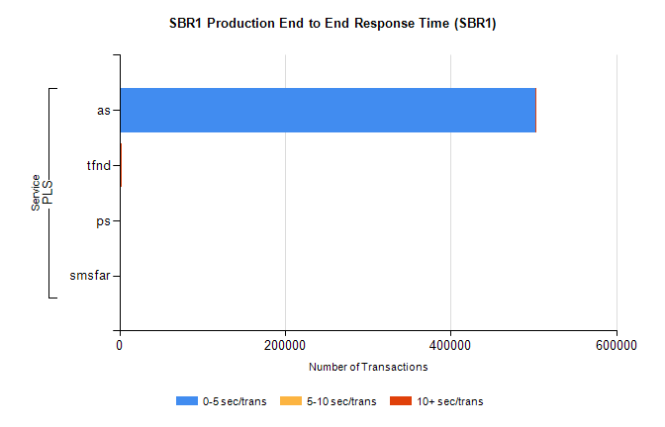
Stream | Service | 0-5 sec/trans | 5-10 sec/trans | 10+ sec/trans | Total | % within 5 sec timing target
PLS | as | 502571 | 267 | 170 | 503008 | 99.9%
PLS | tfnd | 1269 | 875 | 12 | 2156 | 58.9%
PLS | ps | 22 | 20 | 97 | 139 | 15.8%
PLS | smsfar | 7 | 19 |  | 26 | 26.9%

