Transmission Timings Report Week - 18
29/04/2024 - 5/05/2024

SBR2 External Vendor Testing Environment (EVTE3)

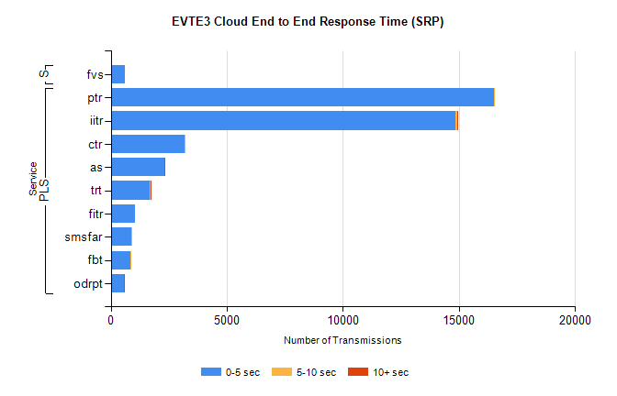
Stream | Service | 0-5 sec | 5-10 sec | >10 sec | Total | % within 5 sec timing target
PLS | ptr | 16502 | 3 | 0 | 16564 | 99.6%
PLS | iitr | 14856 | 55 | 18 | 14966 | 99.3%
PLS | ctr | 3186 | 28 | 0 | 3228 | 98.7%
PLS | as | 2317 | 11 | 14 | 2368 | 97.8%
PLS | trt | 1698 | 10 | 1 | 1720 | 98.7%
PLS | fitr | 1031 | 0 | 0 | 1039 | 99.2%
PLS | smsfar | 889 | 2 | 0 | 892 | 99.7%
PLS | fbt | 844 | 21 | 0 | 865 | 97.6%
PLS | odrpt | 580 | 1 | 2 | 628 | 92.4%
Super | fvs | 614 | 0 | 0 | 614 | 100.0%

SBR2 External Vendor Testing Environment (EVTE3)

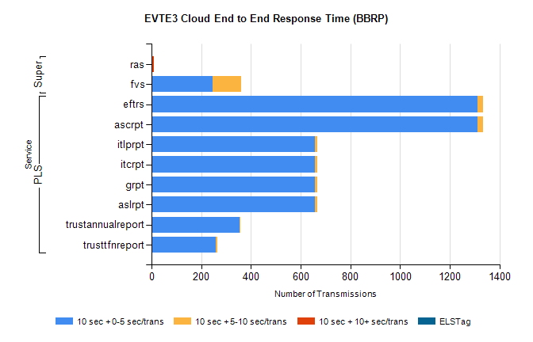
Stream | Service | 10 sec + 0-5 sec /trans | 10 sec + 5-10 sec /trans | 10 sec + >10 sec /trans | Processing Incomplete | ELStag | Total
PLS | ascrpt | 1312 | 22 | 0 | 128 | 0 | 1464
PLS | eftrs | 1312 | 22 | 0 | 128 | 0 | 1464
PLS | aslrpt | 656 | 11 | 0 | 64 | 0 | 732
PLS | grpt | 656 | 11 | 0 | 64 | 0 | 732
PLS | itcrpt | 656 | 11 | 0 | 64 | 0 | 732
PLS | itlprpt | 656 | 11 | 0 | 64 | 0 | 732
PLS | trustannualreport | 353 | 5 | 0 | 0 | 0 | 359
PLS | trusttfnreport | 258 | 6 | 0 | 0 | 0 | 265
Super | ras | 0 | 0 | 9 | 2 | 0 | 519
Super | fvs | 245 | 116 | 0 | 139 | 0 | 501

