Transmission Timings Report Week - 18
29/04/2024 - 5/05/2024

SBR2 Cloud Production2 - Single Requests (SRP)

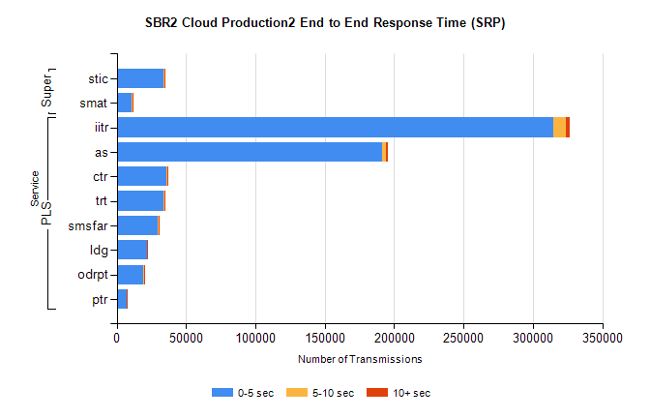
Stream | Service | 0-5 sec | 5-10 sec | >10 sec | Total | % within 5 sec timing target
PLS | iitr | 314725 | 9333 | 2169 | 327126 | 96.2%
PLS | as | 191297 | 3085 | 923 | 195703 | 97.7%
PLS | ctr | 35921 | 651 | 197 | 36862 | 97.4%
PLS | trt | 33620 | 714 | 196 | 34637 | 97.1%
PLS | smsfar | 29898 | 503 | 164 | 30667 | 97.5%
PLS | ldg | 21908 | 70 | 11 | 22079 | 99.2%
PLS | odrpt | 19036 | 1100 | 102 | 20245 | 94.0%
PLS | ptr | 7308 | 142 | 40 | 7511 | 97.3%
Super | stic | 33919 | 521 | 150 | 34648 | 97.9%
Super | smat | 11052 | 343 | 91 | 11509 | 96.0%

SBR2 Cloud Production2 - Bulk or Batch Requests (BBRP)

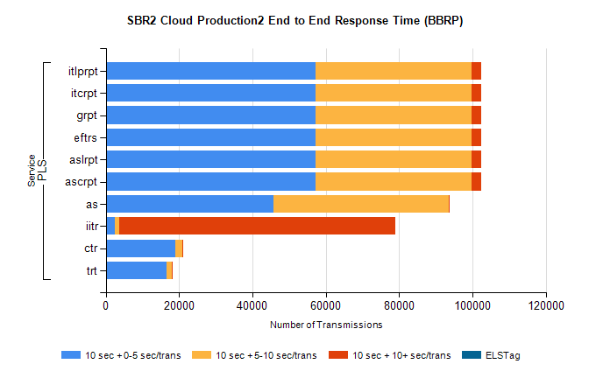
Stream | Service | 10 sec + 0-5 sec /trans | 10 sec + 5-10 sec /trans | 10 sec + >10 sec /trans | Processing Incomplete | ELStag | Total
PLS | ascrpt | 57192 | 42581 | 2690 | 97 | 0 | 103902
PLS | aslrpt | 57192 | 42581 | 2690 | 97 | 0 | 103902
PLS | eftrs | 57192 | 42581 | 2690 | 97 | 0 | 103902
PLS | grpt | 57192 | 42581 | 2690 | 97 | 0 | 103902
PLS | itcrpt | 57192 | 42581 | 2690 | 97 | 0 | 103902
PLS | itlprpt | 57192 | 42581 | 2690 | 97 | 0 | 103902
PLS | as | 45777 | 47698 | 282 | 520 | 0 | 94924
PLS | iitr | 2487 | 1090 | 75345 | 652 | 0 | 83116
PLS | ctr | 18888 | 1978 | 60 | 148 | 0 | 21182
PLS | trt | 16608 | 1351 | 50 | 57 | 0 | 18173

SBR2 Cloud Production2 - ...

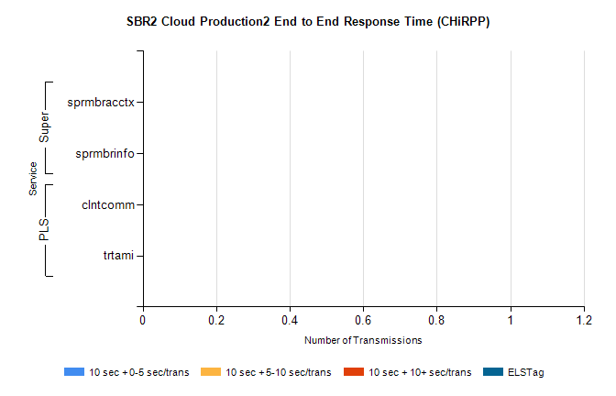
Stream | Service | 10 sec + 0-5 sec /trans | 10 sec + 5-10 sec /trans | 10 sec + >10 sec /trans | Total | % within 5 sec timing target
PLS | clntcomm | 0 | 0 | 0 | 18547 | 0.0%
PLS | trtami | 0 | 0 | 0 | 48 | 0.0%
Super | sprmbracctx | 0 | 0 | 0 | 3993 | 0.0%
Super | sprmbrinfo | 0 | 0 | 0 | 2625 | 0.0%

SBR1 Production Transactions

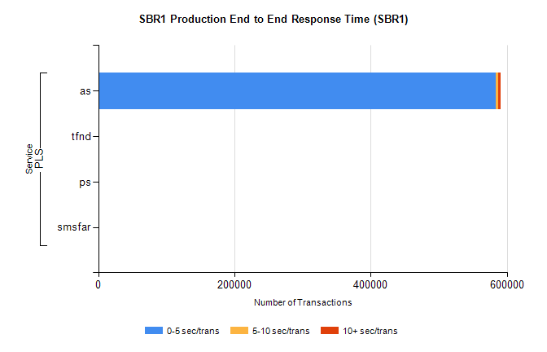
Stream | Service | 0-5 sec/trans | 5-10 sec/trans | 10+ sec/trans | Total | % within 5 sec timing target
PLS | as | 583984 | 3631 | 2974 | 590589 | 98.9%
PLS | tfnd | 221 | 83 | 4 | 308 | 71.8%
PLS | ps | 21 | 24 | 128 | 173 | 12.1%
PLS | smsfar | 13 | 29 | 2 | 44 | 29.5%

