Transmission Timings Report Week - 20
13/05/2024 - 19/05/2024

SBR2 External Vendor Testing Environment (EVTE3)

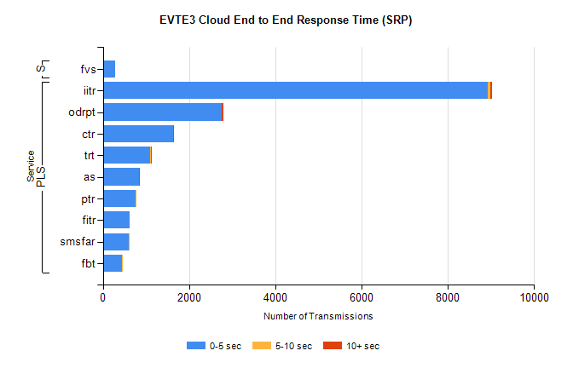
Stream | Service | 0-5 sec | 5-10 sec | >10 sec | Total | % within 5 sec timing target
PLS | iitr | 8934 | 60 | 41 | 9036 | 98.9%
PLS | odrpt | 2758 | 1 | 46 | 2825 | 97.6%
PLS | ctr | 1632 | 7 | 1 | 1664 | 98.1%
PLS | trt | 1105 | 9 | 1 | 1116 | 99.0%
PLS | as | 841 | 6 | 7 | 858 | 98.0%
PLS | ptr | 761 | 8 | 0 | 773 | 98.4%
PLS | fitr | 620 | 0 | 0 | 633 | 97.9%
PLS | smsfar | 596 | 2 | 0 | 600 | 99.3%
PLS | fbt | 453 | 16 | 0 | 470 | 96.4%
Super | fvs | 290 | 0 | 0 | 290 | 100.0%

SBR2 External Vendor Testing Environment (EVTE3)

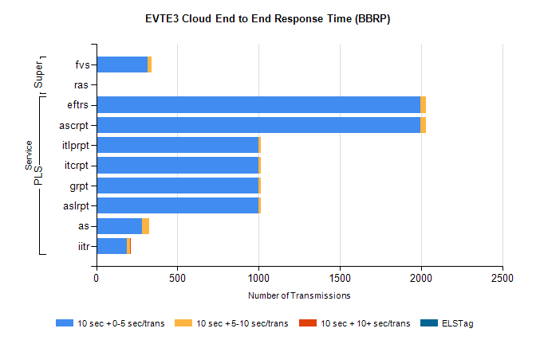
Stream | Service | 10 sec + 0-5 sec /trans | 10 sec + 5-10 sec /trans | 10 sec + >10 sec /trans | Processing Incomplete | ELStag | Total
PLS | ascrpt | 1996 | 34 | 0 | 0 | 0 | 2030
PLS | eftrs | 1996 | 34 | 0 | 0 | 0 | 2030
PLS | aslrpt | 998 | 17 | 0 | 0 | 0 | 1015
PLS | grpt | 998 | 17 | 0 | 0 | 0 | 1015
PLS | itcrpt | 998 | 17 | 0 | 0 | 0 | 1015
PLS | itlprpt | 998 | 17 | 0 | 0 | 0 | 1015
PLS | as | 281 | 45 | 0 | 1 | 0 | 334
PLS | iitr | 191 | 18 | 3 | 18 | 0 | 234
Super | fvs | 316 | 23 | 0 | 89 | 0 | 428
Super | ras | 0 | 0 | 4 | 0 | 0 | 297

