Transmission Timings Report Week - 20
13/05/2024 - 19/05/2024

SBR2 Cloud Production2 - Single Requests (SRP)

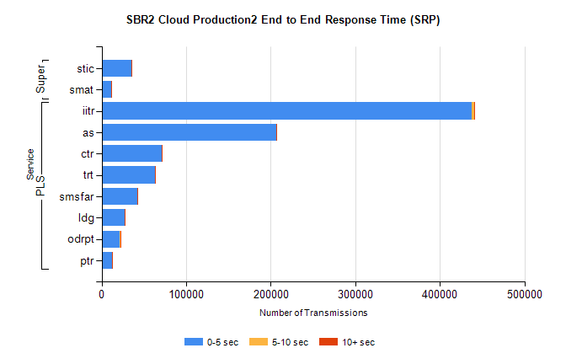
Stream | Service | 0-5 sec | 5-10 sec | >10 sec | Total | % within 5 sec timing target
PLS | iitr | 437879 | 2653 | 479 | 441099 | 99.3%
PLS | as | 206119 | 800 | 169 | 207178 | 99.5%
PLS | ctr | 71191 | 190 | 67 | 71456 | 99.6%
PLS | trt | 63038 | 166 | 37 | 63248 | 99.7%
PLS | smsfar | 42376 | 112 | 41 | 42539 | 99.6%
PLS | ldg | 27110 | 97 | 12 | 27276 | 99.4%
PLS | odrpt | 21505 | 842 | 81 | 22432 | 95.9%
PLS | ptr | 12130 | 32 | 11 | 12179 | 99.6%
Super | stic | 34892 | 235 | 49 | 35181 | 99.2%
Super | smat | 11151 | 184 | 47 | 11386 | 97.9%

SBR2 Cloud Production2 - Bulk or Batch Requests (BBRP)

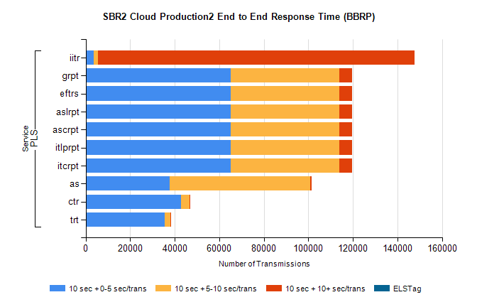
Stream | Service | 10 sec + 0-5 sec /trans | 10 sec + 5-10 sec /trans | 10 sec + >10 sec /trans | Processing Incomplete | ELStag | Total
PLS | iitr | 3599 | 2097 | 141943 | 651 | 0 | 157002
PLS | itcrpt | 65155 | 48830 | 5781 | 44 | 0 | 122319
PLS | itlprpt | 65155 | 48830 | 5781 | 44 | 0 | 122319
PLS | ascrpt | 65155 | 48830 | 5781 | 44 | 0 | 122319
PLS | aslrpt | 65155 | 48830 | 5781 | 44 | 0 | 122319
PLS | eftrs | 65155 | 48830 | 5781 | 44 | 0 | 122319
PLS | grpt | 65155 | 48830 | 5781 | 44 | 0 | 122319
PLS | as | 37838 | 62961 | 695 | 529 | 0 | 102567
PLS | ctr | 42820 | 3838 | 302 | 38 | 0 | 47224
PLS | trt | 35609 | 2405 | 240 | 8 | 0 | 38410

SBR2 Cloud Production2 - ...

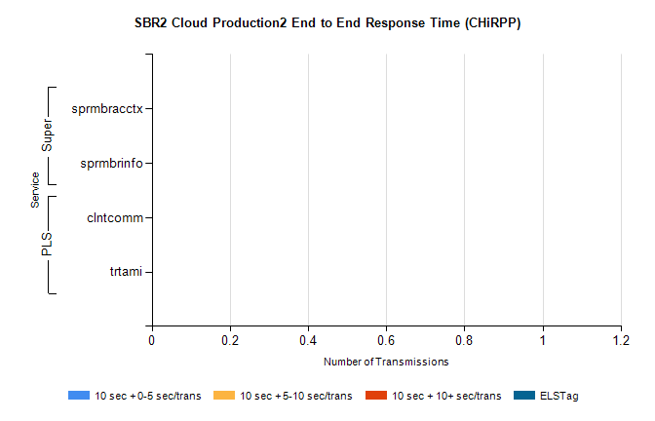
Stream | Service | 10 sec + 0-5 sec /trans | 10 sec + 5-10 sec /trans | 10 sec + >10 sec /trans | Total | % within 5 sec timing target
PLS | clntcomm | 0 | 0 | 0 | 23592 | 0.0%
PLS | trtami | 0 | 0 | 0 | 55 | 0.0%
Super | sprmbracctx | 0 | 0 | 0 | 3384 | 0.0%
Super | sprmbrinfo | 0 | 0 | 0 | 2689 | 0.0%

SBR1 Production Transactions

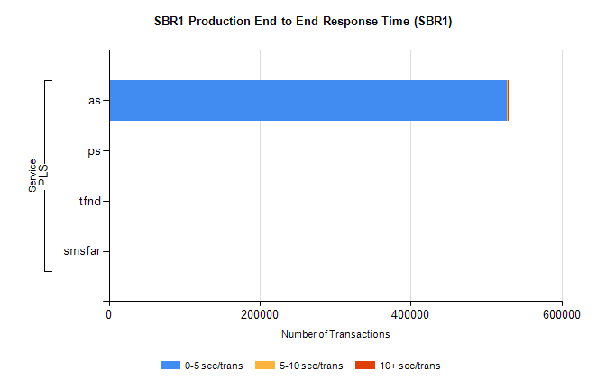
Stream | Service | 0-5 sec/trans | 5-10 sec/trans | 10+ sec/trans | Total | % within 5 sec timing target
PLS | as | 527876 | 330 | 871 | 529077 | 99.8%
PLS | ps | 79 | 57 | 240 | 376 | 21.0%
PLS | tfnd | 229 | 47 | 11 | 287 | 79.8%
PLS | smsfar | 10 | 18 |  | 28 | 35.7%

