Transmission Timings Report Week - 21
20/05/2024 - 26/05/2024

SBR2 External Vendor Testing Environment (EVTE3)

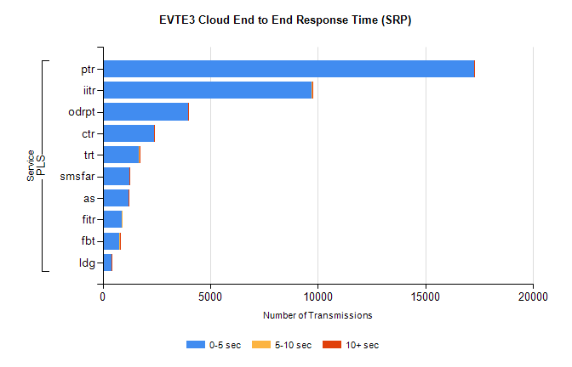
Stream | Service | 0-5 sec | 5-10 sec | >10 sec | Total | % within 5 sec timing target
PLS | ptr | 17244 | 5 | 3 | 17290 | 99.7%
PLS | iitr | 9697 | 68 | 17 | 9790 | 99.1%
PLS | odrpt | 3983 | 3 | 5 | 4003 | 99.5%
PLS | ctr | 2386 | 23 | 2 | 2498 | 95.5%
PLS | trt | 1694 | 9 | 1 | 1852 | 91.5%
PLS | smsfar | 1241 | 2 | 1 | 1246 | 99.6%
PLS | as | 1188 | 7 | 2 | 1231 | 96.5%
PLS | fitr | 876 | 1 | 0 | 877 | 99.9%
PLS | fbt | 784 | 17 | 1 | 802 | 97.8%
PLS | ldg | 412 | 3 | 6 | 422 | 97.6%

SBR2 External Vendor Testing Environment (EVTE3)

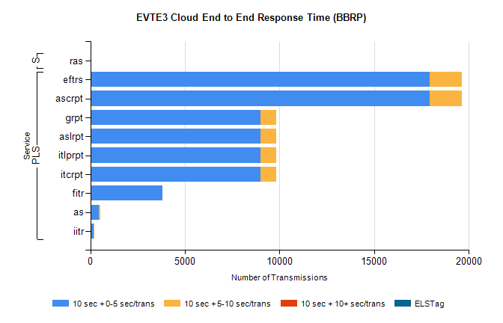
Stream | Service | 10 sec + 0-5 sec /trans | 10 sec + 5-10 sec /trans | 10 sec + >10 sec /trans | Processing Incomplete | ELStag | Total
PLS | ascrpt | 17954 | 1686 | 0 | 0 | 0 | 19642
PLS | eftrs | 17954 | 1686 | 0 | 0 | 0 | 19642
PLS | itcrpt | 8977 | 843 | 0 | 0 | 0 | 9821
PLS | itlprpt | 8977 | 843 | 0 | 0 | 0 | 9821
PLS | aslrpt | 8977 | 843 | 0 | 0 | 0 | 9821
PLS | grpt | 8977 | 843 | 0 | 0 | 0 | 9821
PLS | fitr | 3820 | 0 | 0 | 0 | 0 | 3820
PLS | as | 459 | 60 | 0 | 3 | 0 | 534
PLS | iitr | 173 | 36 | 0 | 0 | 0 | 213
Super | ras | 0 | 0 | 7 | 0 | 0 | 490

