Transmission Timings Report Week - 21
20/05/2024 - 26/05/2024

SBR2 Cloud Production2 - Single Requests (SRP)

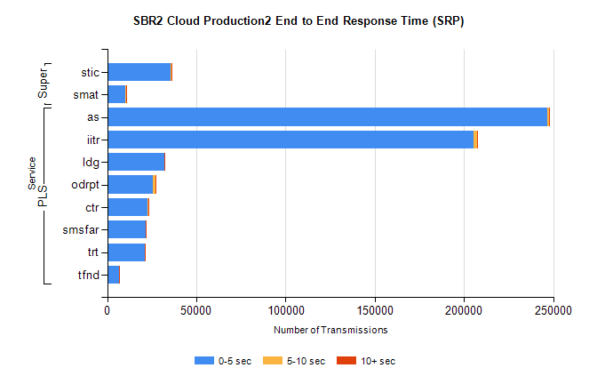
Stream | Service | 0-5 sec | 5-10 sec | >10 sec | Total | % within 5 sec timing target
PLS | as | 246582 | 896 | 224 | 247770 | 99.5%
PLS | iitr | 205340 | 1945 | 299 | 207598 | 98.9%
PLS | ldg | 32116 | 108 | 12 | 32274 | 99.5%
PLS | odrpt | 25740 | 1404 | 215 | 27359 | 94.1%
PLS | ctr | 22856 | 101 | 27 | 22986 | 99.4%
PLS | smsfar | 21517 | 77 | 25 | 21619 | 99.5%
PLS | trt | 21118 | 82 | 25 | 21229 | 99.5%
PLS | tfnd | 6581 | 28 | 5 | 6615 | 99.5%
Super | stic | 35803 | 210 | 58 | 36071 | 99.3%
Super | smat | 10357 | 185 | 45 | 10587 | 97.8%

SBR2 Cloud Production2 - Bulk or Batch Requests (BBRP)

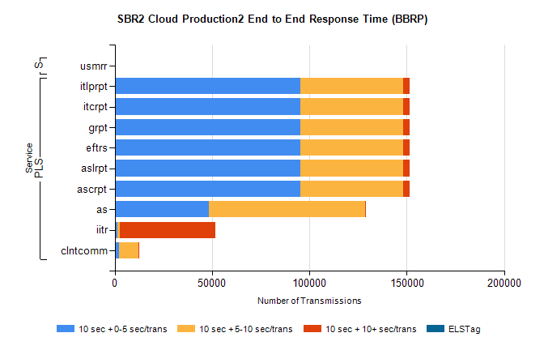
Stream | Service | 10 sec + 0-5 sec /trans | 10 sec + 5-10 sec /trans | 10 sec + >10 sec /trans | Processing Incomplete | ELStag | Total
PLS | ascrpt | 95193 | 52786 | 3418 | 12 | 0 | 153217
PLS | aslrpt | 95193 | 52786 | 3418 | 12 | 0 | 153217
PLS | eftrs | 95193 | 52786 | 3418 | 12 | 0 | 153217
PLS | grpt | 95193 | 52786 | 3418 | 12 | 0 | 153217
PLS | itcrpt | 95193 | 52786 | 3418 | 12 | 0 | 153217
PLS | itlprpt | 95193 | 52786 | 3418 | 12 | 0 | 153217
PLS | as | 48205 | 80238 | 318 | 216 | 0 | 129395
PLS | iitr | 1253 | 1182 | 49113 | 163 | 0 | 54894
PLS | clntcomm | 2332 | 9832 | 224 | 0 | 0 | 13224
Super | usmrr | 3 | 3 | 0 | 37447 | 0 | 37453

SBR2 Cloud Production2 - ...

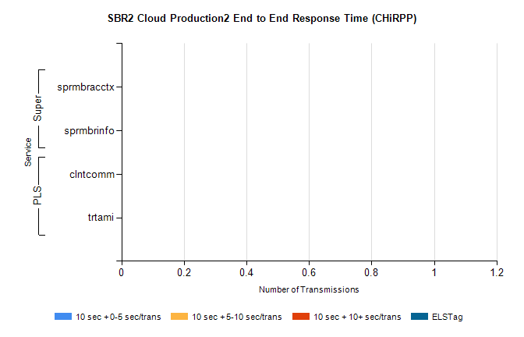
Stream | Service | 10 sec + 0-5 sec /trans | 10 sec + 5-10 sec /trans | 10 sec + >10 sec /trans | Total | % within 5 sec timing target
PLS | clntcomm | 0 | 0 | 0 | 22139 | 0.0%
PLS | trtami | 0 | 0 | 0 | 3 | 0.0%
Super | sprmbracctx | 0 | 0 | 0 | 3470 | 0.0%
Super | sprmbrinfo | 0 | 0 | 0 | 2907 | 0.0%

SBR1 Production Transactions

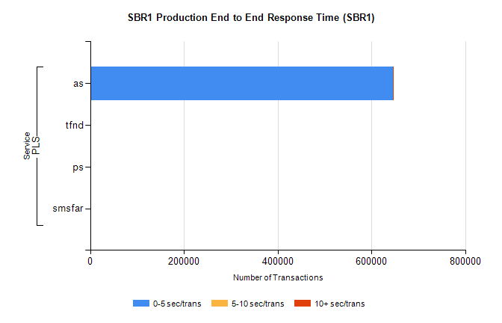
Stream | Service | 0-5 sec/trans | 5-10 sec/trans | 10+ sec/trans | Total | % within 5 sec timing target
PLS | as | 645601 | 492 | 361 | 646454 | 99.9%
PLS | tfnd | 272 | 59 | 7 | 338 | 80.5%
PLS | ps | 66 | 40 | 132 | 238 | 27.7%
PLS | smsfar | 7 | 12 |  | 19 | 36.8%

