Transmission Timings Report Week - 22
27/05/2024 - 2/06/2024

SBR2 External Vendor Testing Environment (EVTE3)

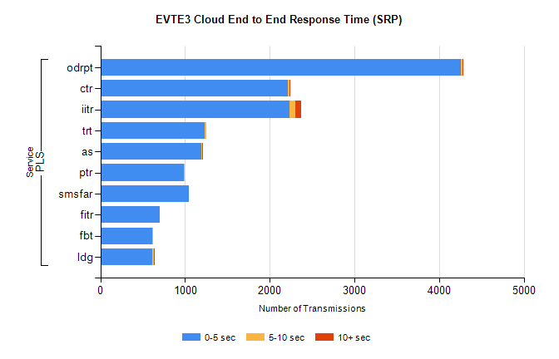
Stream | Service | 0-5 sec | 5-10 sec | >10 sec | Total | % within 5 sec timing target
PLS | odrpt | 4259 | 21 | 5 | 4292 | 99.2%
PLS | ctr | 2215 | 23 | 2 | 2458 | 90.1%
PLS | iitr | 2229 | 72 | 67 | 2384 | 93.5%
PLS | trt | 1236 | 11 | 0 | 1445 | 85.5%
PLS | as | 1193 | 10 | 6 | 1220 | 97.8%
PLS | ptr | 990 | 3 | 0 | 1067 | 92.8%
PLS | smsfar | 1042 | 0 | 0 | 1045 | 99.7%
PLS | fitr | 703 | 0 | 0 | 719 | 97.8%
PLS | fbt | 612 | 15 | 0 | 709 | 86.3%
PLS | ldg | 615 | 18 | 4 | 637 | 96.5%

SBR2 External Vendor Testing Environment (EVTE3)

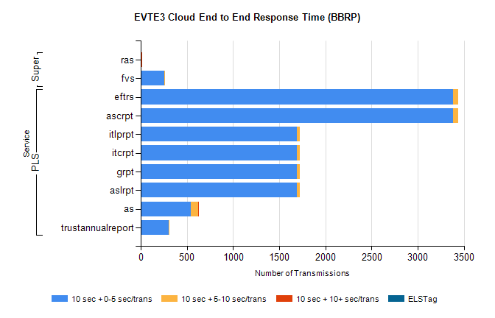
Stream | Service | 10 sec + 0-5 sec /trans | 10 sec + 5-10 sec /trans | 10 sec + >10 sec /trans | Processing Incomplete | ELStag | Total
PLS | ascrpt | 3382 | 60 | 0 | 0 | 0 | 3446
PLS | eftrs | 3382 | 60 | 0 | 0 | 0 | 3446
PLS | aslrpt | 1691 | 30 | 0 | 0 | 0 | 1723
PLS | grpt | 1691 | 30 | 0 | 0 | 0 | 1723
PLS | itcrpt | 1691 | 30 | 0 | 0 | 0 | 1723
PLS | itlprpt | 1691 | 30 | 0 | 0 | 0 | 1723
PLS | as | 539 | 81 | 1 | 4 | 0 | 634
PLS | trustannualreport | 302 | 5 | 0 | 0 | 0 | 307
Super | ras | 0 | 3 | 13 | 0 | 0 | 409
Super | fvs | 255 | 5 | 0 | 0 | 0 | 261

