Transmission Timings Report Week - 22
27/05/2024 - 2/06/2024

SBR2 Cloud Production2 - Single Requests (SRP)

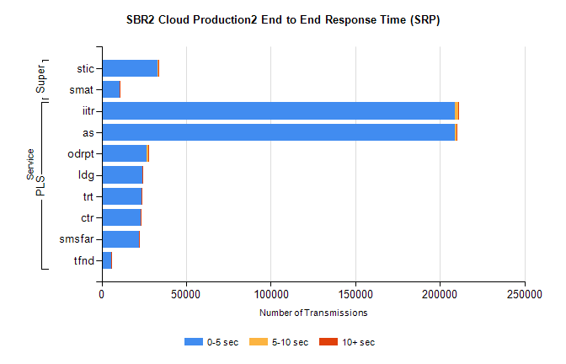
Stream | Service | 0-5 sec | 5-10 sec | >10 sec | Total | % within 5 sec timing target
PLS | iitr | 208602 | 2106 | 315 | 211071 | 98.8%
PLS | as | 209076 | 650 | 207 | 210013 | 99.6%
PLS | odrpt | 26699 | 829 | 98 | 27638 | 96.6%
PLS | ldg | 24184 | 93 | 18 | 24350 | 99.3%
PLS | trt | 23482 | 103 | 25 | 23615 | 99.4%
PLS | ctr | 23210 | 73 | 36 | 23320 | 99.5%
PLS | smsfar | 22088 | 73 | 29 | 22190 | 99.5%
PLS | tfnd | 5637 | 25 | 2 | 5664 | 99.5%
Super | stic | 33268 | 308 | 61 | 33648 | 98.9%
Super | smat | 10627 | 166 | 41 | 10842 | 98.0%

SBR2 Cloud Production2 - Bulk or Batch Requests (BBRP)

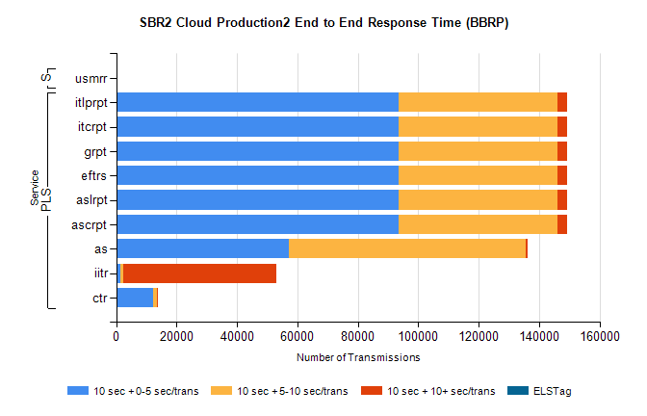
Stream | Service | 10 sec + 0-5 sec /trans | 10 sec + 5-10 sec /trans | 10 sec + >10 sec /trans | Processing Incomplete | ELStag | Total
PLS | ascrpt | 93635 | 52441 | 3281 | 46 | 0 | 151476
PLS | aslrpt | 93635 | 52441 | 3281 | 46 | 0 | 151476
PLS | eftrs | 93635 | 52441 | 3281 | 46 | 0 | 151476
PLS | grpt | 93635 | 52441 | 3281 | 46 | 0 | 151476
PLS | itcrpt | 93635 | 52441 | 3281 | 46 | 0 | 151476
PLS | itlprpt | 93635 | 52441 | 3281 | 46 | 0 | 151476
PLS | as | 57076 | 78452 | 517 | 404 | 0 | 138481
PLS | iitr | 1269 | 1122 | 50799 | 186 | 0 | 56205
PLS | ctr | 12206 | 1177 | 29 | 32 | 0 | 13557
Super | usmrr | 0 | 1 | 0 | 48551 | 0 | 48552

SBR2 Cloud Production2 - ...

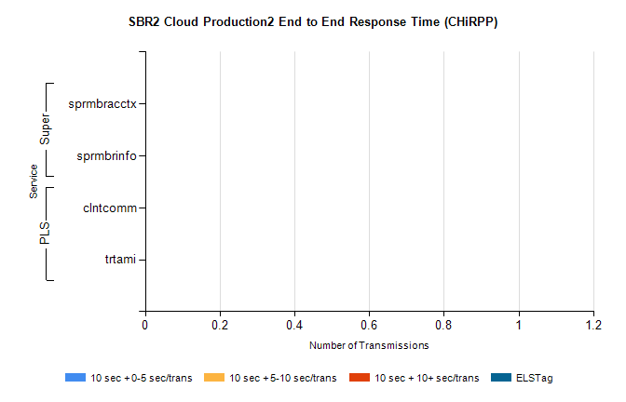
Stream | Service | 10 sec + 0-5 sec /trans | 10 sec + 5-10 sec /trans | 10 sec + >10 sec /trans | Total | % within 5 sec timing target
PLS | clntcomm | 0 | 0 | 0 | 30633 | 0.0%
PLS | trtami | 0 | 0 | 0 | 30 | 0.0%
Super | sprmbracctx | 0 | 0 | 0 | 3634 | 0.0%
Super | sprmbrinfo | 0 | 0 | 0 | 2692 | 0.0%

SBR1 Production Transactions

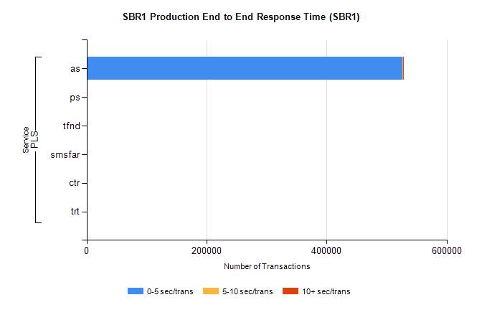
Stream | Service | 0-5 sec/trans | 5-10 sec/trans | 10+ sec/trans | Total | % within 5 sec timing target
PLS | as | 526560 | 354 | 551 | 527465 | 99.8%
PLS | ps | 234 | 69 | 145 | 448 | 52.2%
PLS | tfnd | 206 | 52 | 4 | 262 | 78.6%
PLS | smsfar | 11 | 30 |  | 41 | 26.8%
PLS | ctr |  |  | 13 | 13 | 0.0%
PLS | trt | 1 |  |  | 1 | 100.0%

