Transmission Timings Report Week - 23
3/06/2024 - 9/06/2024

SBR2 External Vendor Testing Environment (EVTE3)

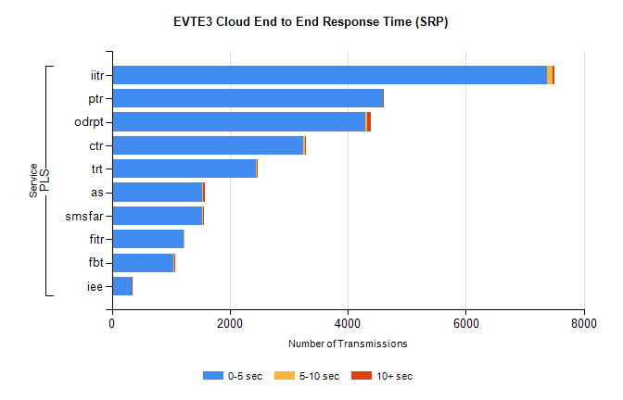
Stream | Service | 0-5 sec | 5-10 sec | >10 sec | Total | % within 5 sec timing target
PLS | iitr | 7380 | 88 | 31 | 7516 | 98.2%
PLS | ptr | 4591 | 11 | 5 | 4621 | 99.4%
PLS | odrpt | 4304 | 18 | 70 | 4397 | 97.9%
PLS | ctr | 3248 | 27 | 12 | 3314 | 98.0%
PLS | trt | 2444 | 11 | 17 | 2599 | 94.0%
PLS | as | 1529 | 21 | 23 | 1595 | 95.9%
PLS | smsfar | 1535 | 7 | 8 | 1552 | 98.9%
PLS | fitr | 1213 | 2 | 0 | 1215 | 99.8%
PLS | fbt | 1049 | 16 | 3 | 1080 | 97.1%
PLS | iee | 342 | 0 | 2 | 344 | 99.4%

SBR2 External Vendor Testing Environment (EVTE3)

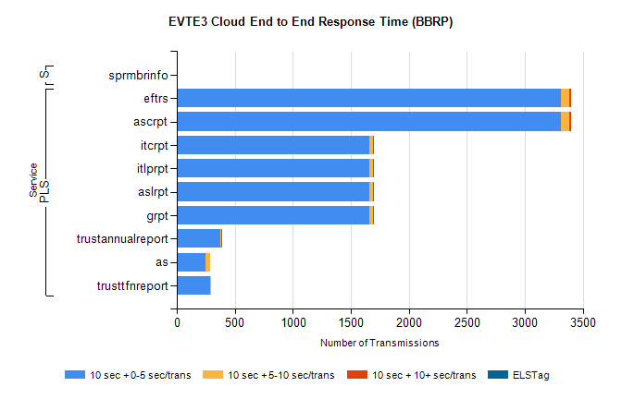
Stream | Service | 10 sec + 0-5 sec /trans | 10 sec + 5-10 sec /trans | 10 sec + >10 sec /trans | Processing Incomplete | ELStag | Total
PLS | ascrpt | 3314 | 72 | 10 | 38 | 0 | 3434
PLS | eftrs | 3314 | 72 | 10 | 38 | 0 | 3434
PLS | grpt | 1657 | 36 | 5 | 19 | 0 | 1717
PLS | aslrpt | 1657 | 36 | 5 | 19 | 0 | 1717
PLS | itlprpt | 1657 | 36 | 5 | 19 | 0 | 1717
PLS | itcrpt | 1657 | 36 | 5 | 19 | 0 | 1717
PLS | trustannualreport | 374 | 7 | 1 | 0 | 0 | 382
PLS | as | 244 | 47 | 0 | 3 | 0 | 294
PLS | trusttfnreport | 291 | 1 | 0 | 0 | 0 | 292
Super | sprmbrinfo | 0 | 0 | 0 | 0 | 0 | 979

