Transmission Timings Report Week - 23
3/06/2024 - 9/06/2024

SBR2 Cloud Production2 - Single Requests (SRP)

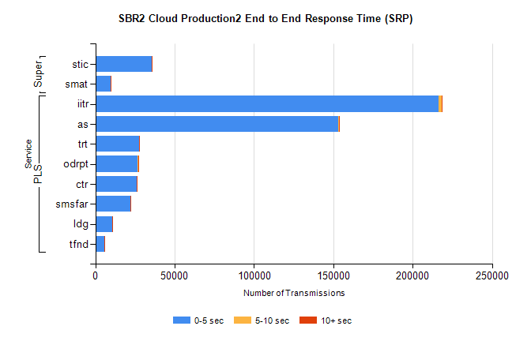
Stream | Service | 0-5 sec | 5-10 sec | >10 sec | Total | % within 5 sec timing target
PLS | iitr | 216407 | 1967 | 272 | 218889 | 98.9%
PLS | as | 153013 | 498 | 63 | 154832 | 98.8%
PLS | trt | 27350 | 113 | 24 | 27512 | 99.4%
PLS | odrpt | 26366 | 917 | 142 | 27432 | 96.1%
PLS | ctr | 26231 | 115 | 27 | 26447 | 99.2%
PLS | smsfar | 22001 | 97 | 22 | 22148 | 99.3%
PLS | ldg | 10469 | 72 | 17 | 11062 | 94.6%
PLS | tfnd | 5863 | 25 | 3 | 5893 | 99.5%
Super | stic | 35532 | 168 | 46 | 35809 | 99.2%
Super | smat | 9700 | 149 | 28 | 9917 | 97.8%

SBR2 Cloud Production2 - Bulk or Batch Requests (BBRP)

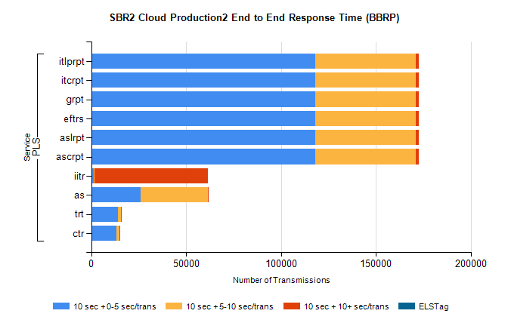
Stream | Service | 10 sec + 0-5 sec /trans | 10 sec + 5-10 sec /trans | 10 sec + >10 sec /trans | Processing Incomplete | ELStag | Total
PLS | ascrpt | 118196 | 52940 | 1601 | 622 | 0 | 175080
PLS | aslrpt | 118196 | 52940 | 1601 | 622 | 0 | 175080
PLS | eftrs | 118196 | 52940 | 1601 | 622 | 0 | 175080
PLS | grpt | 118196 | 52940 | 1601 | 622 | 0 | 175080
PLS | itcrpt | 118196 | 52940 | 1601 | 622 | 0 | 175080
PLS | itlprpt | 118196 | 52940 | 1601 | 622 | 0 | 175080
PLS | iitr | 1446 | 491 | 59569 | 269 | 0 | 63557
PLS | as | 26177 | 35239 | 86 | 113 | 0 | 61862
PLS | trt | 14200 | 1471 | 19 | 10 | 0 | 15731
PLS | ctr | 13227 | 1767 | 18 | 59 | 0 | 15107

SBR2 Cloud Production2 - ...

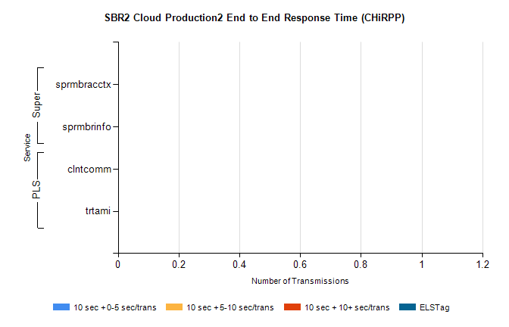
Stream | Service | 10 sec + 0-5 sec /trans | 10 sec + 5-10 sec /trans | 10 sec + >10 sec /trans | Total | % within 5 sec timing target
PLS | clntcomm | 0 | 0 | 0 | 25397 | 0.0%
PLS | trtami | 0 | 0 | 0 | 47 | 0.0%
Super | sprmbracctx | 0 | 0 | 0 | 3130 | 0.0%
Super | sprmbrinfo | 0 | 0 | 0 | 2744 | 0.0%

SBR1 Production Transactions

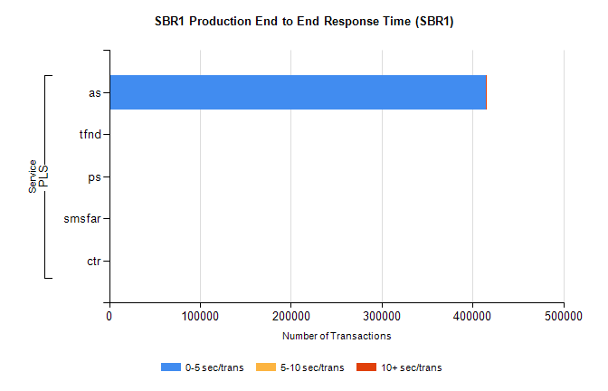
Stream | Service | 0-5 sec/trans | 5-10 sec/trans | 10+ sec/trans | Total | % within 5 sec timing target
PLS | as | 414665 | 174 | 481 | 415320 | 99.8%
PLS | tfnd | 227 | 58 | 6 | 291 | 78.0%
PLS | ps | 74 | 50 | 159 | 283 | 26.1%
PLS | smsfar | 2 | 18 |  | 20 | 10.0%
PLS | ctr | 1 |  | 2 | 3 | 33.3%

