Transmission Timings Report Week - 24
10/06/2024 - 16/06/2024

SBR2 External Vendor Testing Environment (EVTE3)

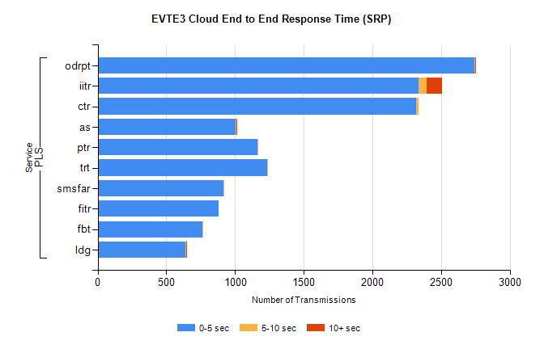
Stream | Service | 0-5 sec | 5-10 sec | >10 sec | Total | % within 5 sec timing target
PLS | odrpt | 2741 | 10 | 2 | 4022 | 68.2%
PLS | iitr | 2335 | 60 | 112 | 3356 | 69.6%
PLS | ctr | 2321 | 16 | 0 | 3134 | 74.1%
PLS | as | 1002 | 10 | 3 | 1495 | 67.0%
PLS | ptr | 1165 | 4 | 0 | 1469 | 79.3%
PLS | trt | 1235 | 3 | 0 | 1420 | 87.0%
PLS | smsfar | 918 | 1 | 0 | 1111 | 82.6%
PLS | fitr | 879 | 0 | 0 | 1065 | 82.5%
PLS | fbt | 762 | 3 | 0 | 939 | 81.2%
PLS | ldg | 640 | 7 | 3 | 822 | 77.9%

SBR2 External Vendor Testing Environment (EVTE3)

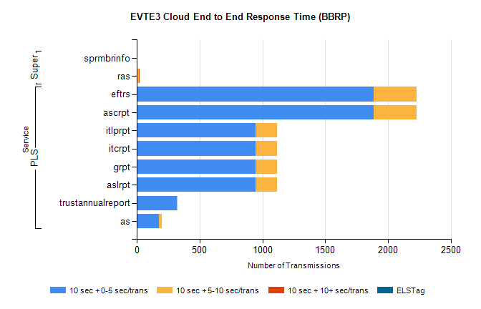
Stream | Service | 10 sec + 0-5 sec /trans | 10 sec + 5-10 sec /trans | 10 sec + >10 sec /trans | Processing Incomplete | ELStag | Total
PLS | ascrpt | 1886 | 344 | 0 | 390 | 0 | 2622
PLS | eftrs | 1886 | 344 | 0 | 390 | 0 | 2622
PLS | aslrpt | 943 | 172 | 0 | 195 | 0 | 1311
PLS | grpt | 943 | 172 | 0 | 195 | 0 | 1311
PLS | itcrpt | 943 | 172 | 0 | 195 | 0 | 1311
PLS | itlprpt | 943 | 172 | 0 | 195 | 0 | 1311
PLS | trustannualreport | 317 | 1 | 0 | 173 | 0 | 491
PLS | as | 175 | 24 | 0 | 169 | 0 | 368
Super | sprmbrinfo | 0 | 0 | 0 | 0 | 0 | 1316
Super | ras | 1 | 16 | 4 | 189 | 0 | 467

