Transmission Timings Report Week - 24
10/06/2024 - 16/06/2024

SBR2 Cloud Production2 - Single Requests (SRP)

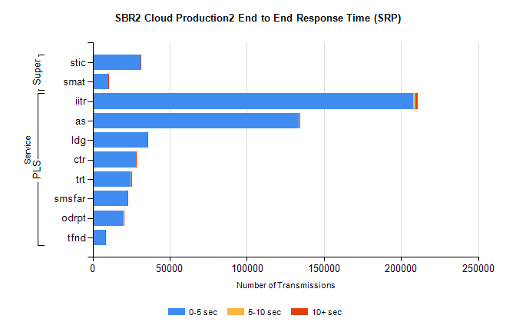
Stream | Service | 0-5 sec | 5-10 sec | >10 sec | Total | % within 5 sec timing target
PLS | iitr | 207985 | 1536 | 1462 | 217426 | 95.7%
PLS | as | 133579 | 350 | 305 | 136888 | 97.6%
PLS | ldg | 35354 | 123 | 16 | 35619 | 99.3%
PLS | ctr | 27851 | 75 | 177 | 28797 | 96.7%
PLS | trt | 24795 | 81 | 168 | 25674 | 96.6%
PLS | smsfar | 22486 | 60 | 243 | 23709 | 94.8%
PLS | odrpt | 19531 | 763 | 98 | 20505 | 95.2%
PLS | tfnd | 8071 | 33 | 29 | 8330 | 96.9%
Super | stic | 30899 | 190 | 185 | 33126 | 93.3%
Super | smat | 10059 | 144 | 65 | 10565 | 95.2%

SBR2 Cloud Production2 - Bulk or Batch Requests (BBRP)

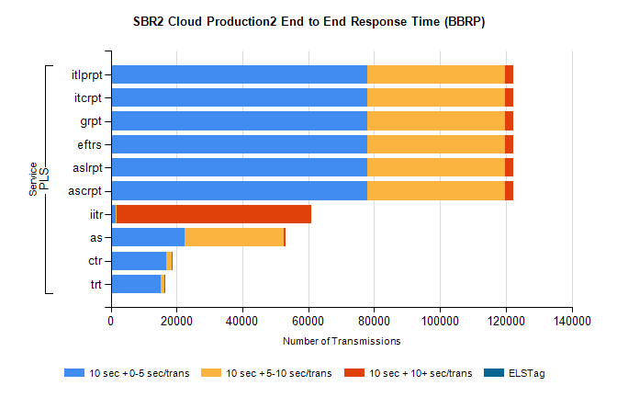
Stream | Service | 10 sec + 0-5 sec /trans | 10 sec + 5-10 sec /trans | 10 sec + >10 sec /trans | Processing Incomplete | ELStag | Total
PLS | ascrpt | 78016 | 41581 | 2631 | 1587 | 0 | 125482
PLS | aslrpt | 78016 | 41581 | 2631 | 1587 | 0 | 125482
PLS | eftrs | 78016 | 41581 | 2631 | 1587 | 0 | 125482
PLS | grpt | 78016 | 41581 | 2631 | 1587 | 0 | 125482
PLS | itcrpt | 78016 | 41581 | 2631 | 1587 | 0 | 125482
PLS | itlprpt | 78016 | 41581 | 2631 | 1587 | 0 | 125482
PLS | iitr | 1450 | 439 | 58928 | 834 | 0 | 63654
PLS | as | 22365 | 30048 | 636 | 591 | 0 | 53943
PLS | ctr | 16974 | 1476 | 348 | 175 | 0 | 19051
PLS | trt | 15261 | 1061 | 288 | 93 | 0 | 16776

SBR2 Cloud Production2 - ...

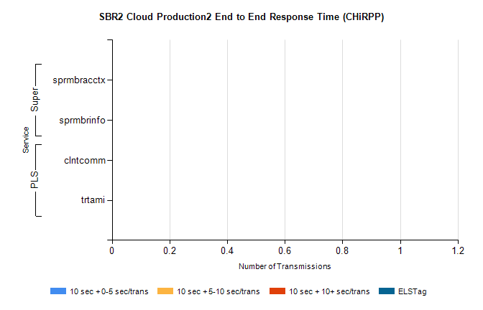
Stream | Service | 10 sec + 0-5 sec /trans | 10 sec + 5-10 sec /trans | 10 sec + >10 sec /trans | Total | % within 5 sec timing target
PLS | clntcomm | 0 | 0 | 0 | 25251 | 0.0%
PLS | trtami | 0 | 0 | 0 | 18 | 0.0%
Super | sprmbracctx | 0 | 0 | 0 | 2751 | 0.0%
Super | sprmbrinfo | 0 | 0 | 0 | 2451 | 0.0%

SBR1 Production Transactions

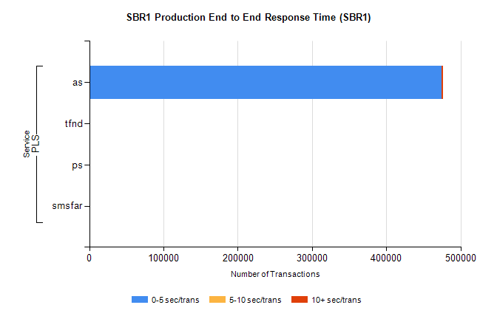
Stream | Service | 0-5 sec/trans | 5-10 sec/trans | 10+ sec/trans | Total | % within 5 sec timing target
PLS | as | 474575 | 223 | 1980 | 476778 | 99.5%
PLS | tfnd | 266 | 48 | 1 | 315 | 84.4%
PLS | ps | 36 | 56 | 145 | 237 | 15.2%
PLS | smsfar | 6 | 26 | 2 | 34 | 17.6%

