Transmission Timings Report Week - 25
17/06/2024 - 23/06/2024

SBR2 External Vendor Testing Environment (EVTE3)

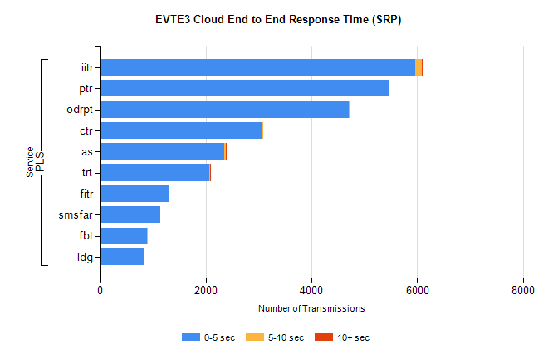
Stream | Service | 0-5 sec | 5-10 sec | >10 sec | Total | % within 5 sec timing target
PLS | iitr | 5968 | 125 | 17 | 6118 | 97.5%
PLS | ptr | 5452 | 12 | 0 | 5478 | 99.5%
PLS | odrpt | 4702 | 16 | 5 | 4726 | 99.5%
PLS | ctr | 3070 | 23 | 0 | 3134 | 98.0%
PLS | as | 2354 | 22 | 9 | 2424 | 97.1%
PLS | trt | 2058 | 16 | 2 | 2187 | 94.1%
PLS | fitr | 1298 | 0 | 0 | 1299 | 99.9%
PLS | smsfar | 1139 | 0 | 0 | 1140 | 99.9%
PLS | fbt | 887 | 16 | 0 | 915 | 96.9%
PLS | ldg | 821 | 9 | 3 | 838 | 98.0%

SBR2 External Vendor Testing Environment (EVTE3)

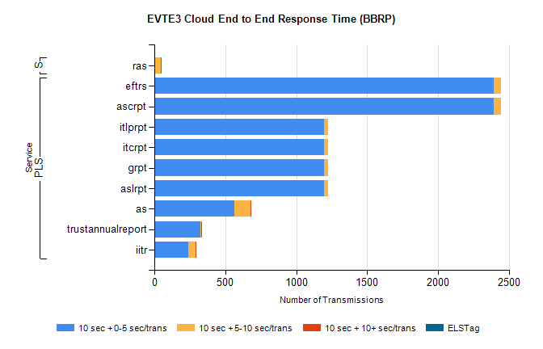
Stream | Service | 10 sec + 0-5 sec /trans | 10 sec + 5-10 sec /trans | 10 sec + >10 sec /trans | Processing Incomplete | ELStag | Total
PLS | ascrpt | 2394 | 52 | 0 | 0 | 0 | 2446
PLS | eftrs | 2394 | 52 | 0 | 0 | 0 | 2446
PLS | aslrpt | 1197 | 26 | 0 | 0 | 0 | 1223
PLS | grpt | 1197 | 26 | 0 | 0 | 0 | 1223
PLS | itcrpt | 1197 | 26 | 0 | 0 | 0 | 1223
PLS | itlprpt | 1197 | 26 | 0 | 0 | 0 | 1223
PLS | as | 564 | 115 | 1 | 7 | 0 | 689
PLS | trustannualreport | 326 | 6 | 1 | 0 | 0 | 333
PLS | iitr | 237 | 56 | 5 | 0 | 0 | 302
Super | ras | 1 | 42 | 6 | 0 | 0 | 604

