Transmission Timings Report Week - 28
8/07/2024 - 14/07/2024

SBR2 External Vendor Testing Environment (EVTE3)

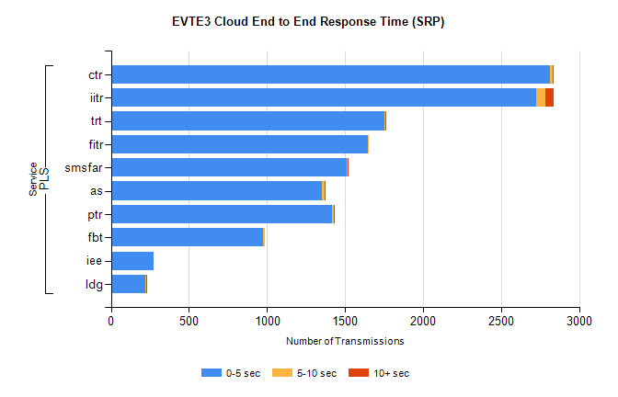
Stream | Service | 0-5 sec | 5-10 sec | >10 sec | Total | % within 5 sec timing target
PLS | ctr | 2811 | 19 | 1 | 2858 | 98.4%
PLS | iitr | 2726 | 59 | 53 | 2841 | 96.0%
PLS | trt | 1751 | 9 | 4 | 1775 | 98.6%
PLS | fitr | 1645 | 6 | 0 | 1651 | 99.6%
PLS | smsfar | 1509 | 8 | 2 | 1519 | 99.3%
PLS | as | 1351 | 16 | 10 | 1444 | 93.6%
PLS | ptr | 1418 | 10 | 2 | 1431 | 99.1%
PLS | fbt | 975 | 13 | 0 | 989 | 98.6%
PLS | iee | 273 | 0 | 0 | 273 | 100.0%
PLS | ldg | 220 | 6 | 5 | 252 | 87.3%

SBR2 External Vendor Testing Environment (EVTE3)

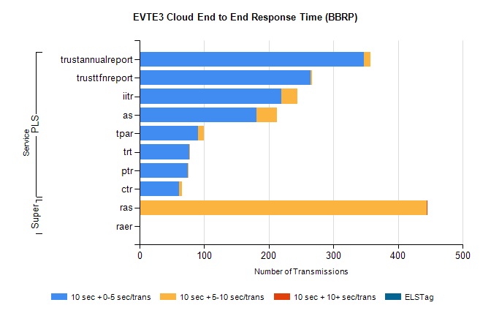
Stream | Service | 10 sec + 0-5 sec /trans | 10 sec + 5-10 sec /trans | 10 sec + >10 sec /trans | Processing Incomplete | ELStag | Total
PLS | trustannualreport | 347 | 10 | 0 | 0 | 0 | 357
PLS | trusttfnreport | 265 | 2 | 0 | 0 | 0 | 267
PLS | iitr | 219 | 25 | 0 | 3 | 0 | 249
PLS | as | 181 | 31 | 0 | 2 | 0 | 214
PLS | tpar | 90 | 9 | 0 | 0 | 0 | 109
PLS | trt | 77 | 1 | 0 | 0 | 0 | 78
PLS | ptr | 75 | 1 | 0 | 0 | 0 | 76
PLS | ctr | 61 | 4 | 0 | 6 | 0 | 74
Super | ras | 0 | 444 | 2 | 0 | 0 | 462
Super | raer | 0 | 0 | 0 | 119 | 0 | 119

