Transmission Timings Report Week - 26
24/06/2024 - 30/06/2024

SBR2 External Vendor Testing Environment (EVTE3)

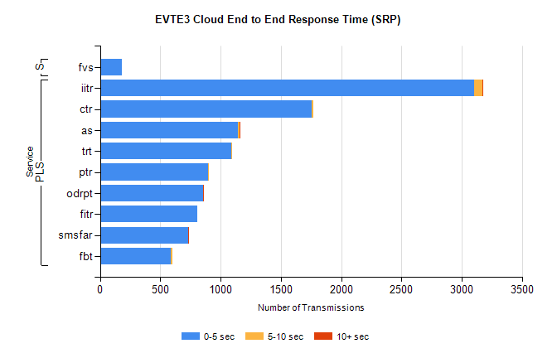
Stream | Service | 0-5 sec | 5-10 sec | >10 sec | Total | % within 5 sec timing target
PLS | iitr | 3103 | 69 | 9 | 3194 | 97.2%
PLS | ctr | 1756 | 12 | 0 | 1886 | 93.1%
PLS | as | 1144 | 15 | 6 | 1233 | 92.8%
PLS | trt | 1090 | 4 | 0 | 1151 | 94.7%
PLS | ptr | 898 | 3 | 0 | 903 | 99.4%
PLS | odrpt | 852 | 3 | 1 | 856 | 99.5%
PLS | fitr | 804 | 0 | 0 | 804 | 100.0%
PLS | smsfar | 732 | 3 | 1 | 739 | 99.1%
PLS | fbt | 586 | 16 | 0 | 602 | 97.3%
Super | fvs | 184 | 0 | 0 | 184 | 100.0%

SBR2 External Vendor Testing Environment (EVTE3)

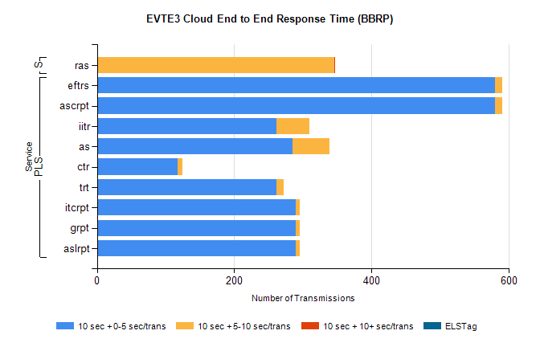
Stream | Service | 10 sec + 0-5 sec /trans | 10 sec + 5-10 sec /trans | 10 sec + >10 sec /trans | Processing Incomplete | ELStag | Total
PLS | ascrpt | 580 | 10 | 0 | 0 | 0 | 590
PLS | eftrs | 580 | 10 | 0 | 0 | 0 | 590
PLS | iitr | 262 | 48 | 0 | 174 | 0 | 490
PLS | as | 285 | 54 | 0 | 18 | 0 | 358
PLS | ctr | 118 | 6 | 0 | 220 | 0 | 345
PLS | trt | 261 | 11 | 0 | 68 | 0 | 340
PLS | aslrpt | 290 | 5 | 0 | 0 | 0 | 295
PLS | grpt | 290 | 5 | 0 | 0 | 0 | 295
PLS | itcrpt | 290 | 5 | 0 | 0 | 0 | 295
Super | ras | 0 | 346 | 1 | 0 | 0 | 457

