Transmission Timings Report Week - 26
24/06/2024 - 30/06/2024

SBR2 Cloud Production2 - Single Requests (SRP)

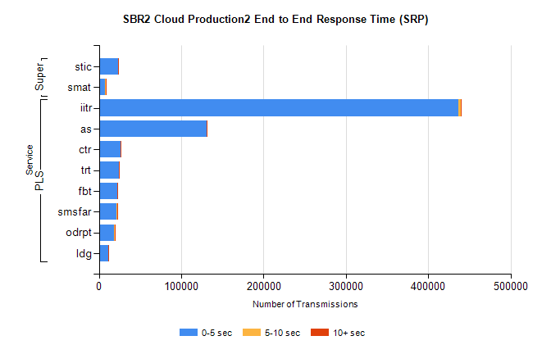
Stream | Service | 0-5 sec | 5-10 sec | >10 sec | Total | % within 5 sec timing target
PLS | iitr | 436453 | 2825 | 1089 | 440393 | 99.1%
PLS | as | 130730 | 336 | 62 | 131150 | 99.7%
PLS | ctr | 25917 | 133 | 34 | 26085 | 99.4%
PLS | trt | 23918 | 106 | 44 | 24068 | 99.4%
PLS | fbt | 21968 | 64 | 33 | 22071 | 99.5%
PLS | smsfar | 21810 | 102 | 30 | 21943 | 99.4%
PLS | odrpt | 18544 | 1135 | 305 | 19984 | 92.8%
PLS | ldg | 10946 | 83 | 4 | 11040 | 99.1%
Super | stic | 23304 | 165 | 75 | 23544 | 99.0%
Super | smat | 7792 | 127 | 47 | 7966 | 97.8%

SBR2 Cloud Production2 - Bulk or Batch Requests (BBRP)

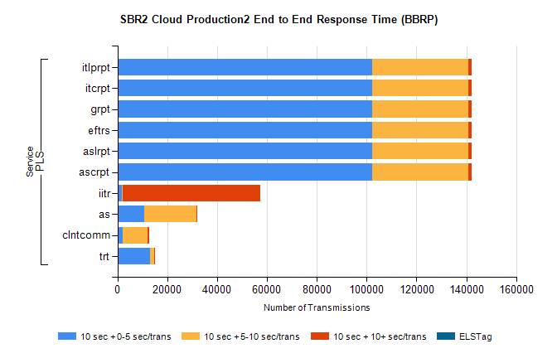
Stream | Service | 10 sec + 0-5 sec /trans | 10 sec + 5-10 sec /trans | 10 sec + >10 sec /trans | Processing Incomplete | ELStag | Total
PLS | ascrpt | 102340 | 38384 | 1458 | 4 | 0 | 143431
PLS | aslrpt | 102340 | 38384 | 1458 | 4 | 0 | 143431
PLS | eftrs | 102340 | 38384 | 1458 | 4 | 0 | 143431
PLS | grpt | 102340 | 38384 | 1458 | 4 | 0 | 143431
PLS | itcrpt | 102340 | 38384 | 1458 | 4 | 0 | 143431
PLS | itlprpt | 102340 | 38384 | 1458 | 4 | 0 | 143431
PLS | iitr | 1713 | 414 | 55314 | 198 | 0 | 59917
PLS | as | 10859 | 20851 | 444 | 127 | 0 | 32927
PLS | clntcomm | 2128 | 10068 | 595 | 2918 | 0 | 16498
PLS | trt | 13183 | 1549 | 74 | 1 | 0 | 14934

SBR2 Cloud Production2 - ...

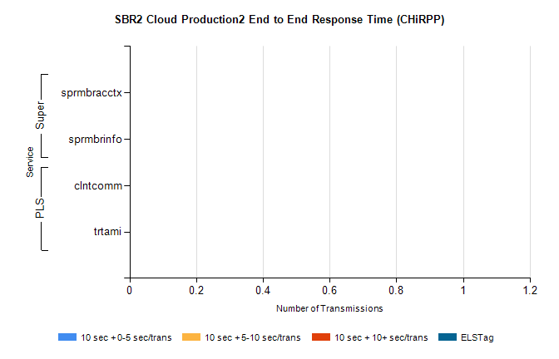
Stream | Service | 10 sec + 0-5 sec /trans | 10 sec + 5-10 sec /trans | 10 sec + >10 sec /trans | Total | % within 5 sec timing target
PLS | clntcomm | 0 | 0 | 0 | 10950 | 0.0%
PLS | trtami | 0 | 0 | 0 | 26 | 0.0%
Super | sprmbracctx | 0 | 0 | 0 | 2459 | 0.0%
Super | sprmbrinfo | 0 | 0 | 0 | 1916 | 0.0%

SBR1 Production Transactions

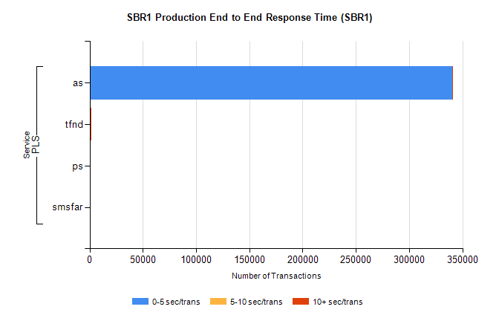
Stream | Service | 0-5 sec/trans | 5-10 sec/trans | 10+ sec/trans | Total | % within 5 sec timing target
PLS | as | 340282 | 307 | 276 | 340865 | 99.8%
PLS | tfnd | 991 | 66 | 3 | 1060 | 93.5%
PLS | ps | 27 | 45 | 154 | 226 | 11.9%
PLS | smsfar | 1 | 10 |  | 11 | 9.1%

