Transmission Timings Report Week - 27
1/07/2024 - 7/07/2024

SBR2 External Vendor Testing Environment (EVTE3)

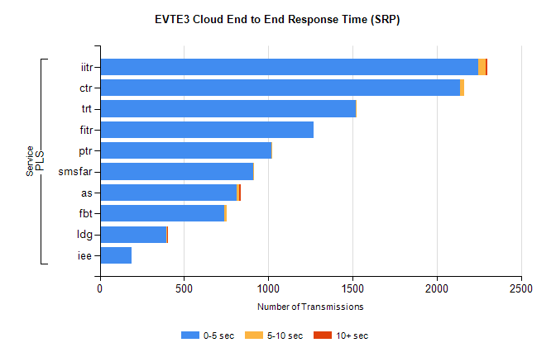
Stream | Service | 0-5 sec | 5-10 sec | >10 sec | Total | % within 5 sec timing target
PLS | iitr | 2248 | 43 | 11 | 2517 | 89.3%
PLS | ctr | 2137 | 26 | 0 | 2230 | 95.8%
PLS | trt | 1520 | 3 | 0 | 1799 | 84.5%
PLS | fitr | 1267 | 0 | 0 | 1290 | 98.2%
PLS | ptr | 1017 | 2 | 0 | 1262 | 80.6%
PLS | smsfar | 912 | 2 | 0 | 1101 | 82.8%
PLS | as | 813 | 13 | 10 | 910 | 89.3%
PLS | fbt | 741 | 11 | 0 | 766 | 96.7%
PLS | ldg | 395 | 5 | 5 | 435 | 90.8%
PLS | iee | 187 | 0 | 0 | 208 | 89.9%

SBR2 External Vendor Testing Environment (EVTE3)

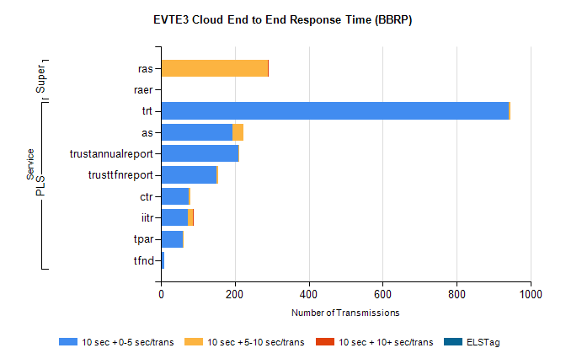
Stream | Service | 10 sec + 0-5 sec /trans | 10 sec + 5-10 sec /trans | 10 sec + >10 sec /trans | Processing Incomplete | ELStag | Total
PLS | trt | 941 | 4 | 0 | 5 | 0 | 950
PLS | as | 194 | 30 | 0 | 54 | 0 | 278
PLS | trustannualreport | 209 | 2 | 0 | 7 | 0 | 218
PLS | trusttfnreport | 150 | 4 | 0 | 7 | 0 | 161
PLS | ctr | 75 | 4 | 0 | 43 | 0 | 122
PLS | iitr | 73 | 13 | 1 | 9 | 0 | 99
PLS | tpar | 59 | 3 | 0 | 15 | 0 | 85
PLS | tfnd | 10 | 0 | 0 | 46 | 0 | 56
Super | ras | 0 | 290 | 2 | 55 | 0 | 363
Super | raer | 0 | 0 | 0 | 77 | 0 | 77

