Transmission Timings Report Week - 27
1/07/2024 - 7/07/2024

SBR2 Cloud Production2 - Single Requests (SRP)

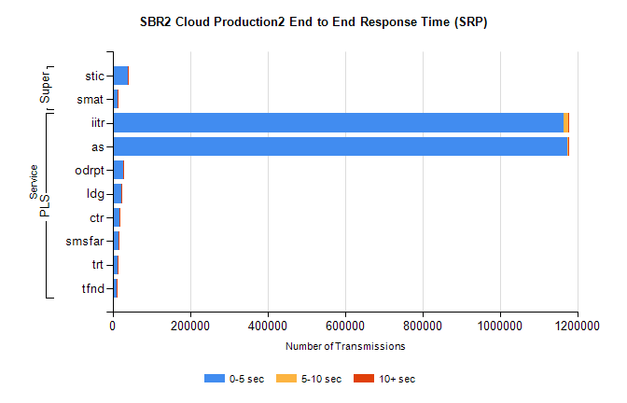
Stream | Service | 0-5 sec | 5-10 sec | >10 sec | Total | % within 5 sec timing target
PLS | iitr | 1163512 | 11384 | 2449 | 1177556 | 98.8%
PLS | as | 1172132 | 2438 | 1375 | 1176200 | 99.7%
PLS | odrpt | 26488 | 1372 | 189 | 28050 | 94.4%
PLS | ldg | 21864 | 210 | 62 | 22180 | 98.6%
PLS | ctr | 17602 | 105 | 32 | 17743 | 99.2%
PLS | smsfar | 15033 | 62 | 26 | 15125 | 99.4%
PLS | trt | 14090 | 97 | 25 | 14215 | 99.1%
PLS | tfnd | 10657 | 49 | 14 | 10720 | 99.4%
Super | stic | 39747 | 260 | 75 | 40091 | 99.1%
Super | smat | 12857 | 279 | 55 | 13204 | 97.4%

SBR2 Cloud Production2 - Bulk or Batch Requests (BBRP)

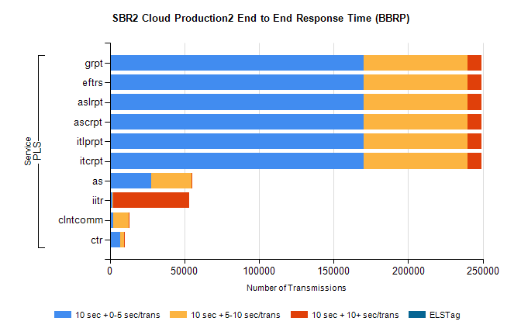
Stream | Service | 10 sec + 0-5 sec /trans | 10 sec + 5-10 sec /trans | 10 sec + >10 sec /trans | Processing Incomplete | ELStag | Total
PLS | itcrpt | 169973 | 69923 | 9465 | 55 | 0 | 254914
PLS | itlprpt | 169972 | 69923 | 9466 | 55 | 0 | 254914
PLS | ascrpt | 169973 | 69923 | 9465 | 55 | 0 | 254914
PLS | aslrpt | 169972 | 69923 | 9466 | 55 | 0 | 254914
PLS | eftrs | 169973 | 69923 | 9465 | 55 | 0 | 254914
PLS | grpt | 169973 | 69923 | 9465 | 55 | 0 | 254914
PLS | as | 27482 | 27054 | 395 | 152 | 0 | 55479
PLS | iitr | 1877 | 483 | 50733 | 254 | 0 | 54113
PLS | clntcomm | 1973 | 10551 | 389 | 199 | 0 | 13896
PLS | ctr | 6980 | 2518 | 165 | 29 | 0 | 9773

SBR2 Cloud Production2 - ...

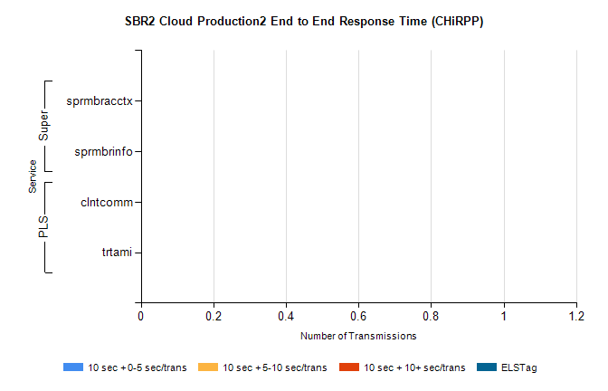
Stream | Service | 10 sec + 0-5 sec /trans | 10 sec + 5-10 sec /trans | 10 sec + >10 sec /trans | Total | % within 5 sec timing target
PLS | clntcomm | 0 | 0 | 0 | 24315 | 0.0%
PLS | trtami | 0 | 0 | 0 | 4 | 0.0%
Super | sprmbracctx | 0 | 0 | 0 | 3922 | 0.0%
Super | sprmbrinfo | 0 | 0 | 0 | 2527 | 0.0%

SBR1 Production Transactions

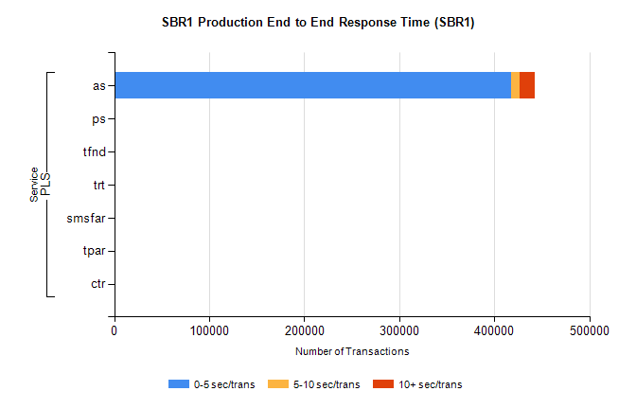
Stream | Service | 0-5 sec/trans | 5-10 sec/trans | 10+ sec/trans | Total | % within 5 sec timing target
PLS | as | 417710 | 8548 | 15907 | 442165 | 94.5%
PLS | ps | 192 | 211 | 431 | 834 | 23.0%
PLS | tfnd | 455 | 67 | 2 | 524 | 86.8%
PLS | trt | 10 | 3 | 31 | 44 | 22.7%
PLS | smsfar | 4 | 17 |  | 21 | 19.0%
PLS | tpar | 12 |  |  | 12 | 100.0%
PLS | ctr | 1 | 1 | 4 | 6 | 16.7%

