Transmission Timings Report Week - 28
8/07/2024 - 14/07/2024

SBR2 Cloud Production2 - Single Requests (SRP)

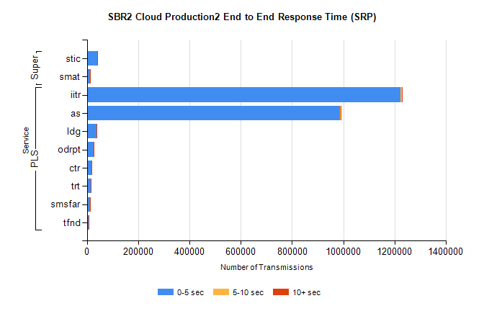
Stream | Service | 0-5 sec | 5-10 sec | >10 sec | Total | % within 5 sec timing target
PLS | iitr | 1223312 | 6015 | 1743 | 1232642 | 99.2%
PLS | as | 985767 | 3076 | 560 | 991601 | 99.4%
PLS | ldg | 38024 | 107 | 20 | 38201 | 99.5%
PLS | odrpt | 26103 | 1521 | 237 | 27864 | 93.7%
PLS | ctr | 18628 | 67 | 12 | 18710 | 99.6%
PLS | trt | 14059 | 59 | 15 | 14136 | 99.5%
PLS | smsfar | 13471 | 35 | 12 | 13518 | 99.7%
PLS | tfnd | 7705 | 37 | 4 | 7754 | 99.4%
Super | stic | 40751 | 217 | 48 | 41036 | 99.3%
Super | smat | 12790 | 231 | 59 | 13103 | 97.6%

SBR2 Cloud Production2 - Bulk or Batch Requests (BBRP)

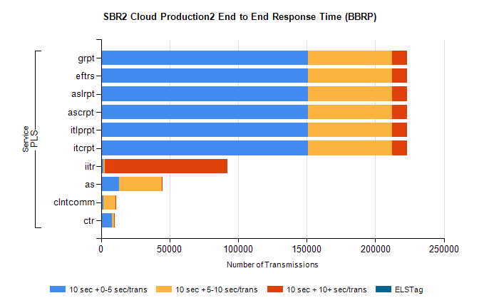
Stream | Service | 10 sec + 0-5 sec /trans | 10 sec + 5-10 sec /trans | 10 sec + >10 sec /trans | Processing Incomplete | ELStag | Total
PLS | itcrpt | 150767 | 61686 | 10480 | 1072 | 0 | 229325
PLS | itlprpt | 150767 | 61686 | 10480 | 1072 | 0 | 229325
PLS | ascrpt | 150767 | 61686 | 10480 | 1072 | 0 | 229325
PLS | aslrpt | 150767 | 61686 | 10480 | 1072 | 0 | 229325
PLS | eftrs | 150767 | 61686 | 10480 | 1072 | 0 | 229325
PLS | grpt | 150767 | 61686 | 10480 | 1072 | 0 | 229325
PLS | iitr | 1461 | 1305 | 89335 | 501 | 0 | 95395
PLS | as | 13365 | 31114 | 73 | 133 | 0 | 44932
PLS | clntcomm | 1645 | 8817 | 351 | 8979 | 0 | 20578
PLS | ctr | 7836 | 1681 | 4 | 8 | 0 | 9553

SBR2 Cloud Production2 - ...

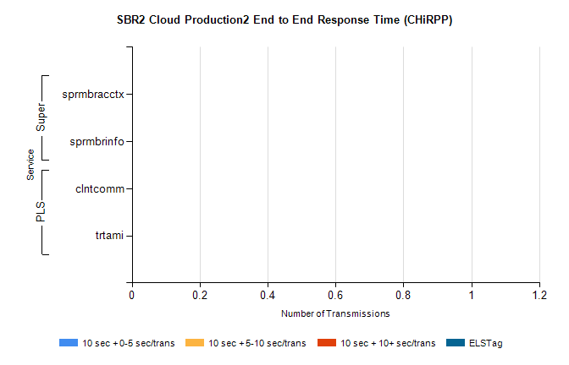
Stream | Service | 10 sec + 0-5 sec /trans | 10 sec + 5-10 sec /trans | 10 sec + >10 sec /trans | Total | % within 5 sec timing target
PLS | clntcomm | 0 | 0 | 0 | 16846 | 0.0%
PLS | trtami | 0 | 0 | 0 | 1 | 0.0%
Super | sprmbracctx | 0 | 0 | 0 | 3669 | 0.0%
Super | sprmbrinfo | 0 | 0 | 0 | 2764 | 0.0%

SBR1 Production Transactions

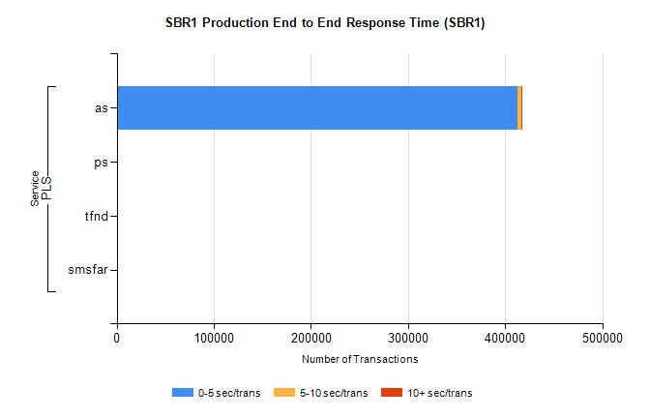
Stream | Service | 0-5 sec/trans | 5-10 sec/trans | 10+ sec/trans | Total | % within 5 sec timing target
PLS | as | 413073 | 3545 | 843 | 417461 | 98.9%
PLS | ps | 370 | 270 | 461 | 1101 | 33.6%
PLS | tfnd | 334 | 57 | 2 | 393 | 85.0%
PLS | smsfar | 7 | 9 |  | 16 | 43.8%

