Transmission Timings Report Week - 29
15/07/2024 - 21/07/2024

SBR2 External Vendor Testing Environment (EVTE3)

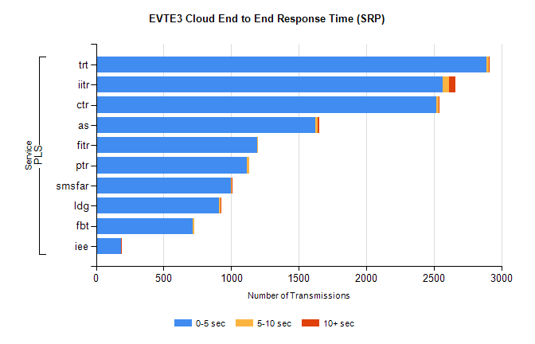
Stream | Service | 0-5 sec | 5-10 sec | >10 sec | Total | % within 5 sec timing target
PLS | trt | 2887 | 20 | 4 | 2943 | 98.1%
PLS | iitr | 2564 | 47 | 48 | 2662 | 96.3%
PLS | ctr | 2519 | 20 | 2 | 2585 | 97.4%
PLS | as | 1625 | 15 | 11 | 1690 | 96.2%
PLS | fitr | 1193 | 6 | 0 | 1226 | 97.3%
PLS | ptr | 1118 | 15 | 0 | 1150 | 97.2%
PLS | smsfar | 999 | 8 | 4 | 1012 | 98.7%
PLS | ldg | 910 | 10 | 6 | 930 | 97.8%
PLS | fbt | 718 | 9 | 0 | 730 | 98.4%
PLS | iee | 187 | 0 | 4 | 191 | 97.9%

SBR2 External Vendor Testing Environment (EVTE3)

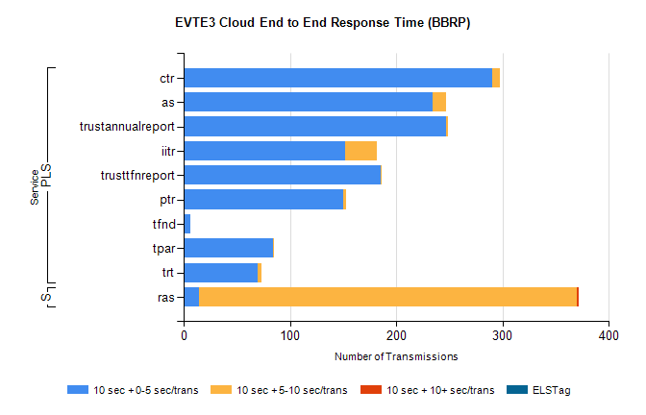
Stream | Service | 10 sec + 0-5 sec /trans | 10 sec + 5-10 sec /trans | 10 sec + >10 sec /trans | Processing Incomplete | ELStag | Total
PLS | ctr | 290 | 8 | 0 | 31 | 0 | 329
PLS | as | 234 | 13 | 0 | 19 | 0 | 266
PLS | trustannualreport | 247 | 2 | 0 | 0 | 0 | 249
PLS | trusttfnreport | 185 | 1 | 0 | 0 | 0 | 186
PLS | iitr | 152 | 30 | 0 | 0 | 0 | 186
PLS | ptr | 150 | 3 | 0 | 6 | 0 | 159
PLS | tfnd | 6 | 0 | 0 | 96 | 0 | 102
PLS | tpar | 84 | 1 | 0 | 0 | 0 | 90
PLS | trt | 70 | 3 | 0 | 2 | 0 | 76
Super | ras | 14 | 356 | 2 | 0 | 0 | 391

