Transmission Timings Report Week - 29
15/07/2024 - 21/07/2024

SBR2 Cloud Production2 - Single Requests (SRP)

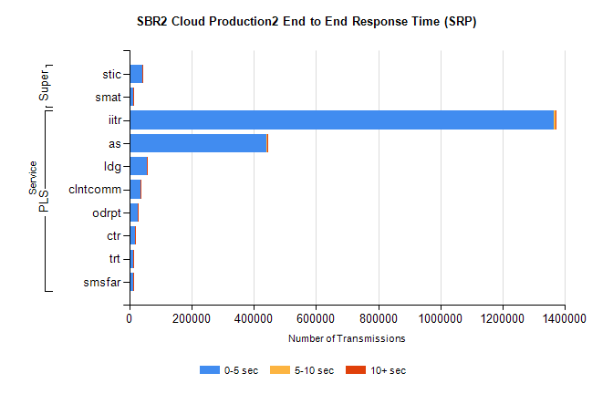
Stream | Service | 0-5 sec | 5-10 sec | >10 sec | Total | % within 5 sec timing target
PLS | iitr | 1363048 | 6891 | 2262 | 1372371 | 99.3%
PLS | as | 441164 | 1702 | 701 | 443633 | 99.4%
PLS | ldg | 57505 | 165 | 39 | 57711 | 99.6%
PLS | clntcomm | 36958 | 336 | 54 | 37349 | 99.0%
PLS | odrpt | 26816 | 951 | 67 | 27835 | 96.3%
PLS | ctr | 18821 | 75 | 27 | 18927 | 99.4%
PLS | trt | 12938 | 48 | 20 | 13013 | 99.4%
PLS | smsfar | 12863 | 48 | 23 | 12934 | 99.5%
Super | stic | 42498 | 261 | 65 | 42826 | 99.2%
Super | smat | 11859 | 171 | 55 | 12086 | 98.1%

SBR2 Cloud Production2 - Bulk or Batch Requests (BBRP)

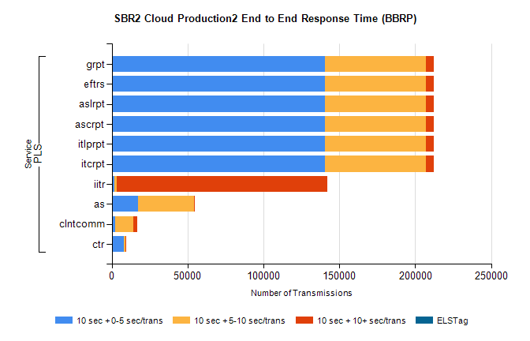
Stream | Service | 10 sec + 0-5 sec /trans | 10 sec + 5-10 sec /trans | 10 sec + >10 sec /trans | Processing Incomplete | ELStag | Total
PLS | itcrpt | 140545 | 66351 | 5133 | 20 | 0 | 215805
PLS | itlprpt | 140545 | 66351 | 5133 | 20 | 0 | 215805
PLS | ascrpt | 140545 | 66351 | 5133 | 20 | 0 | 215805
PLS | aslrpt | 140545 | 66351 | 5133 | 20 | 0 | 215805
PLS | eftrs | 140545 | 66351 | 5133 | 20 | 0 | 215805
PLS | grpt | 140545 | 66351 | 5133 | 20 | 0 | 215805
PLS | iitr | 1777 | 1572 | 138821 | 551 | 0 | 149718
PLS | as | 17073 | 37115 | 182 | 102 | 0 | 54713
PLS | clntcomm | 2430 | 11519 | 2623 | 382 | 0 | 17799
PLS | ctr | 7798 | 1271 | 60 | 8 | 0 | 9157

SBR2 Cloud Production2 - ...

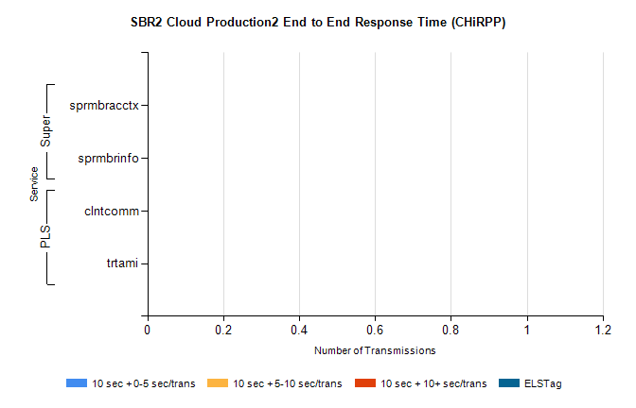
Stream | Service | 10 sec + 0-5 sec /trans | 10 sec + 5-10 sec /trans | 10 sec + >10 sec /trans | Total | % within 5 sec timing target
PLS | clntcomm | 0 | 0 | 0 | 40285 | 0.0%
PLS | trtami | 0 | 0 | 0 | 4 | 0.0%
Super | sprmbracctx | 0 | 0 | 0 | 3378 | 0.0%
Super | sprmbrinfo | 0 | 0 | 0 | 2506 | 0.0%

SBR1 Production Transactions

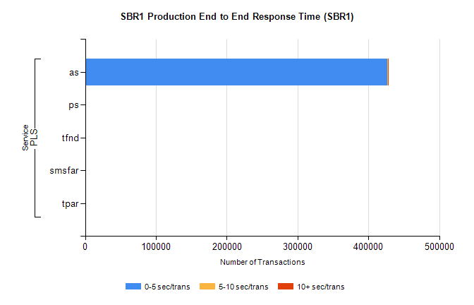
Stream | Service | 0-5 sec/trans | 5-10 sec/trans | 10+ sec/trans | Total | % within 5 sec timing target
PLS | as | 426988 | 143 | 160 | 427291 | 99.9%
PLS | ps | 202 | 189 | 378 | 769 | 26.3%
PLS | tfnd | 232 | 60 | 3 | 295 | 78.6%
PLS | smsfar | 4 | 7 | 1 | 12 | 33.3%
PLS | tpar | 7 |  |  | 7 | 100.0%

