Transmission Timings Report Week - 30
22/07/2024 - 28/07/2024

SBR2 External Vendor Testing Environment (EVTE3)

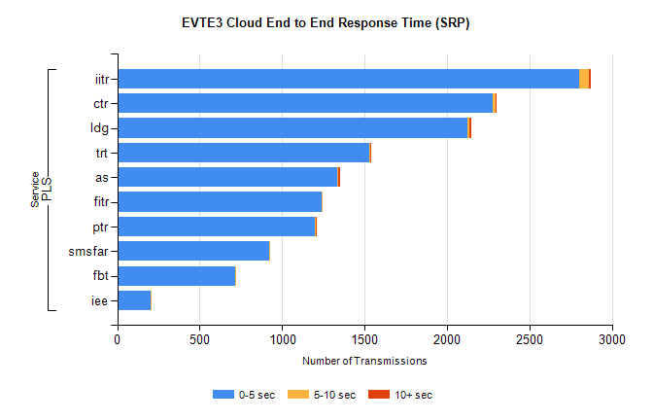
Stream | Service | 0-5 sec | 5-10 sec | >10 sec | Total | % within 5 sec timing target
PLS | iitr | 2800 | 59 | 15 | 2891 | 96.9%
PLS | ctr | 2274 | 21 | 3 | 2316 | 98.2%
PLS | ldg | 2126 | 9 | 12 | 2153 | 98.7%
PLS | trt | 1527 | 6 | 2 | 1568 | 97.4%
PLS | as | 1336 | 5 | 13 | 1403 | 95.2%
PLS | fitr | 1238 | 3 | 0 | 1241 | 99.8%
PLS | ptr | 1200 | 5 | 1 | 1206 | 99.5%
PLS | smsfar | 922 | 1 | 0 | 923 | 99.9%
PLS | fbt | 713 | 5 | 0 | 722 | 98.8%
PLS | iee | 200 | 2 | 0 | 203 | 98.5%

SBR2 External Vendor Testing Environment (EVTE3)

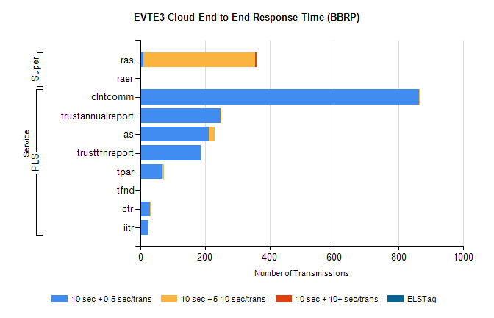
Stream | Service | 10 sec + 0-5 sec /trans | 10 sec + 5-10 sec /trans | 10 sec + >10 sec /trans | Processing Incomplete | ELStag | Total
PLS | clntcomm | 863 | 4 | 0 | 0 | 0 | 875
PLS | trustannualreport | 248 | 3 | 0 | 1 | 0 | 252
PLS | as | 212 | 19 | 0 | 4 | 0 | 237
PLS | trusttfnreport | 187 | 0 | 0 | 0 | 0 | 187
PLS | tpar | 69 | 5 | 0 | 0 | 0 | 80
PLS | tfnd | 0 | 0 | 0 | 45 | 0 | 45
PLS | ctr | 29 | 3 | 0 | 4 | 0 | 36
PLS | iitr | 23 | 3 | 0 | 0 | 0 | 29
Super | ras | 8 | 348 | 3 | 0 | 0 | 376
Super | raer | 0 | 0 | 0 | 83 | 0 | 83

