Transmission Timings Report Week - 30
22/07/2024 - 28/07/2024

SBR2 Cloud Production2 - Single Requests (SRP)

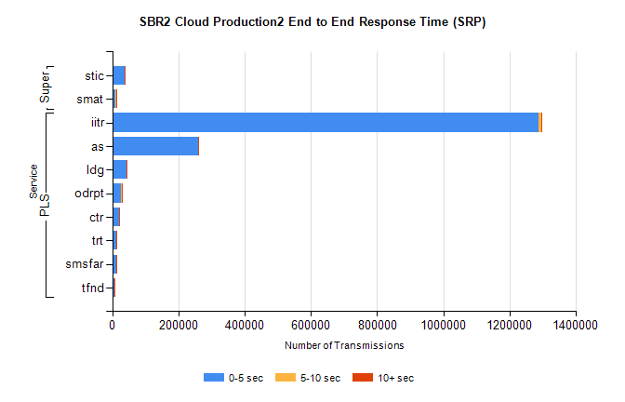
Stream | Service | 0-5 sec | 5-10 sec | >10 sec | Total | % within 5 sec timing target
PLS | iitr | 1287014 | 7791 | 1564 | 1296570 | 99.3%
PLS | as | 258990 | 951 | 179 | 260168 | 99.5%
PLS | ldg | 42679 | 155 | 30 | 42864 | 99.6%
PLS | odrpt | 26889 | 1170 | 179 | 28238 | 95.2%
PLS | ctr | 21474 | 91 | 16 | 21582 | 99.5%
PLS | trt | 13691 | 55 | 11 | 13760 | 99.5%
PLS | smsfar | 13355 | 45 | 18 | 13426 | 99.5%
PLS | tfnd | 6047 | 25 | 2 | 6074 | 99.6%
Super | stic | 38269 | 297 | 43 | 38609 | 99.1%
Super | smat | 10918 | 332 | 45 | 11295 | 96.7%

SBR2 Cloud Production2 - Bulk or Batch Requests (BBRP)

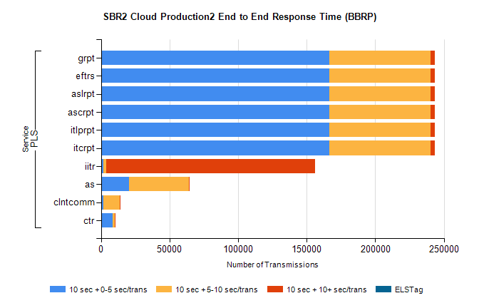
Stream | Service | 10 sec + 0-5 sec /trans | 10 sec + 5-10 sec /trans | 10 sec + >10 sec /trans | Processing Incomplete | ELStag | Total
PLS | itcrpt | 166278 | 73845 | 3131 | 52 | 0 | 248571
PLS | itlprpt | 166278 | 73845 | 3131 | 52 | 0 | 248571
PLS | ascrpt | 166278 | 73845 | 3131 | 52 | 0 | 248571
PLS | aslrpt | 166278 | 73845 | 3131 | 52 | 0 | 248571
PLS | eftrs | 166278 | 73845 | 3131 | 52 | 0 | 248571
PLS | grpt | 166278 | 73845 | 3131 | 52 | 0 | 248571
PLS | iitr | 1863 | 2043 | 152230 | 535 | 0 | 165415
PLS | as | 20257 | 43895 | 142 | 221 | 0 | 64882
PLS | clntcomm | 1939 | 11674 | 417 | 0 | 0 | 14803
PLS | ctr | 8637 | 1409 | 19 | 52 | 0 | 10160

SBR2 Cloud Production2 - ...

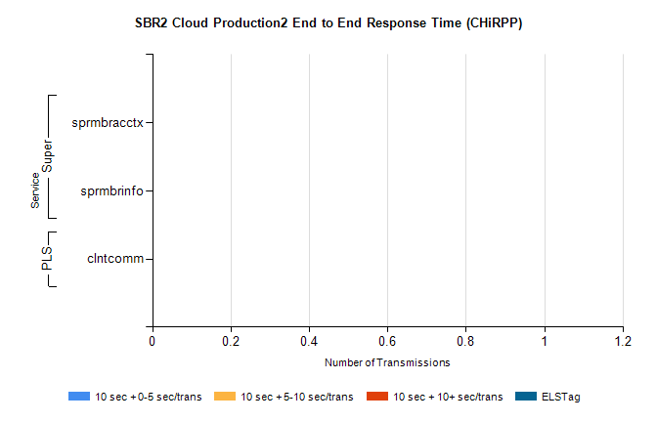
Stream | Service | 10 sec + 0-5 sec /trans | 10 sec + 5-10 sec /trans | 10 sec + >10 sec /trans | Total | % within 5 sec timing target
PLS | clntcomm | 0 | 0 | 0 | 25497 | 0.0%
Super | sprmbracctx | 0 | 0 | 0 | 3462 | 0.0%
Super | sprmbrinfo | 0 | 0 | 0 | 2587 | 0.0%

SBR1 Production Transactions

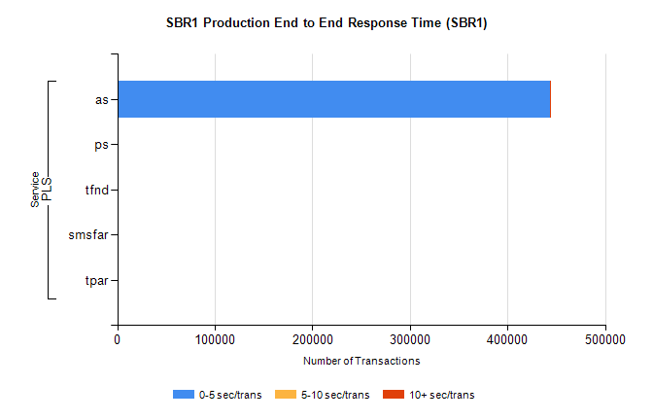
Stream | Service | 0-5 sec/trans | 5-10 sec/trans | 10+ sec/trans | Total | % within 5 sec timing target
PLS | as | 443204 | 440 | 385 | 444029 | 99.8%
PLS | ps | 202 | 190 | 357 | 749 | 27.0%
PLS | tfnd | 188 | 55 | 8 | 251 | 74.9%
PLS | smsfar |  | 14 | 2 | 16 | 0.0%
PLS | tpar | 12 |  |  | 12 | 100.0%

