Transmission Timings Report Week - 31
29/07/2024 - 4/08/2024

SBR2 External Vendor Testing Environment (EVTE3)

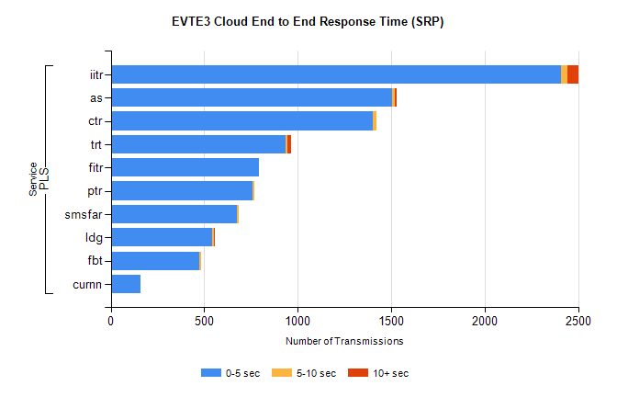
Stream | Service | 0-5 sec | 5-10 sec | >10 sec | Total | % within 5 sec timing target
PLS | iitr | 2407 | 33 | 59 | 2523 | 95.4%
PLS | as | 1505 | 15 | 10 | 1576 | 95.5%
PLS | ctr | 1402 | 17 | 0 | 1446 | 97.0%
PLS | trt | 936 | 9 | 19 | 1045 | 89.6%
PLS | fitr | 792 | 0 | 0 | 793 | 99.9%
PLS | ptr | 758 | 8 | 0 | 768 | 98.7%
PLS | smsfar | 675 | 8 | 0 | 684 | 98.7%
PLS | ldg | 544 | 7 | 4 | 567 | 95.9%
PLS | fbt | 473 | 11 | 0 | 484 | 97.7%
PLS | curnn | 159 | 0 | 0 | 159 | 100.0%

SBR2 External Vendor Testing Environment (EVTE3)

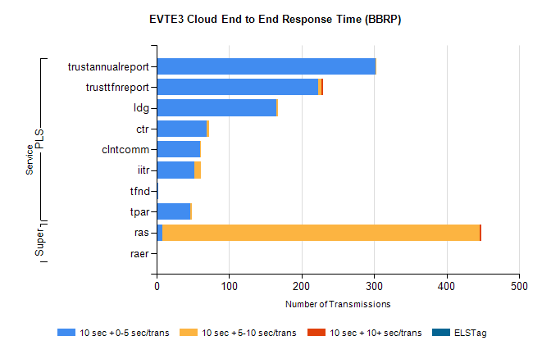
Stream | Service | 10 sec + 0-5 sec /trans | 10 sec + 5-10 sec /trans | 10 sec + >10 sec /trans | Processing Incomplete | ELStag | Total
PLS | trustannualreport | 302 | 1 | 0 | 0 | 0 | 303
PLS | trusttfnreport | 223 | 4 | 3 | 0 | 0 | 230
PLS | ldg | 165 | 2 | 0 | 4 | 0 | 171
PLS | ctr | 69 | 3 | 0 | 10 | 0 | 82
PLS | clntcomm | 60 | 1 | 0 | 3 | 0 | 72
PLS | iitr | 52 | 9 | 0 | 0 | 0 | 65
PLS | tfnd | 2 | 0 | 0 | 62 | 0 | 64
PLS | tpar | 46 | 3 | 0 | 0 | 0 | 56
Super | ras | 8 | 437 | 3 | 2 | 0 | 469
Super | raer | 0 | 0 | 0 | 87 | 0 | 87

