Transmission Timings Report Week - 31
29/07/2024 - 4/08/2024

SBR2 Cloud Production2 - Single Requests (SRP)

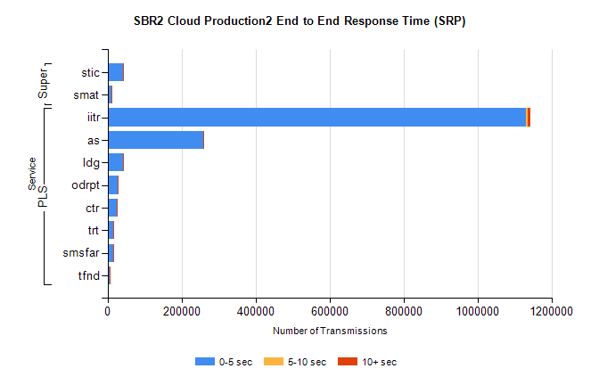
Stream | Service | 0-5 sec | 5-10 sec | >10 sec | Total | % within 5 sec timing target
PLS | iitr | 1129716 | 5278 | 5720 | 1141051 | 99.0%
PLS | as | 257682 | 684 | 293 | 258740 | 99.6%
PLS | ldg | 42205 | 93 | 28 | 42339 | 99.7%
PLS | odrpt | 27664 | 897 | 82 | 28643 | 96.6%
PLS | ctr | 24627 | 77 | 54 | 24760 | 99.5%
PLS | trt | 15641 | 66 | 41 | 15752 | 99.3%
PLS | smsfar | 14577 | 35 | 88 | 14708 | 99.1%
PLS | tfnd | 5838 | 28 | 23 | 5889 | 99.1%
Super | stic | 40967 | 664 | 182 | 41822 | 98.0%
Super | smat | 10347 | 391 | 104 | 10848 | 95.4%

SBR2 Cloud Production2 - Bulk or Batch Requests (BBRP)

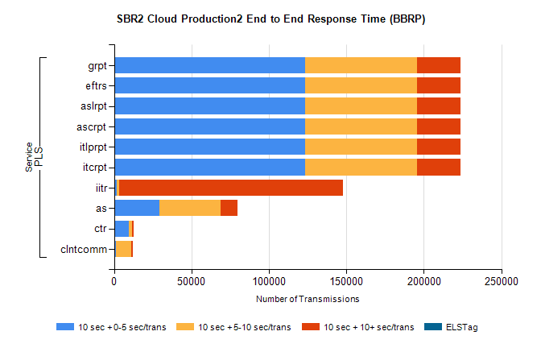
Stream | Service | 10 sec + 0-5 sec /trans | 10 sec + 5-10 sec /trans | 10 sec + >10 sec /trans | Processing Incomplete | ELStag | Total
PLS | itcrpt | 123340 | 72284 | 27961 | 109 | 0 | 236222
PLS | itlprpt | 123340 | 72284 | 27961 | 109 | 0 | 236222
PLS | ascrpt | 123340 | 72284 | 27961 | 109 | 0 | 236222
PLS | aslrpt | 123340 | 72284 | 27961 | 109 | 0 | 236222
PLS | eftrs | 123340 | 72284 | 27961 | 109 | 0 | 236222
PLS | grpt | 123340 | 72284 | 27961 | 109 | 0 | 236222
PLS | iitr | 1567 | 1541 | 144895 | 1727 | 0 | 157573
PLS | as | 29006 | 39658 | 11056 | 544 | 0 | 82288
PLS | ctr | 9502 | 2061 | 1118 | 78 | 0 | 12881
PLS | clntcomm | 1410 | 9856 | 634 | 25 | 0 | 12831

SBR2 Cloud Production2 - ...

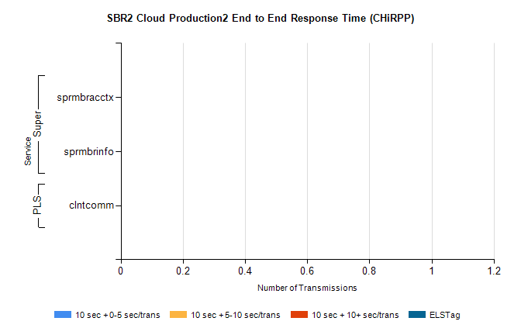
Stream | Service | 10 sec + 0-5 sec /trans | 10 sec + 5-10 sec /trans | 10 sec + >10 sec /trans | Total | % within 5 sec timing target
PLS | clntcomm | 0 | 0 | 0 | 23035 | 0.0%
Super | sprmbracctx | 0 | 0 | 0 | 3901 | 0.0%
Super | sprmbrinfo | 0 | 0 | 0 | 2703 | 0.0%

SBR1 Production Transactions

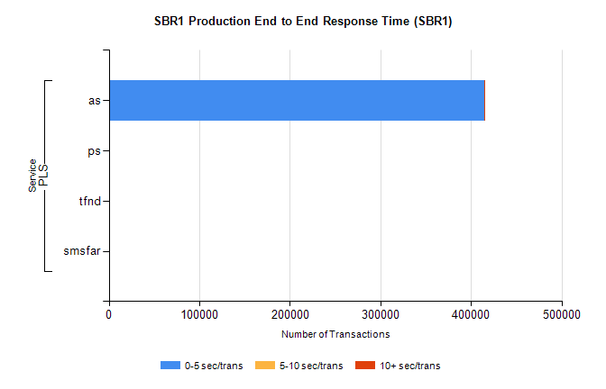
Stream | Service | 0-5 sec/trans | 5-10 sec/trans | 10+ sec/trans | Total | % within 5 sec timing target
PLS | as | 414845 | 158 | 1059 | 416062 | 99.7%
PLS | ps | 147 | 184 | 300 | 631 | 23.3%
PLS | tfnd | 217 | 54 | 1 | 272 | 79.8%
PLS | smsfar | 2 | 22 | 4 | 28 | 7.1%

