Transmission Timings Report Week - 32
5/08/2024 - 11/08/2024

SBR2 External Vendor Testing Environment (EVTE3)

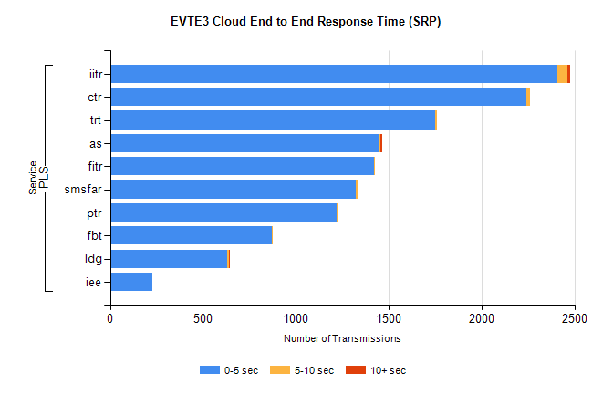
Stream | Service | 0-5 sec | 5-10 sec | >10 sec | Total | % within 5 sec timing target
PLS | iitr | 2406 | 54 | 17 | 2479 | 97.1%
PLS | ctr | 2241 | 20 | 0 | 2274 | 98.5%
PLS | trt | 1749 | 9 | 0 | 1773 | 98.6%
PLS | as | 1445 | 11 | 7 | 1495 | 96.7%
PLS | fitr | 1421 | 1 | 0 | 1423 | 99.9%
PLS | smsfar | 1325 | 7 | 0 | 1333 | 99.4%
PLS | ptr | 1218 | 4 | 0 | 1222 | 99.7%
PLS | fbt | 869 | 9 | 0 | 879 | 98.9%
PLS | ldg | 632 | 9 | 4 | 646 | 97.8%
PLS | iee | 226 | 0 | 0 | 226 | 100.0%

SBR2 External Vendor Testing Environment (EVTE3)

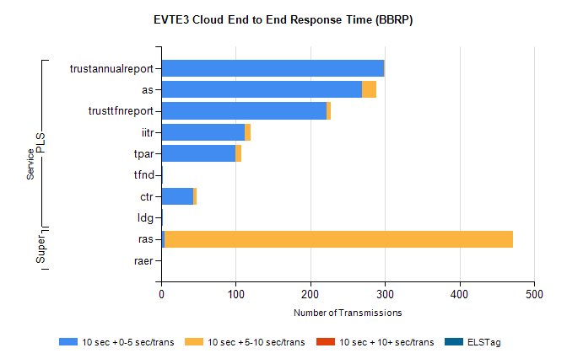
Stream | Service | 10 sec + 0-5 sec /trans | 10 sec + 5-10 sec /trans | 10 sec + >10 sec /trans | Processing Incomplete | ELStag | Total
PLS | trustannualreport | 298 | 1 | 0 | 0 | 0 | 299
PLS | as | 269 | 19 | 0 | 3 | 0 | 291
PLS | trusttfnreport | 222 | 5 | 0 | 0 | 0 | 227
PLS | iitr | 112 | 8 | 0 | 1 | 0 | 122
PLS | tpar | 100 | 7 | 0 | 0 | 0 | 112
PLS | tfnd | 2 | 0 | 0 | 56 | 0 | 58
PLS | ctr | 43 | 4 | 0 | 0 | 0 | 47
PLS | ldg | 2 | 0 | 0 | 35 | 0 | 37
Super | ras | 4 | 468 | 0 | 3 | 0 | 488
Super | raer | 0 | 0 | 0 | 111 | 0 | 111

